Day in the Life of the Hudson River 10/20/16 Data
(Saltfront ~ RM 83)
RIVER MILE 19.5
JFK Marina, Yonkers
Kelly Jakob, Danielle Doucette, Riverside High School 11th-12th grade, 30 students, Museum 25 School 6th grade 30 students, 6 adults
Riverside High School & the Museum School
Latitude 40°59’52”N, Longitude 73°53.03”W
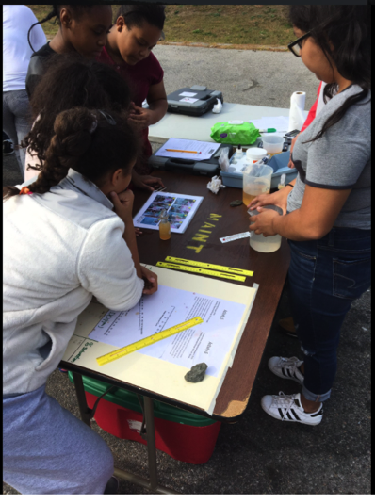 | 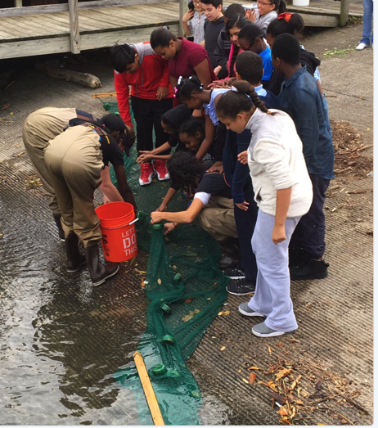 | 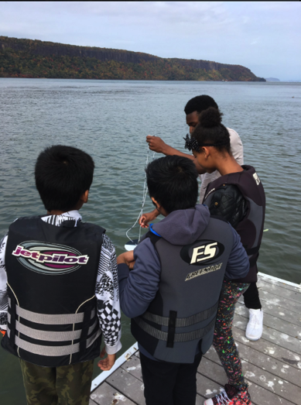

Location: JFK Marina, Yonkers waterfront, Westchester, NY
Area: Waterfront marina with a north facing boat ramp for seining and a wooden walkway along the edge.
Surrounding Land Use: 40% grassy park fenced from the water, 60% cement boat ramp on the northside and large parking lot.
Sampling Site: bulkheaded waterfront, cement ramp for seining,
Plants in area: no
Water depth:
River Bottom:

ITEM | 9:30 AM | 1:30 PM |  |  |  | Comments
Physical
Air temperature | NR
Wind Speed | NR
Weather today | overcast
Weather recently | Warm and dry
Water Surface
ITEM |  |  |  |  |  | Comments
Turbidity – long site tube | NR
Water temperature | AM |  | 67°F |  | 19°C
Chemistry
pH – color kit | 9:31 AM  10:01 AM  10:09 AM  10:17 AM  10:26 AM  11:50 AM  12:00 PM  12:09 PM  12:15 PM |  | 8.4  8.0  8.0  7.5  7.25  8.4  8.0  7.9  7.8 |  | Base  Base  Base  Base  Base  Base  Base  Base  Base
DO – Hach kit | Time |  | H2O Temp |  | DO* | % Saturation
*Seems there were air bubbles in the samples | 9:38 AM  10:01 AM  10:40 AM  11:50 AM  12:00 PM  12:15 PM |  | 18.5°C  19.0  17.0  20.0  19.0  20.0 |  | 12.5  18.0  19.0  18.0  23.0  13.0 | 140%  150%  150%  150%  175%  145%
% saturation | NR
Salinity -refracometer | 15 ppt
Fish Catch  Seine 30 ft. net | 132 |  | Atlantic Silversides |  | 11 cm | DIV 2  TOTAL 147
 | 15 |  | Striped Bass |  | 7 cm
Macroinvert. Catch | 1 |  | Blue crab |  | F – 3 cm | DIV 4  TOTAL 25
 | 1 |  | Mud Crab |  | F
 | 2 |  | Comb Jelly
 | 21 |  | Moon Jelly |  | 9 cm
Tide | Start Time |  | Water Height |  | Current timed 60 secs
*Note – tide was flooding the full sampling time but hard to capture readings from walkway to water surface | 9:26 AM  9:11  9:50  9:54  9:56  10:00  10:27 |  | 90cm  120* wave?  110  110  error  97.5  80 cm |  | Ebb  Ebb  Ebb  Still  Flood  Flood  Flood
Other Items | 4 |  | Water Chestnut

