A Day in the Life of the Hudson River 10/20/16 Data
(Salt Front ~HR RM 80)
RIVER MILE East River 2.3– Cut out at Pier 5, Brooklyn Bridge Park
Christina Tobitsch, Brooklyn Bridge Park Conservancy &
St. Frances Afterschool Program - 12 - 6th graders & 3 adults
40°41’41.5” N – -74°.00’0.17” W
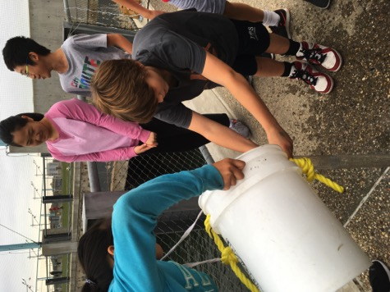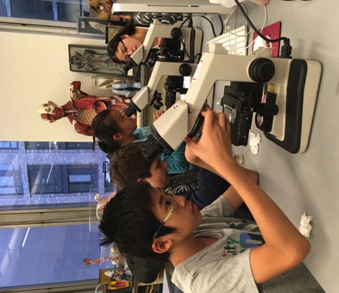
Location: Pier 5 of Brooklyn Bridge Park, south of the Manhattan Bridge and south of the boat marina and in front o the soccer field.
Area: Developed set of piers
Surrounding Land Use: Urban residential and park land
Sampling Site: Rocky shoreline, rip rap
Plants in area: no plants noted in water
Water depth:
River Bottom –unknown
Plants in area – Some algae collected in plankton tows and fish traps

ITEM | Time |  | Reading 1 | Reading 2 | Comments
Physical
Air Temperature | 4:43 PM |  | 21°C  70 °F | 4:47 PM | 21.5°F  71 °F
Wind Speed | 4:45 PM |  | Beaufort 2
Cloud Cover | 4:46 PM |  | overcast
Weather today | Quick drizzle at 5PM
Weather last 3 days | Warm and dry, yesterday abnormally hot!
Water Surface | Choppy
Water Temp. | 4:50 PM | 20°C
 | 5:30 PM | 18.6°C  65.48 °F |  | 18.4°C  65.12 °F
Turbidity – site tube | 5:00 PM | >60 cm |  |  | Tube was only 60 cm
Chemical
DO – tablet (LaMotte test kit) | 5:38PM | 20 C |  | 5.0 mg/L | 55 % saturated
pH – meter | 5:54 PM | 7
Salinity – hydrometer | 5:00 PM | 30 ppt
Nitrates LaMotte | 5:51 PM | 3 ppm
Phosphates LaMotte | 5:48 PM | 2 ppm
Ammonia | 5:53 pm | 1 ppm
MacroCatch – 2 minnow traps and 2 oyster cages | Tube worm  Golden Star Tunicate | 6  NR |  |  | DIV – 5  TOTALS – unable to specify
 | Sea Squirts | many
 | Blue mussel | 1 |  | 1.5 cm
 | Mud crabs | 3 |  | <3cm | 1 M, 1 F, 1 unknown
Other Items
Shipping- commercial | 4:40 PM | Black/White |  | North | Light
 | 4:40 PM | Blue/White |  | North | Loaded
Shipping - Recreational | 4:42 PM | Water Taxi/Yellow |  | North | Light
Observations | More trash and debris floating in the water than usual. Very little plankton found under the microscopes, perhaps because of all the debris.  Birds – mainly gulls overhead

