Day in the Life of the Hudson River 10/20/16 Data
(Saltfront ~RM 83)
RIVER MILE 30.4 – Hook Mountain State Park
Joanne Dickey– Strawtown Art & Garden Studio
Lorraine Marden-Blue Rock School
4^{th,} - 6th – 30 students, total 7 adults
41°7’9” N Latitude - 74° 54’ 46” W Longitude
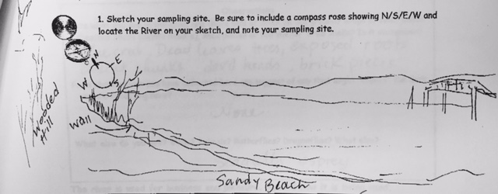
Location: Nyack Beach near Hook Mountain Sandy Beach right side of riverfront area
Area: Park/Boat launch, sandy beach area on the point with riprap
Surrounding Land Use: 5% urban/residential; 45% forested; 50% beach
Sampling Site: Sandy beach with retaining wall enclosing it and behind a lot of trees, picnic tables, sandy and rocky at edges, covered with vegetation beyond the beach, stone wall, riprap shore, concrete docking. Boat launch spits the site and steep bank behind picnic table area. Sandy beach is only available during lower to mid tide. Pipe enters river ~25 ft. south of sampling area
Plants in water: water celery 15%
Along the waterfront: brick, charcoal, slag
Water depth: 3 ft.
River Bottom –sandy, muddy

ITEM | Time |  | Reading 1 | Reading 2 |  | Comments
Physical
Air Temperature | 11:06 AM |  | 21°C  70°F
 | 11:35 AM |  | 22°C  72°F
 | 1:15 PM |  | 21.5°C  71°F
Wind Speed | 1:16 PM |  | Beaufort 3
Cloud Cover | Partly cloudy 26-50%
Weather today | No rain
Weather last 3 days | No rain, warmer than normal
Water | Calm and choppy at different times
*Water Temperature | 10:30 AM | *47°F |  |  | *8.3°C
*seems cold compared to other sites | 11:37 AM | *51°F |  |  | *10.5°C
 | 1:15 PM | *50°F |  |  | *10°C
Turbidity – short site tube | 10:30 AM | 40 JTU  30 JTU |  |  | Average 36 JTU – little turbid – water celery in the area.
Chlorophyll | 12:07 PM | 1.0
Chemical
DO | 10:51 AM  11:37 AM  1:15 PM | 4 ppm  6 ppm  2.5 ppm |  |  | 8.3 ° C  10.5° C  10° C |  | 35%  55%  20%
pH  Indicator solution | 10:30 AM  11:37 AM  1:15 PM | 6.5  7  7.5
Salinity- Quantab  Test strip | 10:30 AM  11:37 AM  1:15 PM | 5037 ppm Cl-  5450 ppm Cl-  4264 ppm Cl- |  |  | 9100 ppm TS  9846 ppm TS  7703 ppm TS
Fish Catch | 15 ft. pull X 4 time | Number Caught |  |  | Species |  | Length of largest
Seine 30 ft. X 4ft.  Mesh 0.25 inch | 1:37 PM | 8 |  |  | Atlantic Silverside |  | 11.5 cm
Fish | Diversity 2  Totals 9 | 1 |  |  | Juvenile Striped Bass |  | 8 cm
Macros | Diversity 1  Totals 1 | 1 |  |  | Blue Crab |  | Male
Tides | Time | Height |  |  | Rate of Change |  | Rising/Falling
 | 10:40 AM | 0 cm |  |  |  |  | Baseline
 | 1:27 PM | 9 cm |  |  |  |  | Rising
 | 2:14 PM | 10 cm |  |  |  |  | Rising
Currents* | Time | CM/30 secs |  |  | Cm/Sec |  | Ebb/Flood/Still
 | 11:10AM | 56 cm |  |  | 1.9 cm/sec |  | Ebb
 | 11:34 AM | 63.5 cm |  |  | 2.1 cm/sec |  | Ebb
 | 1:24 PM | 89 cm |  |  | 3 cm/sec |  | Flood
Shipping Traffic – all recreational | 11:53 AM  12:20 PM  1:12 PM  1:13 PM | Small white  Blue  Motorboat  Sailboat - white |  |  | Southbound  Northbound  Southbound  Northbound
Other Items | Blue crab, dead tree leaves, exposed roots, cement chunks, devil’s heads, brick pieces.  We also saw an osprey! And seagulls.

