Snapshot Day 10/20/16 Data
(Salt Front ~RM 83)
RIVER MILE 32
Lewis & Engel Park
Bridget Baumann & Artie Carlucci, Ossining HS AP Environmental Science
10th-12th grade – 12 students, 1 adults
41°10’N - 73°52’W
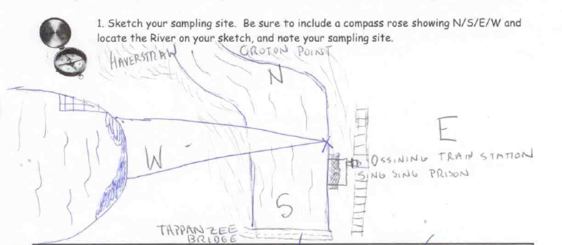
Location: Wading beach at Lewis J. Engel Park, Ossining, NY
Area: Beachfront area with a ferry pier, paved sidewalk, rock wall lining the river, riprap, grass by metro north station
Surrounding Land Use: 50% beach, 15% park, 25% industrial/commercial
Sampling Site: bulkhead lines the shoreline with pier, rock wall, beach, riprap, rocky, weedy, used for picnics and boats. Pipe enters the river North of the sample site.
Plants in the water: 10% water chestnut; 90% water celery
Shoreline: 50% Rocky, 50% Sandy
River Bottom: sandy and muddy with small rocks
Plants: Water chestnut, water celery, *water milfoil (*listed as hornwart on recording sheet)

ITEM | Time |  | Reading 1 | Reading 2 | Comments
Physical
Air Temperature | 12:00 PM  2:00 PM |  | 69°F  68°F | 20.6°C  20°C
Wind Speed | 9:00 AM |  | Beaufort #3 | NW | 8mph
Cloud Cover | 12:00 PM |  | 51%-95% | Mostly cloudy
Weather today | No Rain
Weather last 3 days | Unusually warm
Water | Small wavelets
Water Temperature | 9:30 AM  11:30 AM  12:00 PM | 18 ° C  18 ° C  20 ° C |  | 64° F  64° F  68° F
Turbidity- long site tube | 9:45 AM | <10 cm  >10 cm  >10 cm
Turbidity Comment: Water was very turbid. The water was clear when observed from outside the tube, but was not very directly examined. Light did not penetrate far, showing the water’s ability to block sunlight.
Chemical
DO – LaMotte Green Water test kit | 11:04 AM  11:30 AM  12:00 PM | 2.0 mg/L  3.0 mg/L  4.0 mg/L |  | 18 ° C  20 ° C  20 ° C | 20% saturated  33% saturated  43% saturated
pH (test strips – color match) | 9:50 AM  10:23 AM  10:45 AM  11:25 AM | 6.0  7.0  8.0  7.0
Salinity- plastic hydrometer  (*recorded as ppm but should be ppt) | 11:00 AM  11:30 AM  1:20 PM | 14 ppt  12 ppt  13 ppt |  |  | Average 13 ppt
Nitrogen | 11:04 AM | 15 ppm |  | 15 ppm
Phosphorous | 11:14 AM | 2 ppm |  | 2 ppm
Fish Catch  15 ft. seine | Number Caught | Species |  | Length of largest
9:30 AM | 12 | Atlantic Silversides |  | 10 cm | Diversity - 6
 | 7 | Striped Bass |  | 9 cm | Total Count -24
 | 1 | White Perch |  | 19 cm
 | 1 | Blue Fish |  | 14.5 cm
 | 2 | Naked Goby |  | 2 cm
 | 1 | Pipe fish |  | 17 cm
Macros | 6 | Blue Crab |  | 3male/3 F | Macro Div- 3
 | 15 + | Asian Crab |  |  | Total Count – 24+
 | 3 | Mitten crab
Tides | 9:30 AM  2:00 PM | Set stick  330 cm |  | 4.4 hrs. = 270 minutes | Average 1.22 cm/min
Currents | NR
Shipping - Commercial | 9:00 AM  9:30 AM  1:00 PM | Haverstraw Ferry  Seining Boat for Indian Pt.  Freighter |  | White  Grey  Blue/White | E&W /Loaded  S/ Loaded  North/Loaded
Shipping – Recreational | 9:30 AM | Fishing Boat |  | White | N&S Light
Core Description | Length | Abundant |  | Common | Rare
Collected in 1 meter of water @  11:00 AM | Not listed *no H2S  *no O2 top | Mud  Sand  Pebbles |  | Gravel  Leaves | Wood  Freshwater Mussels  Brick  Slag  Living Vegetation
Observations | Along the beach there are scattered pieces of brick on the ground as well as a few water chestnut seeds and crab shells.
 | Also saw butterflies, various birds (pigeon) and dogs

