Day in the Life of the Hudson River 10/20/16 Data
(Salt Front ~ RM 83)
RIVER MILE 35E
Croton Point Park, Croton on Hudson
Donna Light-Donovan, Croton Harmon High School, 31 HS students, 4 adults
Latitude 41.1868 - Longitude -73.8923
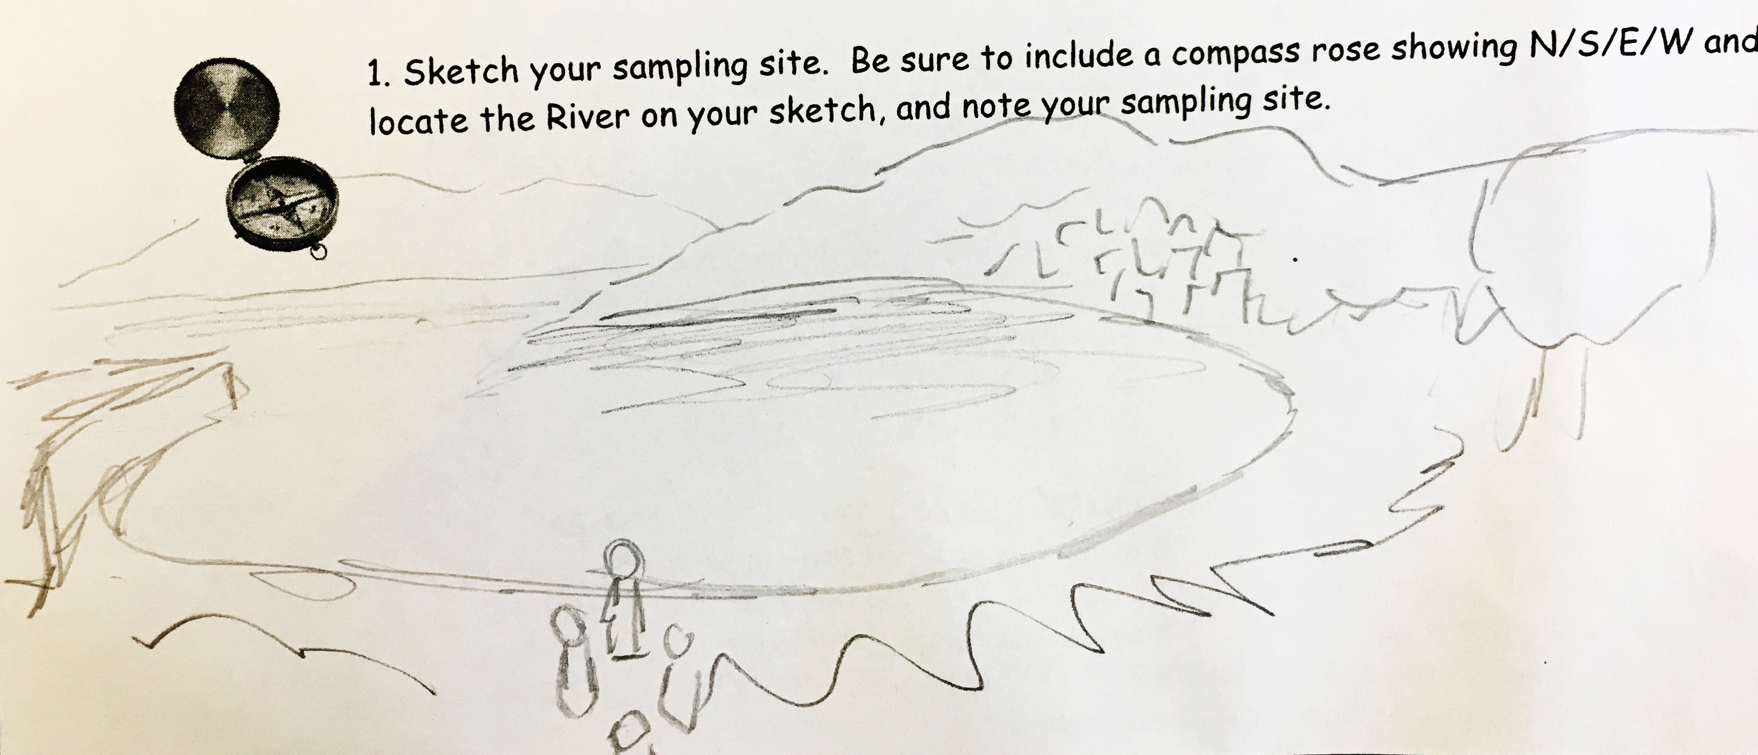
Croton Point Beach (Shea Stevenson)
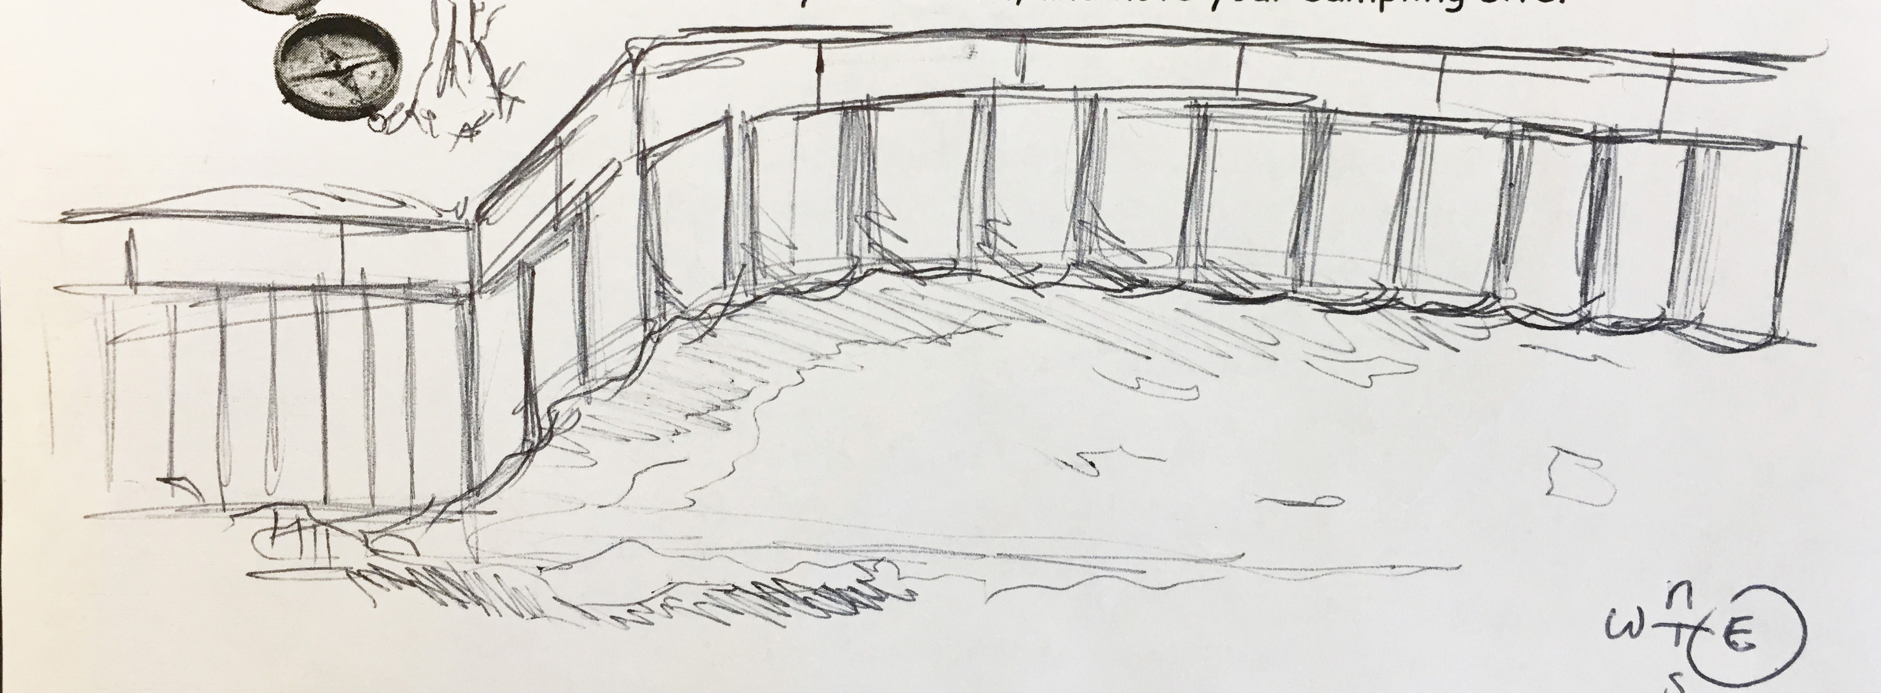
Croton Point Beach retaining wall (Shannon Grounds)
Location: Mother’s Lap, Croton Park NY
Area: Beach surrounded by parkland
Surrounding Land Use: Beach 90%, paved road and parking lot
Sampling Site: Beach area with with raprap @ north end, collected wood debris in area
River Bottom – sandy/muddy bottom - 1 meter deep
Plants in sampling area – Vallisneria Americana (water celery) - < 50% of area

ITEM | Time |  | Reading 1 |  |  | Comments
Physical
Air Temperature | 9:36 AM |  | 63 °F  17 °C
Wind Speed | AM |  | Beaufort #2-3 | 7 mph |  | ENE
Cloud Cover | overcast
Weather today | No rain
Weather recently | Unusually warm
Water Temperature | 9:30 AM | 26 ° C (seems pretty high!)
Water | Calm
Chemical | TIME | Reading
DO | NR
pH | NR
Salinity – Quantabs HR | 9:30 AM | 83. quantab units  8.4  8.4 |  |  | 5426 ppm Cl- | 9802 TS
Turbidity – meter/ | 9:30 AM | 15 NTU  31  35 |  |  | 40 cm  26 cm  22 cm | Average 27 NTU  28 cm
Sediment Core | Comment | Abundant |  |  | Common | Rare
 | Lighter color on top with an oil texture | Sand |  |  | Mud | Clay  Gravel

Fish – | AM | Species
Total Div. 1 | 4 | Banded Killi | 4 cm
Total Catch 4
Macros - | 1 | Fingernail Clam
Total Div. 6 | 1 | Moon Jelly
Total Catch 46 | 1 | Sand Shrimp
 | 1 | Shore Shrimp
 | 1 | Scud
 | 1 | Isopod
Tides | Time | Rising/Falling/ Unchanged | Height in cms
 | 8:30 AM | Low Tide
 | 9:00 AM | Low Tide
Currents | 9:15 AM | 81 cm/ 30 secs | 2.7 cm /sec | Ebb
Shipping | 9:30 AM | Rec – white sailboat | Northbound | Light
 | 10:30 AM | Com – rust barges | Southbound | Light
 | 10:40 AM | Rec - sailboat | Southbound
We will be sending a video that a student, Shannon Angove-Cohen made with her cell phone.

