Day in the Life of the Hudson River 10/20/16 Data
(Saltfront ~ RM 83)
RIVER MILE 37 – Bowline Park, Haverstraw Waterfront
Chuck Barone, Nanuet High School – 30 students, 12th grade APES and NAPES
2 adults
41.° 12’8” N 73.° 57’ 33” W
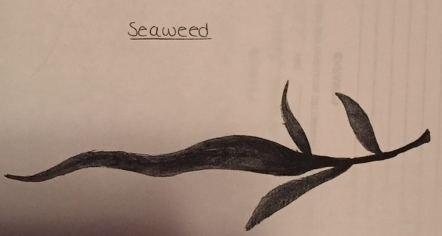 | 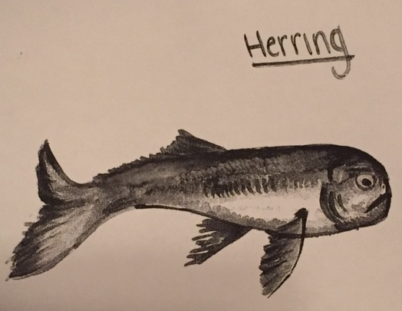

Location: Bowline Park, Haverstraw waterfront, Rockland County NY
Area: Parking lot, recreation, fishing
Surrounding Land Use: 10% beach, 75% Industrial/commercial, 15% urban/residential
Sampling Site: shoreline is sandy, rocky, small beach, bank altered, large rip rap, bulkhead, industrial tress spans the water to the north and east, bricks in the sand
Other Notes: The beach has a distinctive marker showing the high tide line or more commonly referred to as the ‘rack line’ where natural and man made debris line up
Plants in area: 50% algae, 50% seaweed/moss
Water depth:
River Bottom – sandy, squishy, mucky
ITEM | Time |  | Reading 1 | Reading 2 | Comments
Physical
Air Temperature | 8:30 AM  9:30 AM |  | 20.1°C  19.3 | 69.2°F  66.7°F
Wind Speed | 8:30 AM  __________  9:30 AM |  | 4.7 mph  3.0  0  ________  2.3 mph  0  0 | Maximum  Average  Minimum  __________  Maximum  Average  Minumum | North  ___________  North
Cloud Cover | Mostly cloudy
Weather today | Mostly Cloudy |  | 51-75%
Weather last 3 days | unseasonably warm and dry
Water | calm
Water Temp. avg depth 2.5 ft | 8:30 AM  9:30 AM |  | 18,19, 21°C  19,22,22°C | 62,66.70°F  56.8, 71, 71°F | 19.3C & 66F  21 C & 70 F
Turbidity – Long site tube | 8:30 AM  9:30 AM  10:30 AM  11:30 AM  12:30 PM |  | 21,22,23 cm  35, 40, 36  42, 40, 36  40.8,39.2, 42.2  47.6,42.2, 44.4 | AVERAGES | 23 cm  37 cm  41.6 cm  41.46 cm  45.1 cm
Chemical
DO  Drop count | 9:30 AM  8:30 AM  9:30 AM  10:30 AM  11:30 AM |  | 10°C  7.5 ppm  7  5.5  6.7 | 8 ppm  19.3 C  21 C  20C  20.6 C | 70 % sat.  80%  75%  60%  75%.
pH – litmus paper | 8:30 AM  9:30 AM |  | 5,4,5  4,4,4 | AVERAGES | 4.6  4
Salinity:  Hydrometer | 8:30 AM  9:30 AM  10:30 AM  11:30 AM | 11, 10, 11 ppt  10, 10, 11  9,9,10  10, 10 11 |  | AVERAGE | 10.6 ppt  10.5 ppt  9.7 ppt  10.2 ppt
Fish Catch - Seine 4 meters.  Mesh 0.25 inch | Number Caught |  | Species | Length of largest
Fish - Seine 1  8:30 AM | 2 |  | Striped Bass | 10.1 cm | DIV 3  TOTALS 4
 | 1 |  | Atlantic Silverside | 8.8 cm
 | 1 |  | Bay Anchovy | 8.9 cm
Inverts | 1 |  | Shrimp | NR | DIV – 2
 | 1 |  | Crab | NR | TOTALS 2
Seine 2  9:30 AM | 3 |  | Atlantic Silverside | 9 cm | DIV – 3  TOTALS - 10
 | 5 |  | Striped Bass | 20 cm
 | 2 |  | White Perch | 16.1 cm
Seine 4 | 3 |  | Blue Fish | NR | DIV 4
Noon | 3 |  | Herring (sp) | NR | TOTALS 10
 | 3 |  | Blue Herring | NR
 | 1 |  | Bay Anchovy | NR
Tides | 8:30 AM  9:30 AM  11:30 AM  12:45 PM |  | 73 cm  85 cm  75 cm  tide stick under H2O | Rising  Rising  Rising | 0.2 cm/min  0.16 cm/min
Currents | CM/30 secs |  | Cm/Sec | North/South Ebb/Flood/Still | Knots
 | 106.67 |  | 3.56 cm/sec | South ebb | 0.069
 | 109.36 |  | 3.65 cm/sec | North flood | 0.071
 | 52 |  | 1.73 cm/sec | North flood | 0.034
 | 110 |  | 3.67 cm/sec | North flood | 0.07

