Day in the Life of the Hudson River 10/20/16 Data
(Salt front ~ RM 83)
RIVER MILE 39
Riverfront Park, Stony Point Marina, Stony Point, Rockland
Jeanne Maguire, RCC Environmental Science Students through North Rockland HS – 40 12th grade students, 5 adults
Latitude N 41.224 - Longitude W 73.963
North Rockland High School
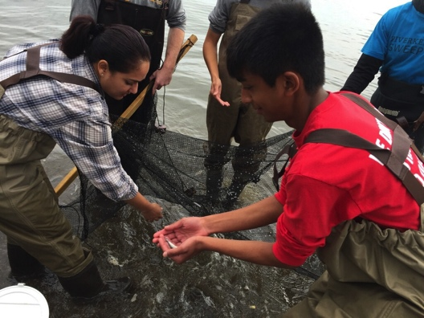 | 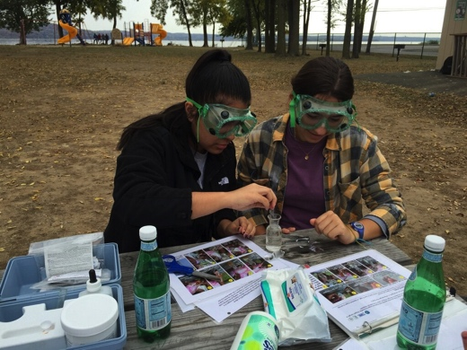

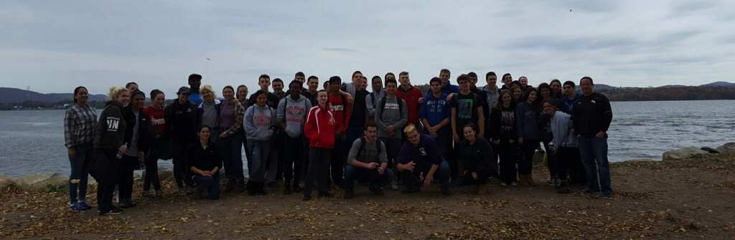

Location: Stony Point Marina Riverfront Park, City of Stony Point in Rockland County
Area: Located along the side of the road at the south end of the marina – Forested in the wider area, Pier, Grassy, Parking Lot
Surrounding Land Use: 25% urban/residential, 60% Industrial/commercial, 15% beach
Sampling Site: Beach sandy and rocky near shore with rip rap edges.
Shoreline: Sandy, muddy, but very rocky with bits of brick and slag
Plants in area: No plants in the water but water chestnut seed pods found on the shoreline
Water Depth: 3 ft.
River Bottom –sandy, little rocky

ITEM | Time |  |  | Reading 1 | Reading 2 |  | Comments
Physical
Air Temperature | 10:35 AM  12:20 PM |  |  | 64 F  69 F | 17 C  20 C
Wind Speed | Beaufort 1 |  |  | 7.1 mph | South
Cloud Cover | 10-12:00 PM |  |  | Partly Cloudy | 26-50% |  | *cloudiness increased from 9AM to noon
Weather today | No rain
Weather recently | Very warm, clear and no wind
Water Surface | Calm
Water  Temperature | 9:55 AM  10:20 AM |  | 19.7ºC  20.2 ºC |  | 67 ºF  68.5 ºF
Turbidity –  Transparency tube | 9:49 AM |  | 59 cm  60  47 |  | Average  55 cm
Chemical
DO | 9:55 AM |  | 19.7 ºC |  | 10 ppm |  |  | 110%  Saturation
pH  color match test kit | 9:00 AM  11:00 AM |  | 7.5  7.8  7.5 |  |  |  |  | Average 7.6
Salinity – High Range  quantabs | 10:20 AM  11:00 AM |  | 7.6 Quan #  8.0 Quan # |  |  |  |  | 5512 TS  6105 TS
Fish Catch- 9:40-12:15 AM | Number Caught |  | Species Fish |  | Size of largest |  |  | Seine
9 ft net X 4ft– | 8 |  | Striped Bass |  | 5 cm |  |  | DIV 3
18 seines | 1 |  | Atlantic Silversides |  | 9 cm |  |  | TOTALS 10
 | 1 |  | Hogchoker |  | 4 cm
 |  |  | Invert
 | 3 |  | Blue Crab |  | M
 | few |  | Mussels
 | many |  | Barnacles
 | DIV 3 |  | Total Inverts 3+
Tides |  | 9:17 AM | 82 cm |  | Rising
 |  | 9:50 AM | 108 cm |  | Rising
 |  | 12:20 PM | 89 cm |  | Falling
Current |  | CM/30 sec | Cm/sec |  | Kts | Ebb/Flood N/S
9:42 AM |  | 91.44 | 3.048 |  | 0.06 | N - Flood
12:20 PM |  | 457.2 | 15.24 |  | 0.30 | N - Flood

