Day in the Life of the Hudson River 10/20/16 Data
RIVER MILE 55
(Salt Front ~RM 83)
Little Stony Point
Pete Salmansohn, Andrea Maasik, of the Hudson Highlands Land Trust
Mark Patinella, Leah Horn additional teachers/chaperones,
30 Haldane Middle (7th) and 5 chaperones
41°25’N - 73°58’W
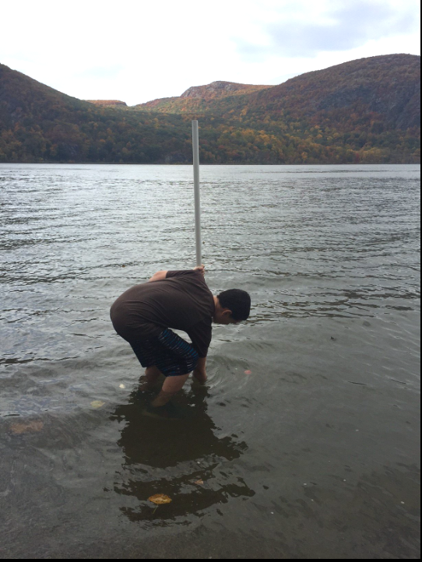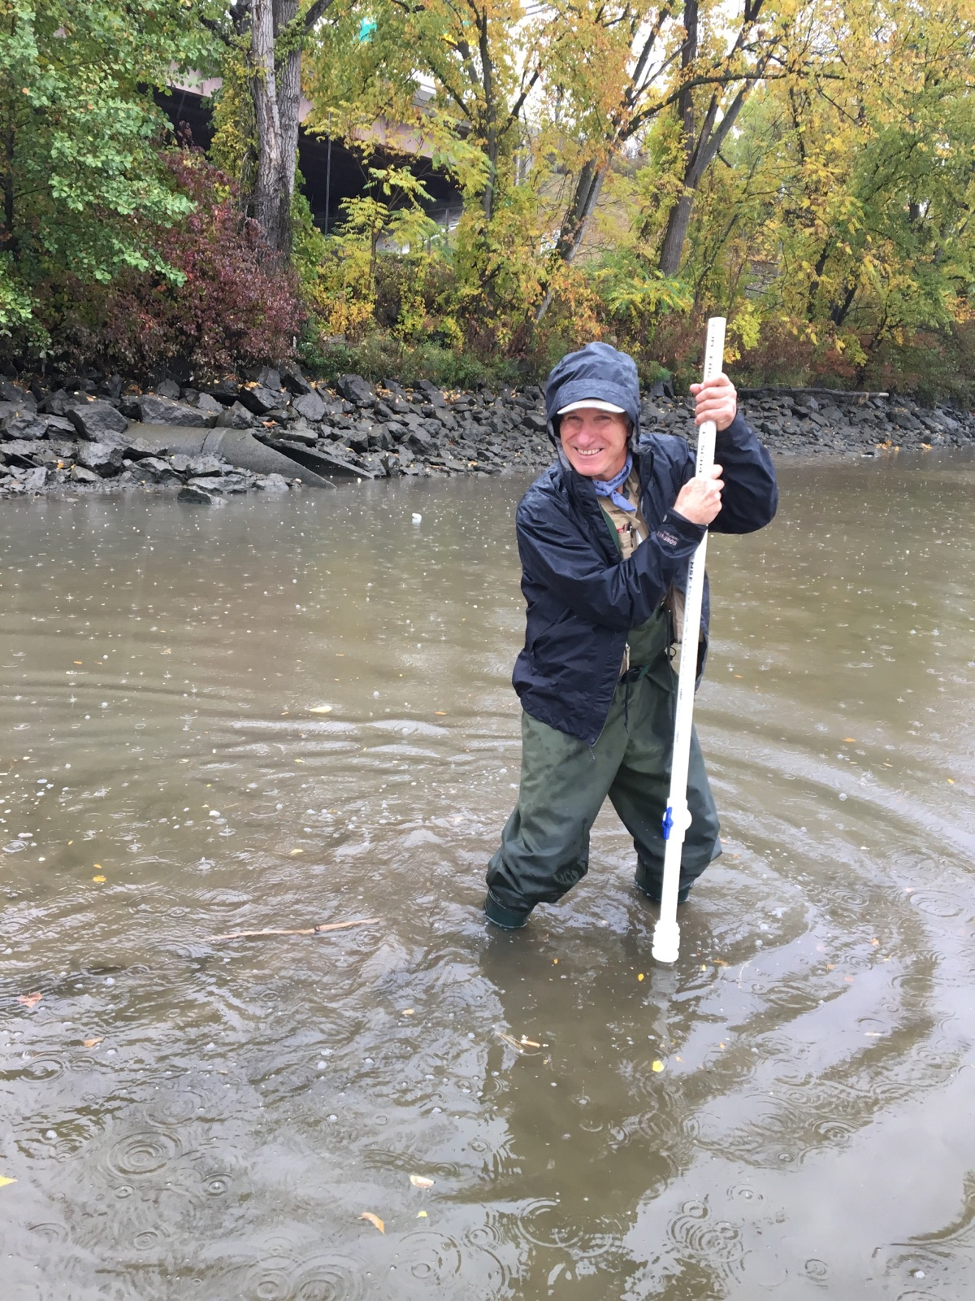
Location: Little Stony Point beach, Cold Spring, Putnam County
Area: On the beach at Little Stony Point, facing Beacon across from Storm King, swimming, picnics, boating, jogging and fishing are main uses
Surrounding Land Use: 80% forested & 20% beach
Sampling Site: beach area, concrete, docking with pier
River Bottom –sandy
SAMPLING TIMES 9AM to 1PM
ITEM | Time |  | Reading 1 |  |  | Reading 2 | Comments
Physical
Air Temperature | 9:50 AM  10:00 AM  10:33 AM  11:33 AM |  | 10°C  10°C  10°C  11.7°C |  |  | 50 °F  50 °F  50 °F  53 °F
Wind Speed | 9:50 AM |  | Beaufort 1
Cloud Cover | 9:50 AM  10:00 AM  10:33 AM  11:33 AM  12:00 PM |  | Mostly cloudy  Mostly cloudy  Partly cloudy  Partly cloudy  Partly cloudy
Weather today | No rain
Weather recently | Fall like, cool
Water | NR
Water Temperature | 9:50 AM  10:00 AM  10:33 AM  11:33 AM | 15.6°C  15.6  15.6  15.6 |  |  | 60 °F  60 °F  60 °F  60 °F
Turbidity – | 9:50 AM  10:00 AM  10:33 AM  11:33 AM | 2.5 ml std turbid  1 ml  1.5 ml  1.5 ml
Chemical
DO  (ampules) | 9:50 AM  10:00 AM  10:33 AM  11:33 AM  12:00 PM | 9 mg/L  7  8  8 |  |  | 15.6°C  15.6  15.6  15.6 |  | 90% Sat.  75%  80%  80%
pH – wide range pH strips | 9:50 AM  10:00 AM  10:33 AM  11:33 AM  12:00 PM | 6.5  6.5  6.5  6.5
Salinity – quantabs -LR | NR
Fish & Crab Catch | Time | Species |  |  | Number |  | Size of Largest
Diversity-7 |  | White Perch |  |  | 4 |  | 13 cm
Totals - 13 |  | Catfish |  |  | 1 |  | 8 cm
 |  | Tessellated Darter |  |  | 1 |  | 5 cm
 |  | Goby |  |  | 2 |  | 8 cm
 |  | Hog Choker |  |  | 3 |  | 4 cm
 |  | Pumpkinseed sunfish |  |  | 1 |  | 8 cm
 |  | Spottail Shiner |  |  | 1 |  | NR
Macroinvert |  | Bluecrabs (Female) |  |  | 2
Div = 2  Totals 4 |  | Crabs (Male) |  |  | 2
Tides – tide stick | 9:50 AM  10:00 AM  10:33 AM  11:33 AM  12:00 PM | 2 cm  2 cm  8.5 cm  12 cm  8.5 cm |  |  | Still  Rising  Rising  Rising
Currents | Time | Cm/sec |  |  | kts
 | 9:50 AM  10:33 AM | 24.6 cm/sec  23.9 cm/sec |  |  |  |  | Flood
Core Description | Length | Rare |  | Common | Abundant |  | Notes
Traffic
Other Observations

