Day in the Life of the Hudson River 10/20/16 Data
(Saltfront ~RM 83)
RIVER MILE 57
Donahue Memorial Park, Cornwall Landing, Village of Cornwall-On-Hudson, Town of Cornwall, Orange County, NY
Christopher O’Sullivan, NYSOPRHP Trailside Museums & Zoo
Deborah Gilson and teacher team @ Willow Ave. Elementary -
Mary Lynne Malone, Orange County
Tom Lake, DEC HREP
4th grade – 75 – 4th grade students, 13 adults
GPS Latitude 41°26’36”N Longitude 74°0’1”W
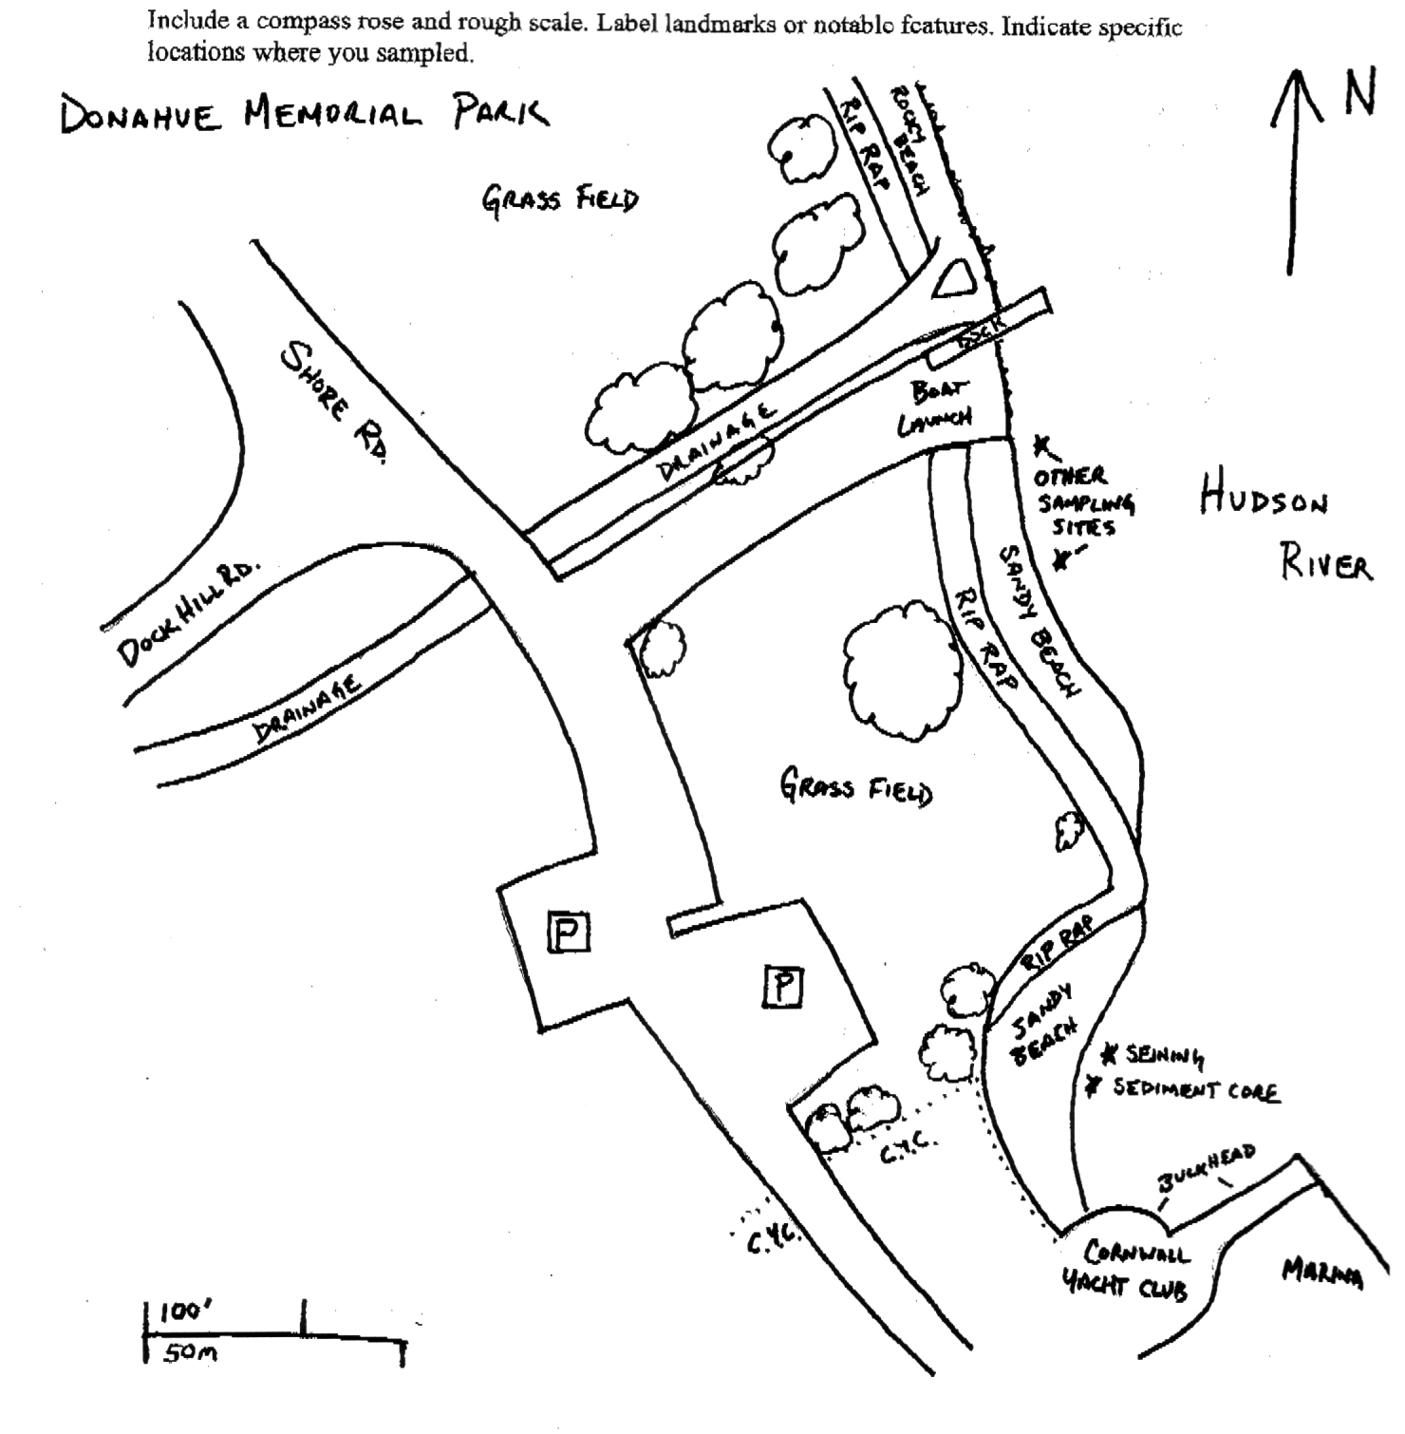
Location: Donahue Memorial Park
Area: Sandy beach used for seining & sediment core, 2nd beach are for other sampling.
Surrounding Land Use: 100% open and grassy park
Sampling Site: pier, sandy beach, altered banks, shoreline riprap, bulkhead, collected wood & debris in area,
Plants in area: NR
Water depth: NR
River Bottom – muddy, rocky
Observations – Rocky, algae in sampling area and sampled in sunlight

ITEM | Time |  | Reading 1 | Reading 2 | Comments
Physical
Air Temperature |  |  | °C
Wind Speed
Cloud Cover
Weather today
Weather recently
Water Temperature | Tom | 19°C  °C |  | 66°F
Water Surface | NR
Turbidity
Long sight tube
Chemical
DO  Drop count kit | NR
pH (indicator sol.)
Salinity - | Tom | 4.0 ppt
Fish Catch | Number Caught | Species |  | Size |  | Comment
(Yoy) = young of yer | 15 | Striped Bass (yoy) |  | 77-86 mm |  | DIV 5  TOTAL 61
(a) - adult | 15 | American shad (yoy) |  | 94-98 mm
 | 18 | Spottail shiner (a)
 | 4 | Banded killifish (a)
 | 9 | White perch (a)
Tides | TIME | RISING/  FALLING |  | HEIGHT IN CM |  | RATE OF CHANGE
Currents
Boat
Other Observations

