Day in the Life of the Hudson River 10/20/16 Data
(Salt Front ~ RM 83)
RIVER MILE 65 – Chelsea Boat Launch, Wappinger Falls, NY
Rosellen Hardt, Wappinger Junior HS
29 students 7th grade, 7 adults, 4 adults

Location: Chelsea Boat Launch, Wappinger Falls, Dutchess County, NY
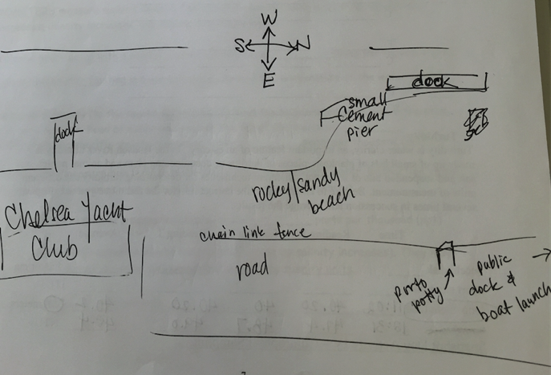
Area: rocky sandy beach for core samples and seining, dock for chemistry
Surrounding Land Use: 25% urban/residential, beach 10%, 40% Industrial/Commercial, 25% beach,
Sampling Site: beach area with pier, riprap shoreline, concrete docking in area
Plants: 1/8 area - pickerelweed, reed grass, water celery, water milfoil
Water depth: 20 ft.
River Bottom –muddy, rocky

ITEM | Time | Reading 1 | Reading 2 | Comments
Physical
Air Temperature | 10:36 AM  11:03 AM  11:22 AM | 20.2 °C  19.6  20.7 | 68.3°F  67  69
Wind Speed – | Time | Clouds | Beaufort # | Wind m/s
 | 11:03 AM | Overcast  76-100% | 2 - SW | 5 kts average
Cloud Cover | 10:06  10:26  10:55  12:24  12:52 | Partly cloudy Mostly  Mostly  Clear  Clear | 25-50 %  51-75  51-75  <25  <25
Weather today | No rain | Consistent weather throughout day
Weather last 3 days | Weather for past 3 days: Warm (low 80s) and dry (no rain)
Water | Choppy
Water Temperature | 11:30 AM | 18°C  17.5°C | 64.4°F  63.5 | Avg. 17.75 °C  64°F
Turbidity - Long site tube | 11:02 AM  _________  12:31 PM | 40.2 cm  40  40.2 cm  __________  47.4 cm  48.7  49.0 |  | Avg. 40.2 cm  _____________  48.4 cm
Chemical
DO | NR
pH -  color match | 10:45 AM  11:15 AM  11:50 AM  12:20 PM | 7.0  7.5  7.5  7.4
Salinity | NR
Fish Catch 10:30-12:30 PM | Time | Fish Species | # caught | Length cm
20 ft. net |  | Striped Bass | 3 | 8 cm
 |  | Tessellated Darter | 2 | 6
 |  | Spottail Shiner | 11 | 5.5
 |  | Golden Shiner | 1 | 6
 |  | Alewife Herring | 2 | 6.5
 |  | Banded Killifish | 3 | 6
 |  | Porgy | 1 | 6
 |  | White Perch | 2 | 7
 |  | Pumpkinseed | 3 | 8
 |  | Northern Kingfish | 4
TOTAL DIV - 10 | TOTAL | CATCH 32
Macroinvert | Number | Macros | Number | Additional Info
 |  | Blue Crab | 3 | All Male
Macro – Div. 1 | Totals 3
Tides | 10:15AM | Rising
 | 11:00 AM | Rising
 | 11:45 AM | Rising
Currents | Cm/30 Sec | Cm/sec | Knots | Ebb/Flood N/S
10:19 AM  11:30 AM  12:45 PM | 1305  640.5  641 | 43.5  21.4  21.4 | 0.85  0.42  0.42 | Ebb S  Ebb S  Flood N
Core Sampling | Description | Rare | Common | Abundant
10:15 AM | 12.7 cm |  | Sand | Clay
 |  |  | Gravel
 |  |  | Pebbles
10:48 AM | 10.2 cm |  | Gravel | Clay
 |  |  |  | Sand
 |  |  |  | Pebbles
12:37 PM | 12.7 cm | Wood | Clay
 |  |  | Mud
 |  |  | Sand
 |  |  | Gravel
 |  |  | Pebbles

