Day in the Life of the Hudson River 10/20/16 Data
(Saltfront ~ RM 83)
RIVER MILE 76W
Bob Shepard Highland Landing Park, Highland, Dutchess County
Kevin Rizzo, Highland, 30 students, 8th grade Living Environment, 3 adults
41.715758° - 73.948°
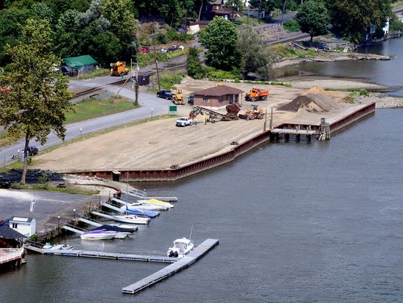
N

W E

S
Location: Bob Shepard Highland Landing Park, Highland, New York.
Area: New park, pier, grassy, parking lot. Park used for fishing, boating
Surrounding Land Use: 20 % commercial/industrial; 40% urban/residential; 30% forested; 10% beach
Sampling Site: shoreline is riprap, banks altered, concrete bulkhead, wood bulkhead, banks altered, broken concrete and docking debris, construction debris, some brick on shoreline.
Plants in area: ~20% plants in water – water chestnut
Water depth: 2 ft. to 50 ft.
River Bottom –rocky, muddy
Sampled 9:00 AM to 1:00 PM
ITEM | Time |  | Farenheit | Celcius | Comments
Physical
Air Temperature | 9:30 AM  10:30 AM  1:00 PM |  | 55 °F  65 °F  69 °F | 13°C  18°C  20.6°C
Wind Speed | NR
Cloud Cover | 9;30 AM |  | 26-50%  partly cluody | Water condition | Choppy
Weather today | No rain today
Weather last 3 days | Warm and dry
Water Temp. | 10:30 AM  11:30 AM  12:30 PM | 64°F  64  64 |  | 18°C  18  18
Turbidity – Secchi disc | 12:30 PM | 97 cm  62 cm
Long sight tube | 12:30 PM | 92 cm
Chemical
DO - meter | 11:30 AM | 18°C |  |  |  | >50%
pH – litmus paper & pH pen | 9:30 AM  10:30 AM  11:30 AM  12:30 PM | 7  8  8  9
Salinity - | NR
Fish Catch – 20 feet net | Number Caught | Species |  | Largest
Fish | 224 | River Herring |  | NR |  | Diversity 8 Total Catch 282
 | 14 | Blue back Herring |  | 7.6 cm
 | 1 | Blue Gill Sunfish
 | 3 | Killifish |  | 5 cm
 | 33 | Spottail shiner
 | 2 | Striped Bass |  | 10 cm
 | 1 | White Perch |  | 10 cm
 | 3 | Northern Kingfish
Macroinvert | 1 | Blue Crab |  | Male |  | Diversity 1  Total 1
Tides – Time | Falling/  Rising | Height in cm |  | Rate/change cm/min |  | Rate per min.
9:50 AM  10:50 AM  11:10 AM  11:20 AM  11:30 AM  12:30 PM  12:55 PM | Still  Falling  Rising  Rising  Rising  Rising | -20 cm  -20 cm  -10 cm  +4 cm  -+10 cm  +20 cm  +26 cm
Currents | Time | Cm/30sec |  | Still/ebb/flood |  | Comment
 | 10:09 AM  10:30 AM  11:30 AM | 320 cm |  | still  ebb  flood |  | 10cm/sec
Sediment Core | Description | Common |  | Abundant
 | 15.25 cm | Clay  Mud  Oyster Shells  Freshwater Mussels  Zebra mussels  Brick bits
Ship Traffic – Commercial | 1:09 PM | UBC |  | White/red/yellow |  | Southbound
Ship Traffic - Recreational | 10:31 AM  11:04 AM  12:25 PM  12:40 PM | Sailboat  NY593M4  Coast Guard  NY54391X |  | White/Maroon  White/blue  Black/White  Shite/Blue |  | South – light  North – light  South – light  South - light
Other Observations | Chestnut seeds, birds – seagulls, squirrel

