Day in the Life of the Hudson River 10/20/16 Data
(Salt Front ~ RM 83)
RIVER MILE 92
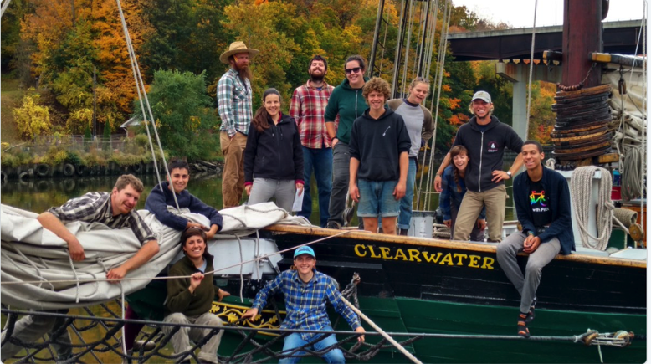
The Clearwater Crew!
Mid-River on the Clearwater, Kingston, Ulster County
GPS Latitude 41°55 N Longitude 73°57 W
Maura Niemisto, Hudson River Sloop Clearwater
Lenape Elementary School – 5th grade, 50 students, 12 adults

Location: Mid-River from Kingston Point, City of Kingston

ITEM | Time |  | Reading 1 | Reading 2 | Comments
Physical
Air Temperature | 10:18 AM |  | 62.8°F  17.3°C
Wind Speed | 11:32 AM |  | Beaufort 1 | East | 2 kts
Cloud Cover | 10:18 AM |  | 100% thick clouds - overcast
Weather today | Overcast
Weather recently | Dry, hot and sunny
Water Surface | Calm
Water Temperature | Time | Temperature #1 |  | Temperature #2 | Average
Water Depth -surface | 10:56 AM | 63.3°F  17.9°C
Chemical
DO  Drop count | 10:56 AM | 10 ppm |  | 17.9 C | 100% saturated
pH – color match kit | 10:56 AM | 8.0
Salinity - refractometer and hydrometer | below detection of these tools |  |  | .
Turbidity – long sight tube | 81 cm | Looks turbid, dark and cloudy
Fish Catch  Trawl net with ~8 ft. of head rope | Number Caught- 15 | Species - 2 |  | Largest Size | 10:49-10:59 AM trawl
 | 1 | White perch |  | 16 cm | FISH
 | 44 | Hog Choker |  | 11 cm | Diversity 3
 | 1 | Catfish |  | 10 cm | Total 46
 | 2 | Blue crab |  |  | MACRO  Diversity 1 Totals 2
Currents | 10:18 AM  11:32 AM | Ebb  Ebb
Traffic- Commercial | 10:07 AM | ‘Brooklyn’ – tug and barge |  | White | Northbound Loaded with fuel
 | 11:45 | Ubc Seattle |  | Red | Southbound – deep draft ship
 |  | ‘Evelyn Cutler’ |  | Red | Southbound – Light fuel barge and tug
Traffic – Recreational | 10:57 AM | Launch boat |  | white | Northbound 2 passengers
 | 11:56 AM | Powerboat |  | white | southbound
 | 12:06 PM | Fishing Boat |  | Blue | southbound
Other Items | Egrets, gulls, bald eagle, crows, heron, deer

