Day in the Life of the Hudson River 10/20/16 Data
(Salt Front ~RM 83)
RIVER MILE 97
Sojourner Truth/Ulster Landing State Park, Town of Ulster, Ulster Co.
Latitude 42°N, Longitude 73°56’W
Deanna Rizzo, Duane Wolff Kingston High School
APES 11-12th graders – 20 students, 2 adults
GPS 42°0’18” N - 73°56’38” W

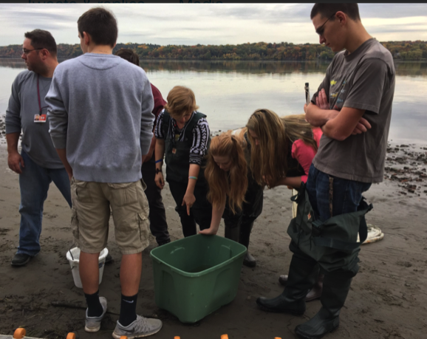 | 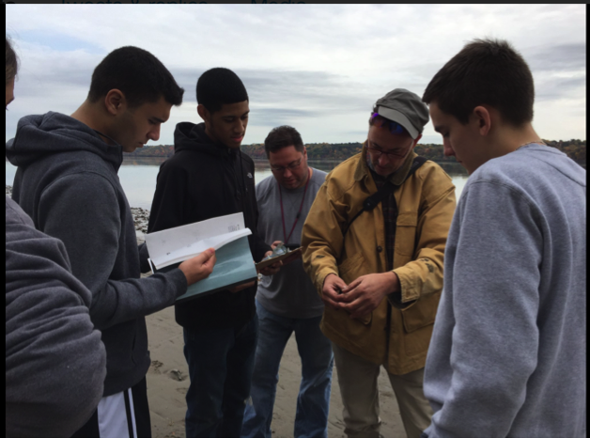

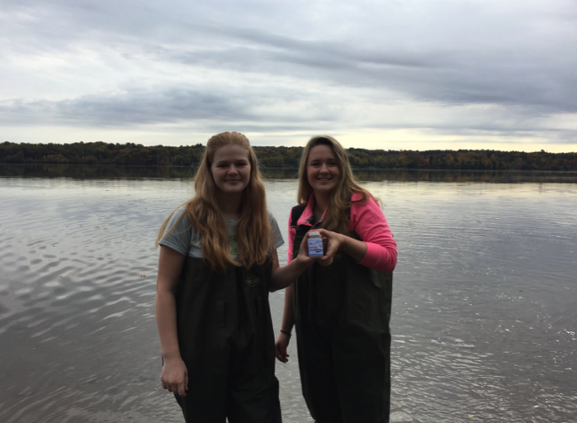
Location: Swimming beach, Sojourner Truth/Ulster Landing Park, Town of Ulster, Ulster County
Area: Forested, fishing pier, swimming beach, has a building with restrooms
Surrounding Land Use: Beach 70%; Forested area 30%; parkland with grass and picnic area
Shoreline: 80% sandy, 20% rocky
Sampling Site: beach, altered bank with concrete bulkhead, Rip rap, brick pieces in the area, slag in the area, drainage from bulkhead north of site immediately
Plants in water area: no plants
River Bottom: sandy
ITEM | Time |  | Reading 1 | Reading 2 | Comments
Physical
Air Temperature | 10:21 AM |  | 17°C  51°F
 | 11:13 AM |  | 19°C  65°F
Wind Speed | AM |  | 1 Beaufort |  | NE
Cloud Cover | AM |  | overcast | >75%
Weather today | No precip
Weather recently | Very warm and clear - dry
Water Temperature | NR
Water Surface | calm
Turbidity - meter | NR
Chemical
DO – meter | N/R
pH - | Time |  |  |  | Average
Litmus paper & indicator solution | 10:20 AM | 7.8  8.5  7.8 |  |  | Average 8.0
Salinity –LR quantabs | 10:20 AM | 36 ppm Cl-  36 ppm Cl- |  | 65 ppm TS
Nitrates | 10:20 AM | 0 ppm  0 ppm
Phosphates | 10:20 AM | Positive test |  | No numeric data = qualitative testing
 | 10:20 AM | 240 ppm  240 ppm |  |  | Average 240 ppm
Fish Catch  27.5’seine X 3.5 X/1/8 inch mesh | Species | Number |  | Length of largest | Seine #
All catches | 21 | Spottail Shiner |  | 12 cm | DIV 9
Fish Recorded Together | 21 | Tessellated Darter |  | 12 cm | TOTALS 95
 | 5 | Common Shiner |  | 10.5 cm
 | 2 | Yellow Perch |  | 17 cm
 | 20 | Striped Bass |  | 12 cm
 | 1 | Goldfish |  | 7 cm
 | 12 | Bull Catfish |  | 26 cm
 | 1 | Hog Choker |  | 12 cm
 | 1 2 | Bluegill Sunfish |  | 6 cm
Macro | 35 | Blue Crab |  |  | DIV 1  TOTALS 35
Grand Total | Diversity 7 | Total Catch 124
Tides | Time | Depth |  | Rate | Falling/Rising
 | 9:55 AM | 0 |  | Set | Set
 | 10:12 AM | 49 cm |  | 10 cm/20 | Rising
 | 10:24 AM | 87 cm |  | 9 cm/30 min | Rising
 | 10:35 AM | 120 cm |  |  | Rising
 | 11:03 AM | 250 cm |  |  | Rising
 | 11:27 AM | 400 cm |  |  | Rising
 | 12:15 PM | 250 cm |  |  | Falling
Currents | Time | Cm/Sec |  | Cm/Sec | N/S  E/F/Still
 | 10:19 AM | 0
 | 10:6 AM | 152 |  | 5.1 | Ebb
 | 10:50 AM | 250 |  | 8.3 | Ebb
 | 12:14 PM | 200 |  | 6.7 | Flood
Traffic - Commercial
Time | Name | Color |  | N/S | Loaded/Light
10:50AM | Barge w/tug | Red/Black |  | North | Light
11:09 AM | UBC Seattle | White |  | South | Light
11:57 AM | Barge w/ tug | White |  | North | Light
Recreational
11:30 AM | N/R | White |  | South | Light
Other Items | Devil’s heads, black walnut, seaweed, duckweed, bricks, birds, fish
Core | Length | Rare |  | Common | Abundant
11:30 AM – water 21 cm deep | 16 cm  H2S smell  Oxidized top – streak | Gravel  Pebbles  Freshwater Mussels  Zebra mussel |  | Clay  Mud  Brick | Sand
BOTTOM < 16 cm length> TOP

Streak of gray sand along bottom.

