Snapshot Day 10/20/16 Data
Mohawk River Valley
SCHOHARIE RIVER SITE RIVER MILE
Middleburgh, NY
Mollie Burgett, Middleburgh High School & 11 students 11/12th grade
42.599109 Lat and -74.331429 Long
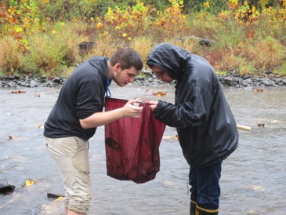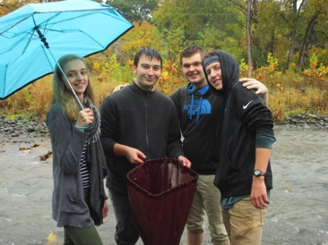
Location: On the Schoharie Creek, creek access point is below Timothy Murphy Park Middleburgh, Schoharie County
Sample location runs right along river street (one of the main streets in the village) and is
full of cobbles, some grasses and short shrubs under 4 feet tall. The trees along the bank on one side make a break between the road and the creek and the other side divide the creek from farm fields.
Surrounding Land Use: 20% urban/residential, 20% farmland, 20 % forested, 30% beach, 10% industrial/commercial
Shoreline: Banks altered, Riprap, Concrete blocking, rocky, 1 stormdrain of some sort occasionally discharges in to the creek just south from the sample site - ~200 ft. down. Lots of cobbles in stream channel, area covered in vegetation
River Bottom: Mostly rocky although sandy and muddy and brick on ground
Water Depth: 0-120 cm
Water Conditions: Calm, clear
Plants in water: no

ITEM | Time |  | Reading 1 | Reading 2 | Comments
Physical
Air Temperature | 1:30 PM |  | 12.5°C
Wind Speed |  |  | Beaufort #2 | South
Cloud Cover | 1:30 PM |  | Overcast
Weather today | 1:30 PM |  | Rain off and on
Weather recently | 80°F dry weather last 2 days
Water Temperature | 1:10 PM  1:10 PM  1:21 PM | 12°C  12  13 |  | Average | 12.3 °C
Turbidity - 60 cm  Site tube | 12:50 PM | 14.9 cm |  | Storm water outflow
 | 12:45 PM | 38.3 cm |  | Main Stem
 | 12:55 PM | 34.6 cm
 | 1:40 PM | 10 cm
Chemical
DO – drop count – | Time | Temp |  | ppm DO | % saturation
Bridge | 1:10 PM  1:45 PM | °C |  | 12 ppm | 110%
Under Bridge | 1:10 PPM |  |  | 13 | 120%
Riffle | 1:45 PM  1:21 PM | °C |  | 15  13 | 140%  120%
Outflow | 1:45 PM |  |  | 11 | 1035
pH – test strips  Average - 6.5 | 1:03 PM  1:09 PM  1:15 PM  1:30 PM | 7, 7  7, 7  6  6 |  | Average | 6.5
Flow Rate (no current up here) | Riffle | 69 cm/sec |  | Used apple | Slow moving water
Nitrates | 1:09 PM  1:40 PM | 0 ppm  0 ppm |  | Under bridge
Phosphates | 1:14 PM  1:35 PM | 0 ppm  0 ppm |  | Under bridge
 | Main stem of creek at surface | Moved backwards because of wind
Fish –6 ft. net 5 meter pull – Haul 1 | 1 | Northern Hog Sucker |  | 9 cm - | DIV – 2  TOTAL- 5
(Nothing haul 2) | 4 | Eastern Silvery Minnow
Haul 3 | 6 | Eastern Silvery Minnow |  |  | Div – 1  Total 6
Haul 4 | 3 | Northern Hog Sucker |  |  | Div – 2  Total 8
 | 5 | Eastern Silvery Minnow |  | 7 cm
Fish Totals | DIV 2 | TOTALS 19
Macroinvertebrates | Number | Species |  |  | Diversity 9
Kicknet &hand net | 20 | Fishfly larvae |  |  | Totals 183
 | 21 | Mayfly larvae
 | 9 | Helgramite
 | 27 | Stonefly
 | 2 | Water Beetle
 | 5 | Water Penny
 | 10 | Rusty Crayfish
 | 9 | Aquatic Worms
 | 80 | Caddisfly
Observations | 1 bald eagle, 2 ducks (species unknown), flock of geese’

