Day in the Life of the Hudson River 10/12/17 Data
(Hudson River Salt Front ~RM 65)
Bronx River Mile 4.0 Hunts Point Riverside Park, Bronx, NY
Michelle Luebke, Bronx River Alliance
Patrick Callahan, Bronx Center for Science & Mathematics
Thirteen 11th and 12th grade APES students, 2 adults
Lat 40.8172 – Lon. -73.8810
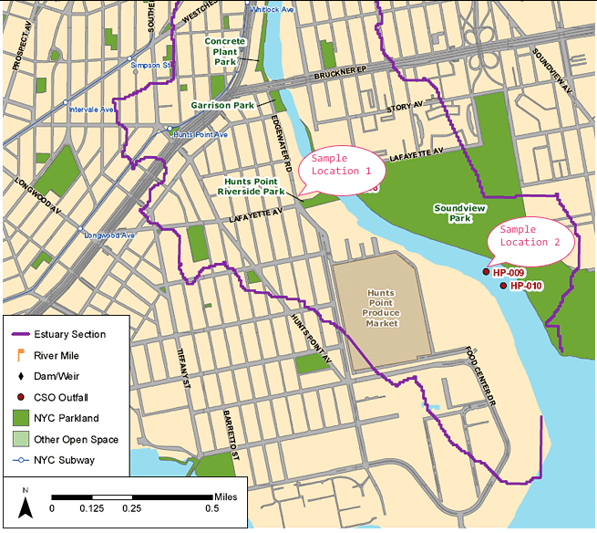

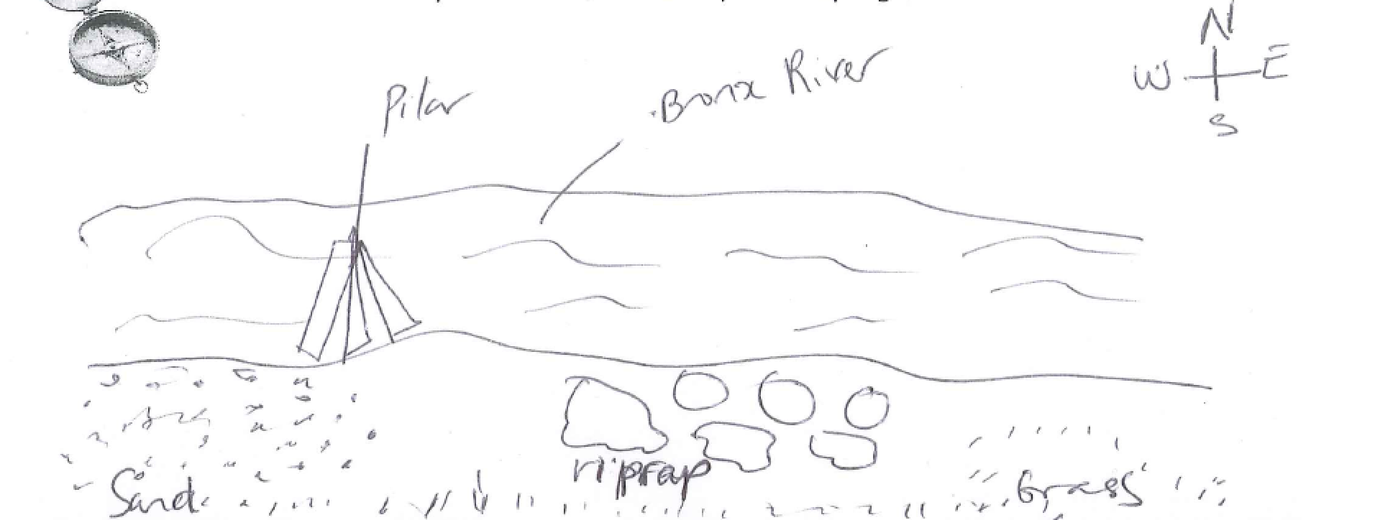
Location: Hunts Point, Riverside Park, Bronx River
Area: Mostly used for boating and fishing. Pier with grassy area and parking lot
Surrounding Land Use: 5% beach; 95% industrial/commercial
Sampling Site: Beach, pier, shoreline riprap, covered with vegetation, debris in the area
Shoreline: rocky, rip rap with pipe entering the water
River Bottom: Muddy, Rocky
Plants in area: 10% golden rod

Sampling Location 1 – Dock – Sample time 6:04 PM
ITEM | Time | Reading 1 | Reading 2 | Comments
Air Temperature | 10:11 AM | 58°F  14°C | Wind meter | 8 mph NE
Cloud Cover | 10:11 AM | Overcast >75%
Weather Today | 10:10 AM | Hard Drizzle
Weather Last 3 days | Usually warm temperatures
Turbidity  Long site tube & Secchi | 10:44 AM | 105.2cm  71.1  100 | 92.1 cm average
 | 11:25 AM | 74 cm  100 cm  83 cm | 85.6 cm average
Water Temperature | 10:29 AM | 52°F  20°C | 51°F  19°C | 51.5°F  19.5°C
 | 10:37 AM | 52°F  20°C | 52°F  20°C | 52°F  20°C
 | 10:45 M | 52°F  20°C | 52°F  20°C | 52°F  20°C
DO | 10:34 AM  11:00 AM  11:12 AM  11:06 AM  11:24 AM  11:29 AM | 4.3 ppm  4.9 ppm  4.5 ppm  6.0 ppm  3.8  2.4 | 18 °C  18 °C  18 °C  20°C  20°C  20°C | 42% saturation  49%  45%  60%  40%  25%
pH | 10:31 AM | 6  5  6 | 6.5  6 | Average 6
 | 11:24 AM | 6  6  7 | 7  7  7 | 7  7 Average 7  7
Salinity - refractometer | 11:43 AM  11:51 AM  11:55 AM | 20 ppt  18 ppt  18 ppt | 20 ppt  18 ppt  18 ppt | 18 ppt  18 ppt  18 ppt
Seine | Total catch | Species | Largest
 | 1 | Mummichog | 3 cm
Macroinvertbrates | 69 | Marsh Grass Shrimp
 | 5 | Atlantic Mud Crab | 3 F  2 M
Tides | Low Tide  High Tide | 9:12 AM  3:16 AM
Observation | Debris and fish scale – smells anoxic.  Blue heron, cormorant and seagulls

