Day in the Life of the Hudson River 10/12/17 Data
(Salt Front ~RM 65)
EAST RIVER MILE 13.5
Ferry Point Park, Bronx NY
Steve Stanne, New York State DEC Hudson River Estuary Program
Bethany Rigging-Walio Amadou, West Bronx Academy, 20 (9th) graders and 2 adults
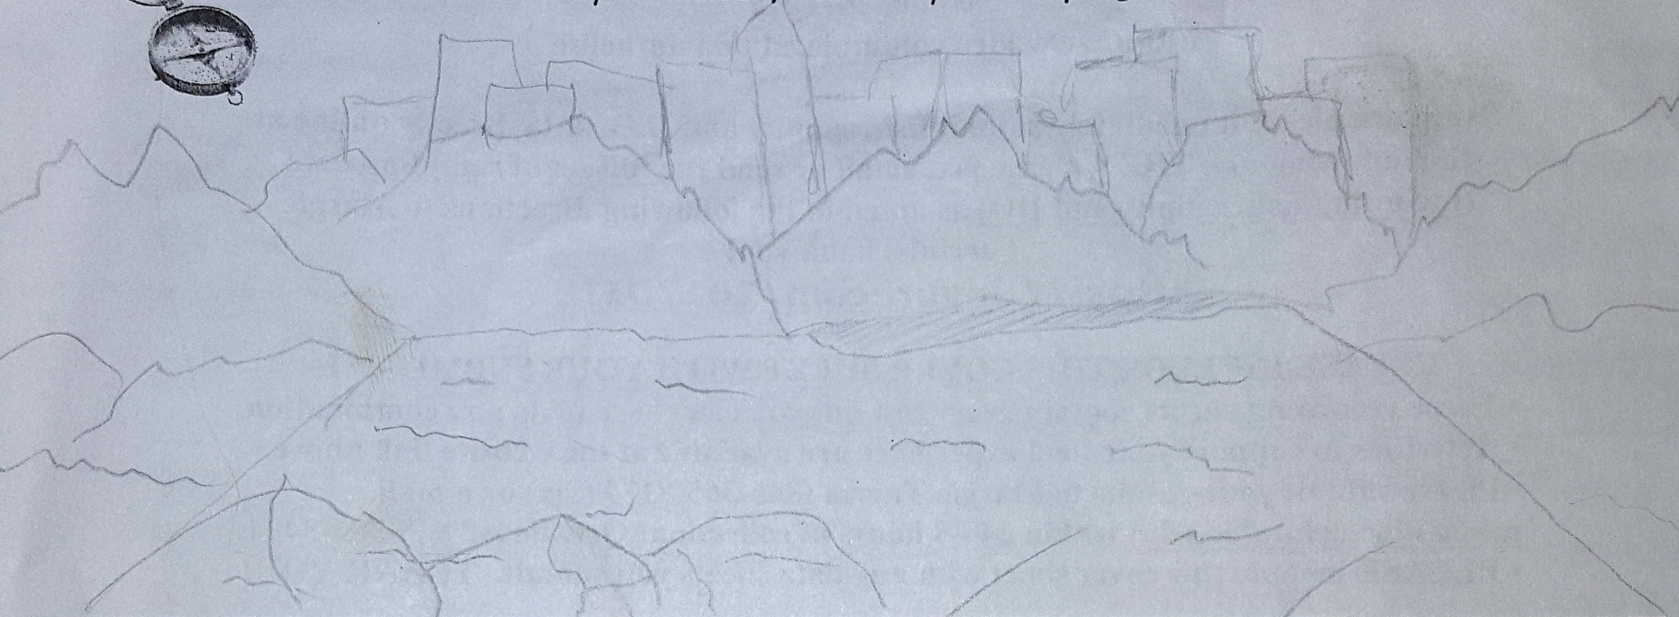

Location: Ferry Point Park beach, Bronx NY below the Bronx-Whitestone Bridge across the East River.
Area: Large park area used for picnics and sports with spartina covered marsh along the water and forested beyond
Surrounding Land Use: Beach and park. 50% sandy, 10% muddy, 30% rocky
Sampling Site shoreline: sandy beach, tidal marsh area covered with dense spartina
Plants in area: n/a
River Bottom – sandy, rocky
Water: Calm, no waves
ITEM | Time | Reading 1 | Reading 2 | Comments
Physical |  |  | 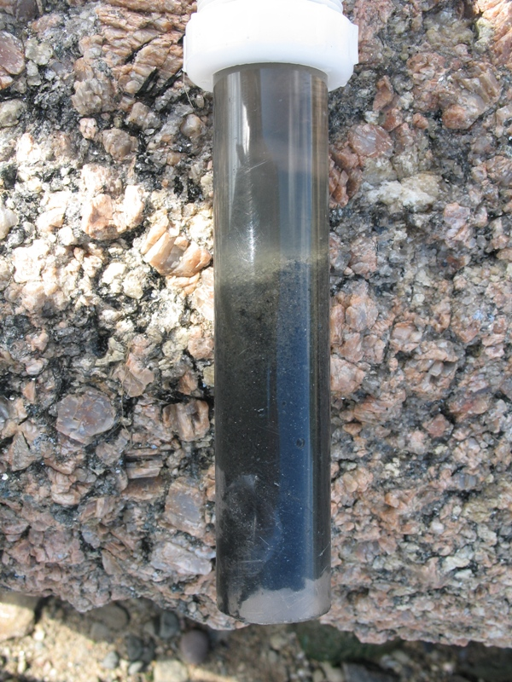  CORE SAMPLE
Air Temperature |  | °C
Wind Speed | 11:54 AM | 2 to 4 Beaufort
Weather today
Weather recently
Water Temperature  13 cm depth | 11:53 AM | 19.9°C
Chemical – | Time
DO – probe
pH – indicator solution | 12:06 PM | 9  9
Salinity – | 12:30 PM | 26 ppt |  | Hydrometer
Fish Catch - Seine net 30 feet X 4 ft., 1.4 inch mesh- | Number Caught – | Species | Size of largest | Notes
FISH | 182 | Atlantic Silverside
 | 3 | mummichogs
TOTAL CATCH | 185 | FISH DIVERSITY | 2
macroinvertebrates
 | Good amount | Blue Crabs
 | 5 | Ctenaphore (Leidy’s comb jelly)
 | 5 | Asian Crabs
MACRO INV | DIV 3
Tides
Currents | 1
Sediment Core | TOP | BOTTOM
 | brown top (oxidized) | black color
Commercial Traffic | Time | Color | N/S | Loaded/Light
 | 11:53 AM | Brown | N | Loaded
 | 11:53 AM | Black | N | Loaded
 | 11:56 AM | Red | N | Light
Other Observations | Bits of glass | shells | Rat | Seagulls
 | Seaweed | Small fish in tide pool | Seems a good environment for crabs – lots of rocks

