Day in the Life of the Hudson River 10/12/17 Data
(Salt Front ~RM 65)
EAST RIVER MILE 13.5
Ferry Point Park, Bronx NY
Steve Stanne, New York State DEC Hudson River Estuary Program
Linda Ewool, Renaissance High School of Musical Theater & Technology,
8 Chemistry Students (11th graders) and 2 adults
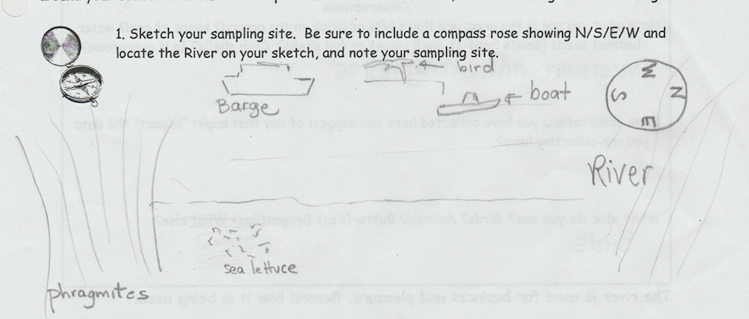
40.81° Latitude -73.84° Longitude

Location: Ferry Point Park beach, Bronx NY below the Bronx-Whitestone Bridge across the East River.
Area: Large park area used for picnics and sports with spartina covered marsh along the water and forested beyond
Surrounding Land Use: Beach and park. 50% sandy, 50% rocky
Sampling Site shoreline: sandy beach, tidal marsh area covered with dense spartina
Plants in area: 55% Phragmites Australis, 30% sea lettuce, 15% algae
River Bottom – sandy, rocky
Water: Calm, no waves
ITEM | Time | Reading 1 | Reading 2 | Comments
Physical | 9:30-11:30 AM sampled
Air Temperature | 11:25 AM | 21.5°C | 68°F
Wind Speed |  | 2 to 4 Beaufort
Weather today | 11:00 AM | Slight Rain Overcast | Lasted ~ 30 minutes
Weather recently | 10/10 Partly cloudy | 10/11 Mostly cloudy | 10/12 Cloudy & rain
Turbidity – long site tube | 11:00 AM | 58 cm | Water appeared cloudy
Water Temperature | 3-4 ft. deep | 22°C  71°F
Chemical –
DO – | 11AM | 22°C | 8 mg/L | 90% saturated
pH – indicator solution | NR
Salinity – 11:20 AM | Hydrometer | 24 ppt | Refractometer | 30 ppt
Fish Catch - Seine net 30 feet X 4 ft., 1.4 inch mesh- | Number Caught – | Species | Size of largest | Notes
11:00 AM - FISH  3 hauls | 3 | Atlantic Silverside | 8 cm | DIV 3  TOTAL 16
 | 12 | mummichogs | 5 cm
 | 1 | Northern pipefish | 18 cm
macroinvertebrates | 1 | Spider crab | Tiny | DIV 6
 | 1 | Green Crab |  | TOTALS 3 crab + others
 | 1 | Blue Crab | Tiny
 | Not tallied | Ctenaphore (Leidy’s comb jelly)
 | Too many to count | Shrimp – 2 types - mostly Palemonetes
MACRO INV | DIV 3
Tides | NR
Currents | NR
Sediment Core | TOP | BOTTOM
 | NR
Commercial Traffic | Time | Color | N/S | Loaded/ Light
 | 11:00 AM | Dark color vessel | Not moving | loaded
We also saw what appeared to be a Coast Guard boat traveling northbound
Other Observations – area is full of reeds. Birds!

