Day in the Life of the Hudson River 10/12/17 Data
(Salt Front ~RM 65)
RIVER MILE -1
Governor’s Island, Upper NY Bay/Buttermilk Channel, NW side
Christine Jimenez - Urban Assembly New York Harbor School
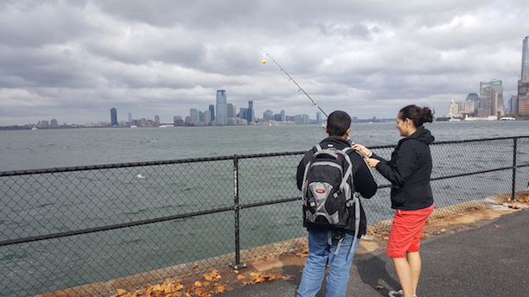
125 students 10th – 12th graders, 3 adults – 4 classes
Latitude N 40.690810- Longitude W -74.021404
Location: Soisson’s Landing , NE Governor’s Island – Upper NY Bay
Area: Pier along waterfront of the island, grassy parking lot
Surrounding Land Use: 100% urban, residential
Sampling Site: Pier, shoreline is Rocky, RipRap, Banks Altered, Concrete Bulkhead
Water Area: Bottom rocky, muddy, sandy
Plants in area: 40% algae/seaweed
Water depth: surface samples
Times: Data collected throughout the day
Water: Choppy, green

ITEM | Time | Reading 1 | Reading 2 | Comments
Physical
Air Temperature | 11:25 am  12:06 pm  12:21 pm  1:04 pm  1:17 pm  1:30 pm | 17°C  20°C  20°C  20°C  18°C  20°C | Wind Speed: | 10.7 mph  8.5 mph  12.3 mph  15.4 mph  9.4 mph  8.5 mph
Cloud Cover | 11:25 am  12:06 pm  12:21 pm  1:04 pm  1:17 pm  1:30 pm | Overcast  Overcast  Overcast  Overcast  Mostly Cloudy  Mostly Cloudy
Weather today | Rain in early AM
Weather recently | Some rain over past 3 days
Water depth | 5 meters deep
Water Temperature | Mid Day | 23 °C  20  23  20 |  | Average 21.5
Turbidity – turbidity tube | MidDay | 95 cm  43cm  34cm |  | Average 57.3 cm
Chemical
DO  (tablets) | MidDay | 4 mg/L | 21.5 °C | 42% saturation
pH – Lamotte wide range pH kit | MidDay | 7.5  8.0  8.0  7.5  7.8  8  6  7.2  6.4 |  | Average 7.2
Salinity  (Hydrometer) | MidDay | 23 ppt  22  22  25  22  26  24  22 |  | Average 23.5 ppt
Nitrates – test stripes | MidDay | 0.5  0.5  1.0  0.0 |  | Average 0.5 mg/L
Tides | NR
Currents | 11:20 am 12:07 pm  12:27 pm  1:03 pm | 22.5 cm/s  1 cm/s  30.48 cm/s  17.72 cm/s | Flood  Flood  Flood  Flood
Fishing – poles used each class | Baby clams as bait | No catch
Commercial Traffic | Staten Island Ferry | Every 2 hours | Battery to St. George SI | Orange
 | Liberty Island Tours | Periodic | Battery & Island | White
 | Barges | Loaded with goods
 | Fishing Boats
Recreational traffic | Steady Traffic from recreational vessels, fishing boats and sailboats – moving both N & S
Observations | Observations: Rip rap lining the shore, abutting a stone wall that runs into the water. Seaweed on some of the rocks, but not covering too much. A cormorant was present, but otherwise there was not too much visible sea life.

