Day in the Life of the Hudson River 10/12/17 Data
Freshwater Feed to the Hudson River
Hoosick River, Hoosick Falls NY
Deb Mabey, Hoosick Falls High School AP SUNY ESF Env. Science 5 students
Doug Reed, Hudson Basin River Watch
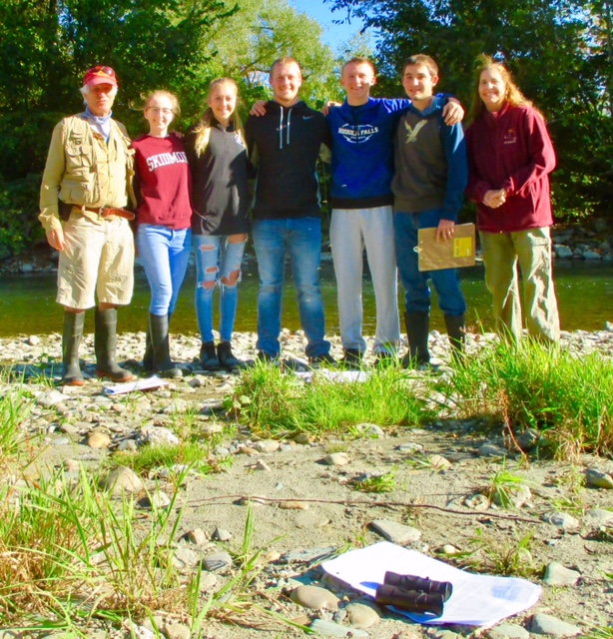
Location: Hoosick River, Hoosick Falls, Rensselaer County, NY
Area: River
Surrounding Land Use: Farms on the right side of the river, road on the left side of the river.
Water level: Low
Air Temperature |  | 50°F  10°C
Weather | Sunny | No cloud cover | Last Day of Rain yesterday
Water Temperature |  | 61°F  16°C
Dissolved Oxygen |  | 7 mg/L
pH |  | 7
Flow Rate | 5 ft. per second flow rate | 152 cm/sec
Fish | 4 | Minnow
macroinvertebrates | 2  1  42  2  40  1  1 | Crayfish  Helgramite  Mayflies  Water Pennies  Aquatic worms  Caddisfly  Stonefly

