Snapshot Day 10/12/17 Data
Mohawk River Valley
OTSQUAGO CREEK SITE RIVER MILE
Middleburgh, NY
Lance Elliott, Fort Plain High School &
12 students from the 10-12th grade Environmental Study Team
John McKeeby, Schoharie River Center (3 adults total)
42º55’48.46” N and -74º37’21.54”W
300 ft. elevation
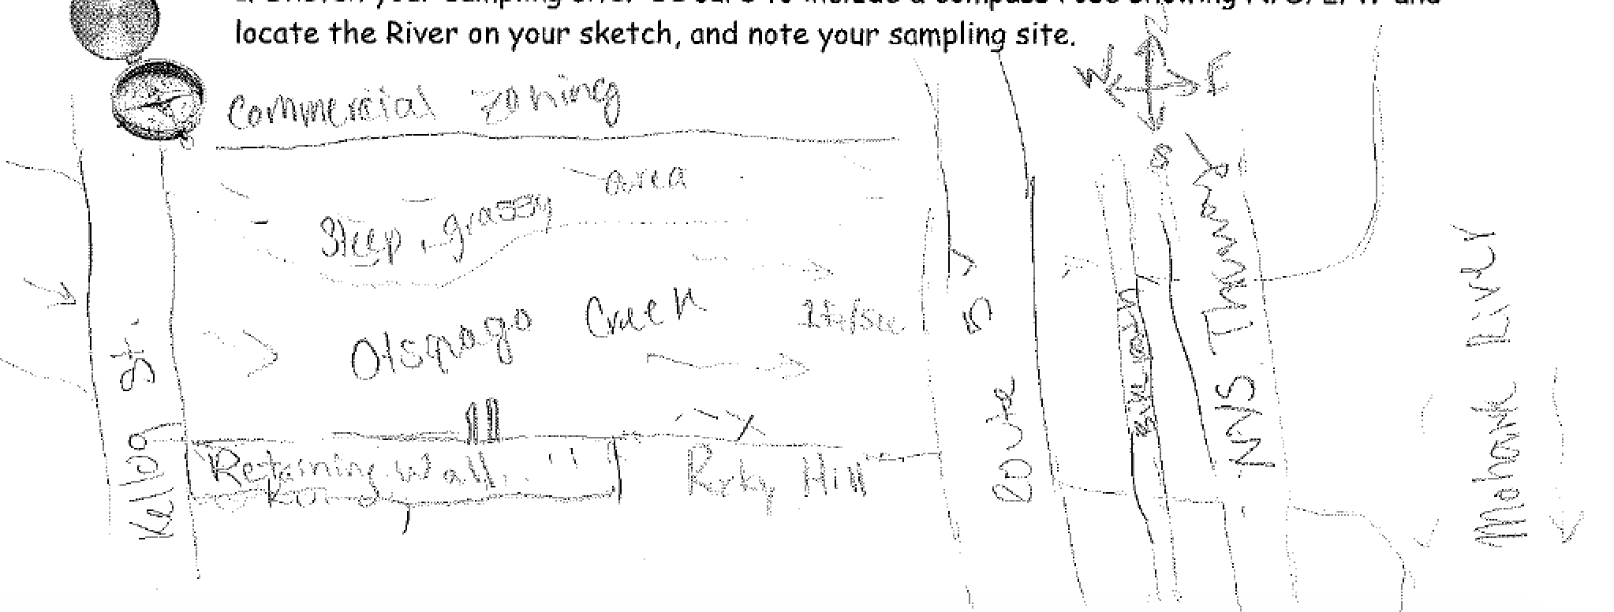
Location: On the OtsquagoCreek, Fort Plain, NY
Surrounding Land Use: Forested and grassy,15% urban/residential, 15% forested, 50% Industrial/Commercial, 35% Roadways
Shoreline: 100% Rocky, banks altered, covered with vegetation, riprap and 2 pipes entering upstream
Note: Area seems to be a dumping ground for dead vegetation, some garbage
River Bottom: Rocky
Water Depth: 4 inches
Water Conditions: Calm
Plants in water: mainly algae, 1% loofstrife around the stream area

ITEM | Time | Reading 1 | Reading 2 | Comments
Physical
Air Temperature | 3:35 PM | 17.3ºC | 63.1ºF
Wind Speed | 3:35 PM | 7 mph | SE
Weather today | 3:40 PM clear <25% cloud cover  Rain 0.03 in/last 24 hrs.
Weather recently | Rain yesterday; Temp dropped
Water Temperature | 3:34 PM | 17ºC | 62.6 ºF | In 4 inches of water
Turbidity - Absorbometric meter | 4:27 PM | 1 FAU (Formazin Attenuation Unit) = 1 NTU | Very clear
Chemical
DO – drop count | Time | Temp | ppm DO | % saturation
 | 3:45 PM | 17ºC | 9.4 ppm | 95%
pH – meter | 3:30 PM | 8.9
Alkalinity – LaMotte Code 3467 | 4:00 PM | 80 mg/L
Nitrates | 4:13 PM | 0.6 mg/L
Phosphates | 4:23 PM | 0.12 mg/L
Salinity – Quantabs LR tabs | 1.4 quantab units | 0.005 naCl | 32 ppm Cl- | 58 ppm TS
Current | Cm/sec | Area
 | 30.5 cm/sec | average
macroinvertebrate | Number | Name | Length of longest
 | 8  11  19  28  1  2  1 | Flathead mayfly  Brushleg mayflay  Fingernet caddisfly  Common net spiner  Aquatic snail  Common Stonefly  Cranefly
Macroinvert | DIV 7 | TOTAL 70
Other Observations | chipmonk | Turkey vulture | pidgeon

