Snapshot Day 10/12/17 Data
(Saltfront ~ RM 65)
RM -2 , Valentino Pier
Barbara Taragan, Elissa Eisenberg, Taraneh, Josh, Cora, Nineka
2 SCA – Joanna and Chelsea Robinson (seining photo!)
Robert Pincus, Climatologist
Barent Roth, Parsons/New School professor and students Taina Guarda and Shreen Bhansali to trawl plastics in the water
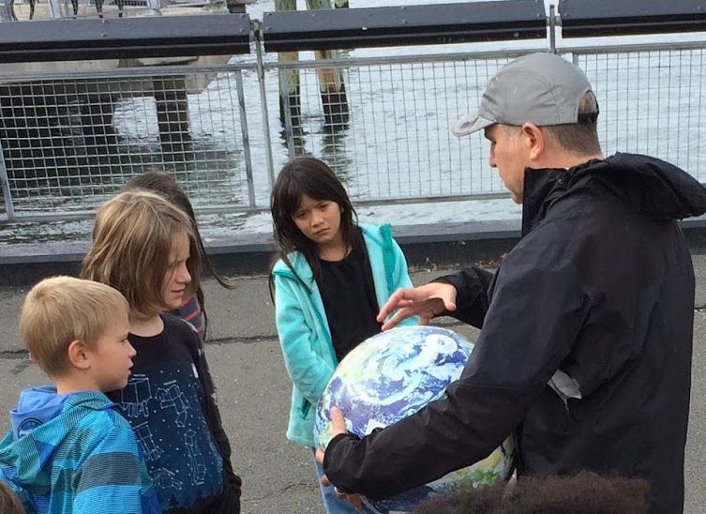
The Brooklyn New School PS 146 - 4th graders – 100 students, Adults 15
GPS Latitude N : 40°40’42. 10” - W-74°01’06.07
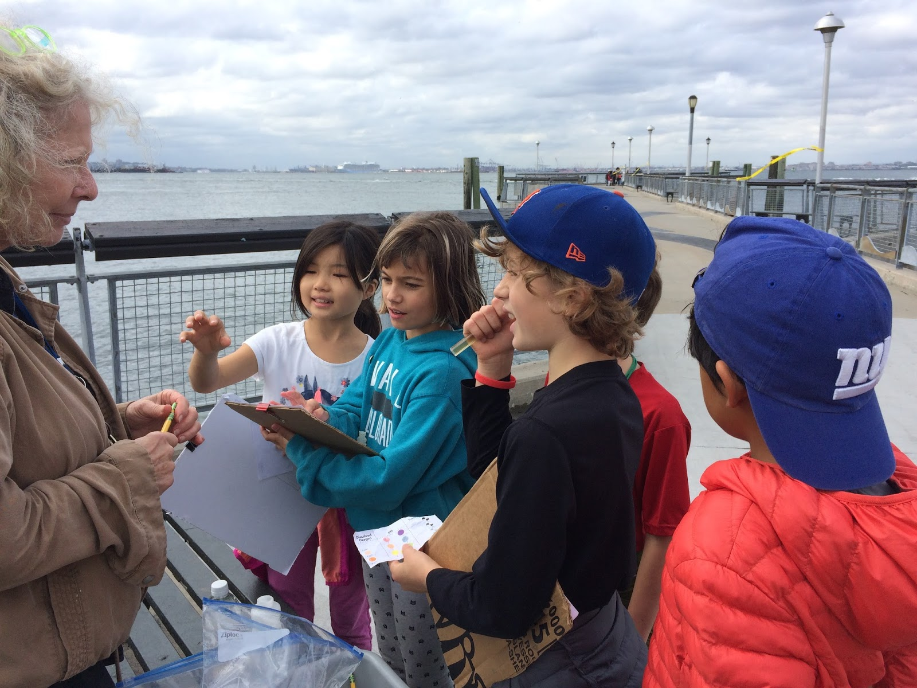 | 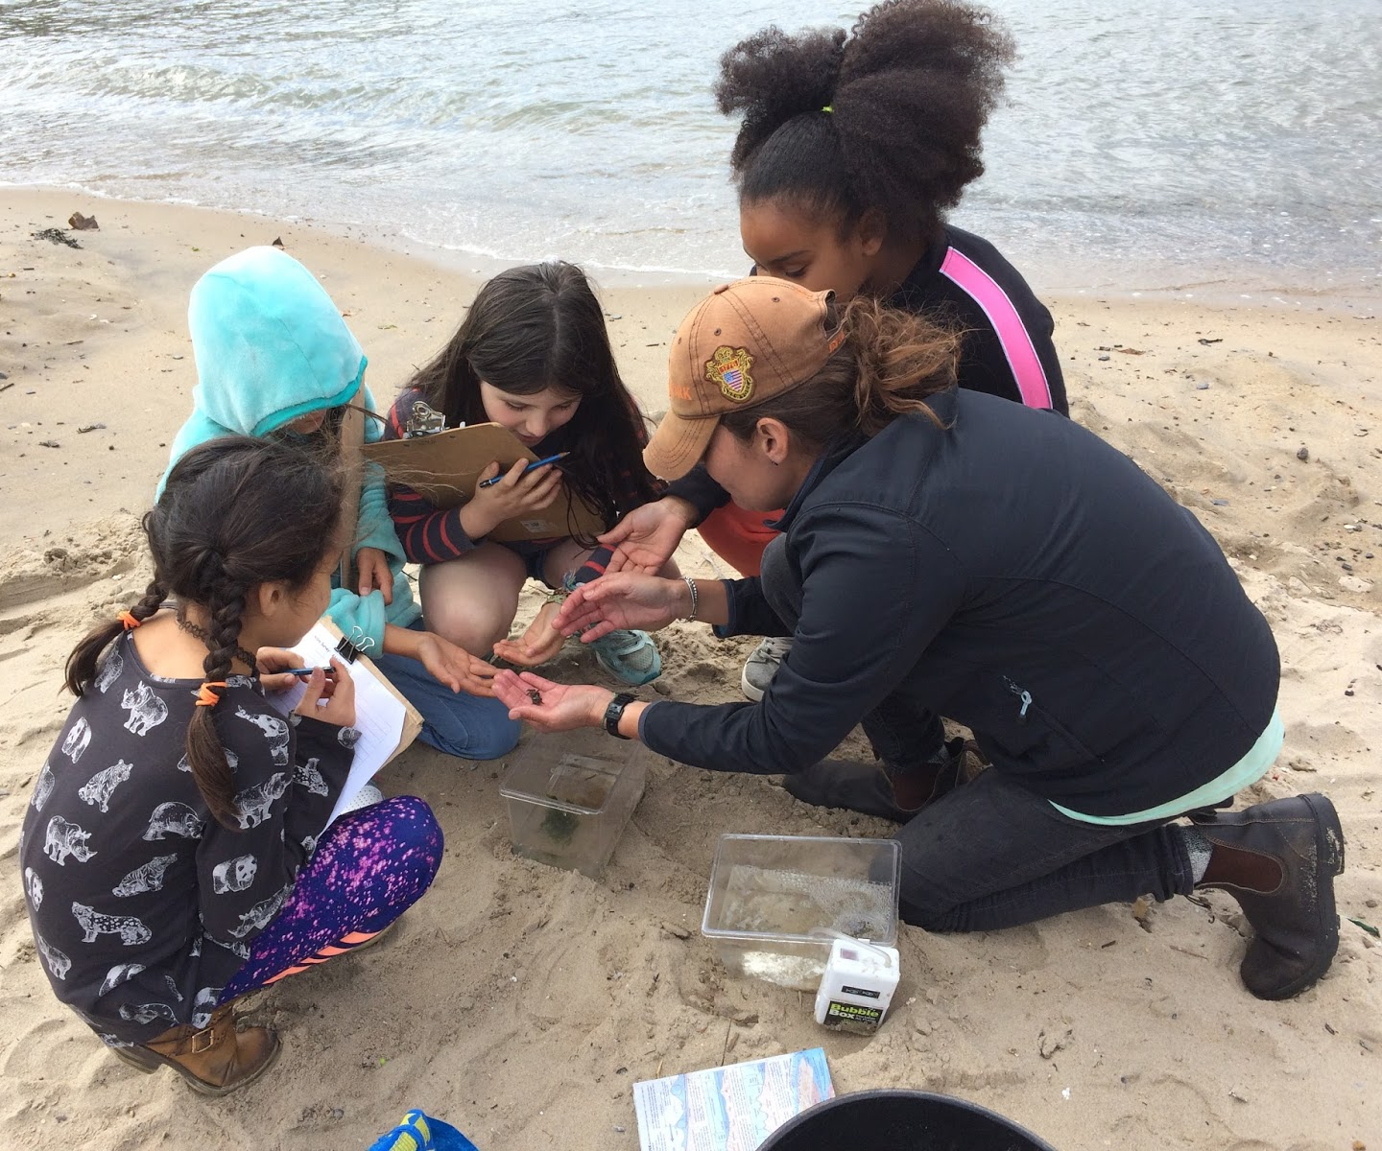 | 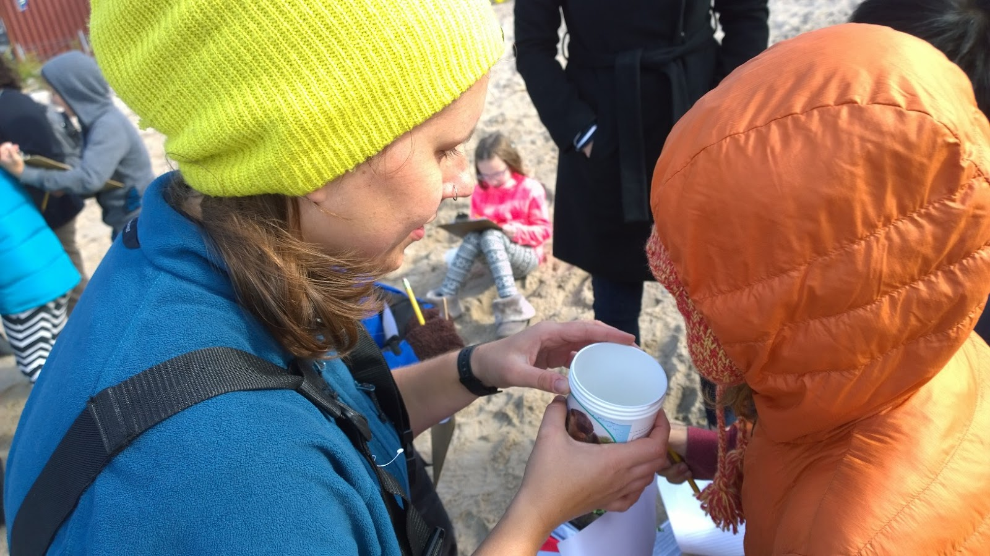

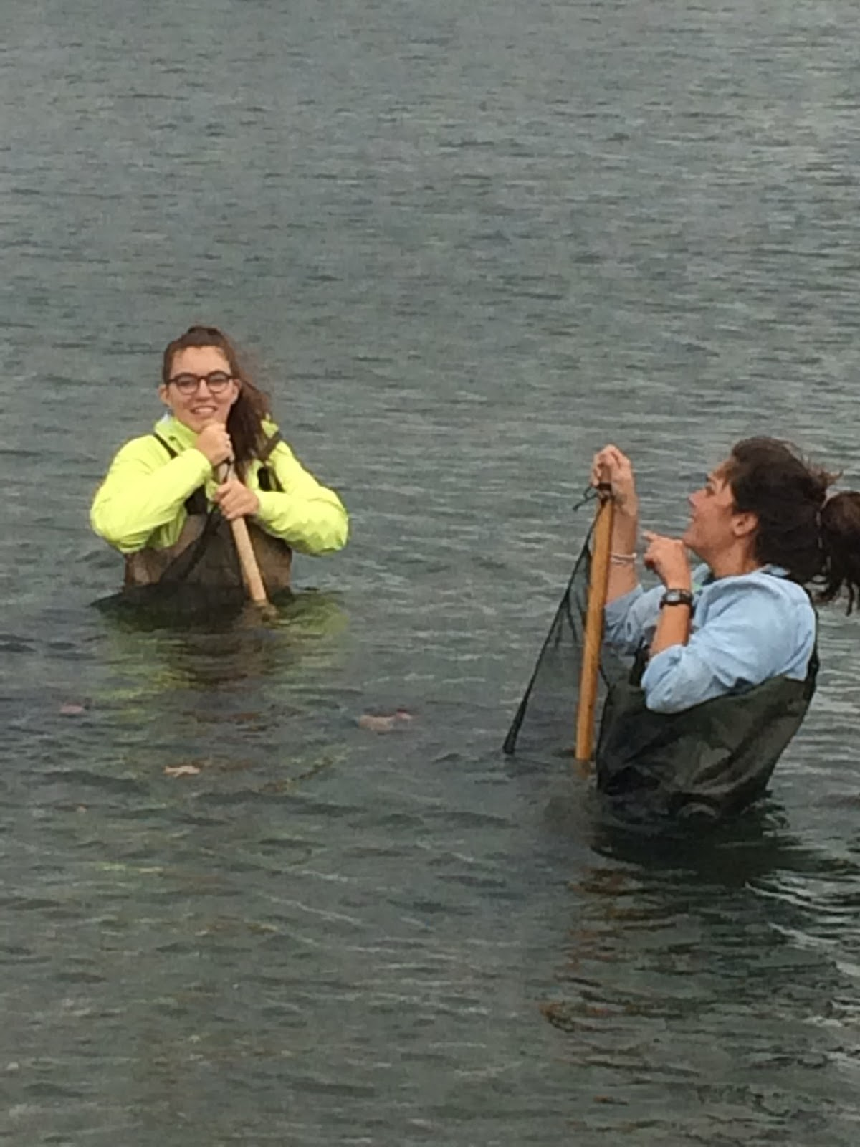
Location: Valentino Pier, Redhook, Brooklyn, NY
Area: A large pile of rocks with a small rocky “beach”; area with large pier;
Surrounding Land Use: Beach – 5%; Urban/residential 10%; Industrial/Commercial 75%; 10% other- surrounding area landscaped with sea grasses. It is used as a dog walk although signs prohibit that use. Fishing was happening at end of the pier.
Sampling Site: beach
Shoreline: Pier, riprap
River Bottom : sandy and rocky near the little beach area
Water Surface : Choppy

ITEM | Time | Reading 1 | Reading 2 |  | Comments
Physical
Air Temperature | NR | °C
Wind Speed | NR | Beaufort
Cloud Cover | Overcast
Weather today | Some precip in the AM
Weather recently | Warm and some rain last 2 days but dry before that
Water Temperature | 12:00 PM | 20°C |  | °C
Water | choppy
Turbidity – short sight tube | 9:00 – 1:00 PM | 30 JTU
Chemical
DO  Lamotte DO tablet | 9;00 AM  12:00 PM | 19°C  20°C |  | 8 ppm  4 ppm | 90%  33%
pH –indicator solution with LaMott testabs | 12:00 PM | 7  6.5  7 |  |  | Average 6.8
Salinity – hydrometer | 9:00 -1:00 PM | 25 ppt  25 ppt  25 ppt |  |  | Average 25 ppt
Fish Catch  14 ft..seine net, mesh size ¼ inch | Number Caught | Species |  | Length of largest | Catch Totals
3-4 seines  fish - # of silversides not recorded – used a figure based on prior catches for a full day at this site | 20 | Atlantic Silversides |  |  | Diversity 1  Total Catch 20
Macroinvert. | NR
Tides | NR
Currents | 12:00 PM | North
Shipping
Other Items
Other activities | Students were joined by several scientists for the day. One who studied the ocean gyres and their role in moving plastics throughout the ocean. Eleven of the Twelve student trawls brought up plastics. See attached newsletter for more details. One who is a climatologist and reviewed the common language that scientists use in communicating.

