Day in the Life of the Hudson River 10/12/17 Data
(Salt front ~RM 83)
RIVER MILE -4
Bush Terminal Park, Brooklyn
Katie McCarthy with Blyss Buitrago, Sunset Park High School, 100 students 11th grade, 5 adults
40.652 lat, -74.0189 lon
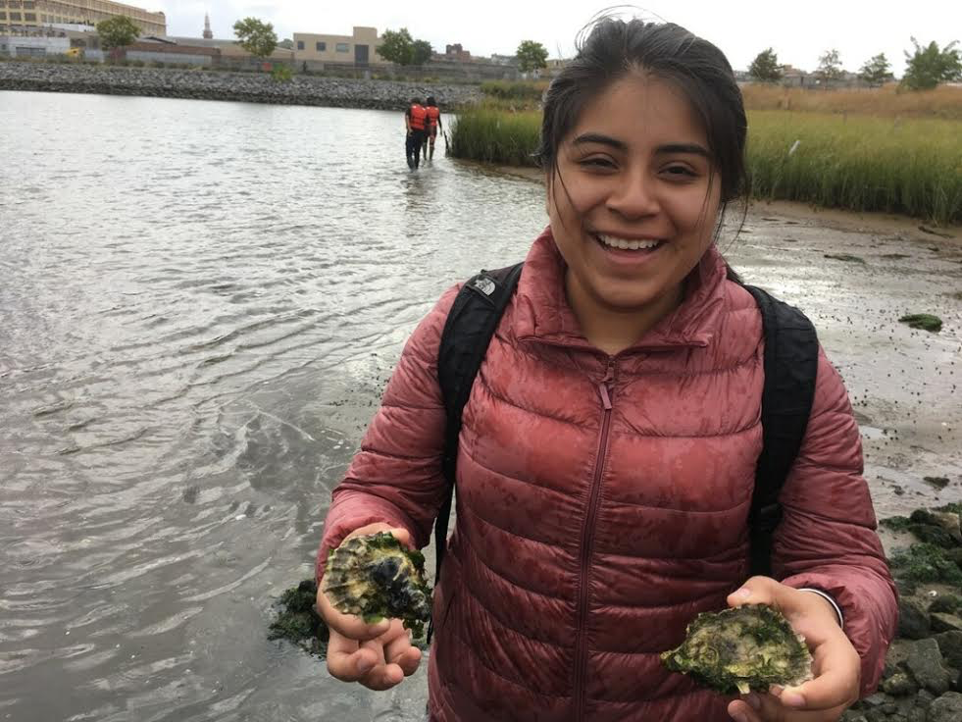 | 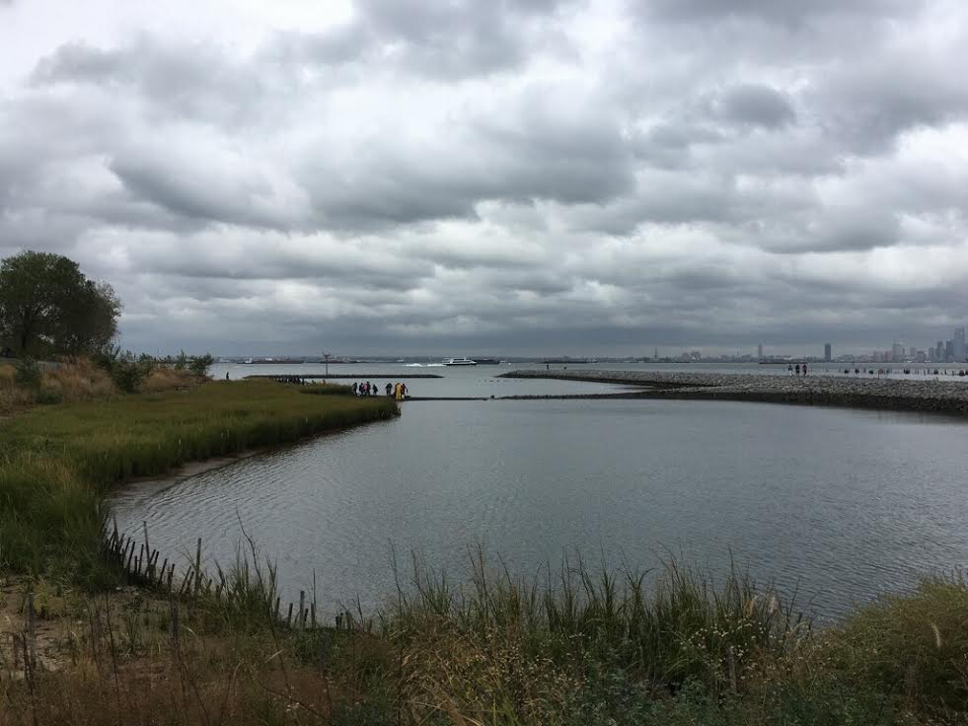 | 

Surrounding area: dirt/sand, garbage. Collected 27lbs of trash, mostly plastic
Water: Notes: AM: light green, no oil sheen, no garbage. PM Dark blue, no oil, little garbage

ITEM | Time | Readings
Physical
Air Temperature | 9:00-11:00  1:00-3:00 | 60ºF  64 |  | 15.6ºC  17.8
Wind Speed | 9:00-11:00  1:00-3:00 | 25-31mph  19-24mph |  | SW  SE | Beaufort Force 1
Weather past 3 days | Rained for past three days
Cloud Cover | Cloudy in the morning, partly cloudy in the afternoon
Water Temp | 10:26  1:23  2:18  1:51 | 61ºF  61  60  64 |  | 17ºC  18  20  18
Turbidity –  Long Sight Tube | 10:11  1:23  1:50  2:18 | 94cm  120  125  122
Chemical | Time | ppm |  | Temp | % Sat
DO | 10:40  1:36  1:42  1:46 | 5  6  6  8 |  | 18ºC  18  20  20 | 52.8  63  66  88
pH | 1:29  1:47 | 7.5  7.5 |  | 7.0 | 7.0
Salinity | 9:00-11:00 | 34ppt  34ppt  26ppt
Nitrates | 9:30  10:25  1:25 | 5ppm  5ppm  0-5ppm |  | 5ppm
Ammonia | 9:30  1:27 | 4ppm  .5ppm
Tides - H2O depth | Time | Tide |  | Height cm
 | 9:46  10:20  1:00-3:00 | Low tide  Medium high  Medium high |  | 46  47  46
Sediment Core | Smell | Color |  | Quality | Notes
Core 1 | Earthy | Brown |  | Grainy | Worms present
Core 2 | Briny | Light brown/sandy |  | Clumpy/muddy
Boat Traffic | Fisherman
Observations:  Nets are on the ground  High tides  Windy  Rocks are almost squares or triangles  The waves go in different directions  I saw fish |  |  | Wonderings:  Why do they look like this
Notes: Coliform Bacteria: The gel in the tube turned orange, that means that fecal coliform bacteria are not present in this area of the Hudson River. Their presence in the water serves as a reliable indication of fecal contamination. These recordings were taken on the trip, and the results read 24 hours later, 10/13 at 10:15AM. There is no fecal contamination at this time.

