Day in the Life of the Hudson River 10/12/17 Data
(Saltfront ~ RM 65)
RIVER MILE -5
Bayridge American Veterans’ Memorial Pier
40. 6397°N, W-74 .0387°W
Alicia Smith & International School of Brooklyn
27 Fifth graders, 4 adults
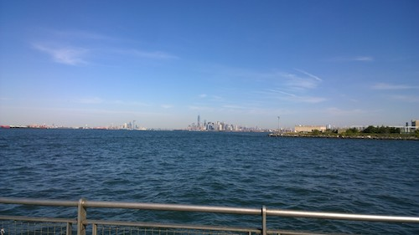
View from the pier. Owl Sewage treatment plant visible in the foreground.

Location: Pier American Veterans’ Memorial Pier, by highway, Park, 2 water treatment plants
Area: Pier – bulkhead – mainly concrete & wood. Two parks – Owl’s head and Shore Road Park. Water treatment plant <0.5 miles to the NE, ferry dock present, highway present, park nearby
Surrounding Land Use: 85% urban/residential, 5% Industrial Commercial, 5% park, 5% highway
Sampling Site: Saltwater bay, cannot see the bottom. Recreational pier with bulkhead– rocks near the edge, banks altered /riprap, all hard edged, steep wall dividing water from land, pipe entering water from treatment plant
Shoreline: Rocky at shoreline
Depth: ~ 9-10 ft.
Plants in area: No plants in water but 25 % of rocks on shoreline are covered,
Bottom: could not see to tell

Note: One person caught a 24 inch shark but released it back into the water (Ex[ect dogfish)
ITEM | Time |  | Readings
Physical
Air Temperature | 11:26 AM  11:43 AM  12:10 PM |  | 18°C  18 °C  18.5
Wind Speed | 11:43 AM |  | Beaufort 3 | 10 kts | SW
Cloud Cover | 11:43 AM |  | Mostly cloudy | 51-75%
Weather today | No rain during this session |  |  | Water surface | Choppy due to wind
Weather recently | Unusually warm temperatures, rained steadily on Mon & Wed night before sampling day
Water Temperatures & averages | 11:29 AM  11:59 AM  12:18 PM | 21°C  21°C  21°C
Turbidity | 11:25AM  11:45 AM  12:01 PM  12:21 PM | 100 cm  87 cm  100 cm  94 cm |  |  | Avg. 95.25 cm
Chemical | Time | ppm |  | Temp | % Sat
DO  Drop count kit | 11:40 AM | 6.8 |  | 21°C | 75%
pH  color match kit | 3:40 PM | 7
Salinity -hydrometer | 11:29 AM | 29.5 ppt
Nitrates | 3:40 P M | <5 ppm
Fish Catch | Time | Species |  | # caught | Size
*Tides - water depth | Time | *Distance to water |  | *Rate of change | *Flood or Ebb
Measuring down from pier using a secchi disk | 11:40 AM  11:57 AM  12:15 PM | 200 cm  250 cm -fall  150 cm - rise |  | N/A  -50 cm  +100 cm
Currents  Time | Cm/30 sec | Cm/sec |  | Kts | Ebb/Flood N/S
11:26 AM | 919.5 | 30.65 |  | 0.596 kts | flood
11:45 AM | 944.8 | 31.5 |  | 0.613 kts | flood
12:00 PM | 685.8 | 22.86 |  | 0.445 kts | flood
12:18 PM | 1005.8 | 33.5 |  | 0.652 | flood
Shipping Traffic- Commercial | 11:30 AM | Ferry |  | White | North & southbound
 | 11:40 AM | Ferry |  | White | North & southbound
 | 12:15 PM | Ferry |  | White | North & southbound

