Day in the Life of the Hudson River 10/12/17 Data
(Salt Front ~RM65)
RIVER MILE 0.5

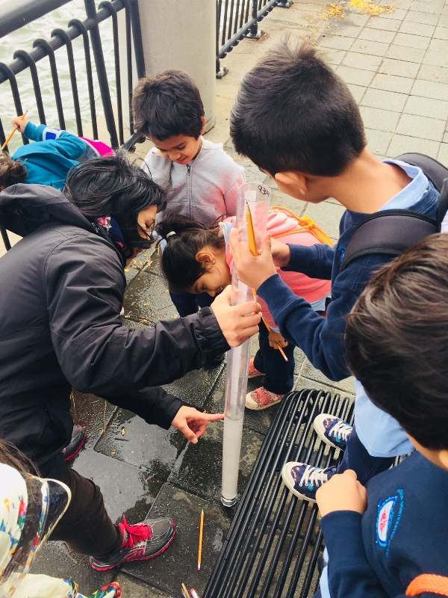

Morris Canal Basin, Jersey City, New Jersey
Grace Sanvictores, Hudson Montessori School 4th, 5th, 6th graders – 20 students, 4 adults

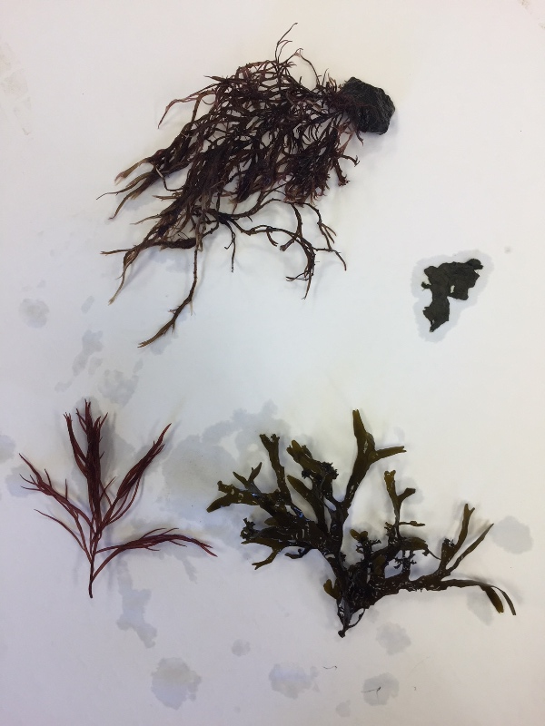
Location: Walking & Fishing Pier, Morris Canal Basin, Jersey City, New Jersey
Area: Waterfront pier along a developed area, walkway with railings
Surrounding Land Use: Urban Industrial 100%;
Sampling Site: Waterfront pier jutting out along the waterfront, surrounds a canal inlet
Plants in Area: Seaweed plants (see picture)

ITEM | Time |  | Reading 1 | Reading 2 | Comments
Physical
Air Temperature | AM |  | 15.5°C  60 °F
Wind Speed | 11:38 AM |  | Beaufort #4 | Anemometer 3.8 mps NE
Cloud Cover | NR
Weather today | Cool, a bit damp and windy
Weather recently | NR
Water Temperature | 11:38 AM | 21°C  70°F
Turbidity | 11:38 AM | 41 cm |  | average
pH indicator strips | 11:38 AM | 4
DO – O2 ProfitTest | 11:38 AM | 5 ppm
Salinity - hydrometer | 11:38 AM | 25 ppt
Fish Catch - seine | Species - | Number |  | Length of largest | Diversity & Totals
 | Unable to seine
Tides | 12 inches 9:30 AM
 | 48 inches Noon
Current | ebbing

