A Day in the Life of the Hudson River 10/12/17 Data
(Salt Front ~HR RM 65)
RIVER MILE East River 1.7
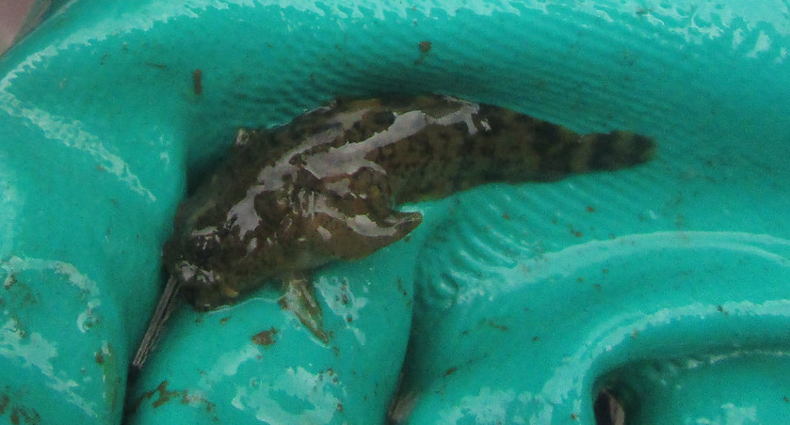
Grubby Sculpin (Myoxocephalus aenaeus)

Janet Villas, Brooklyn Friends School, 56 eight graders, and 6 adults
Isa Del Bello and staff from the Brooklyn Bridge Conservancy
Latitude 40.704546 – Longitude 73.988771
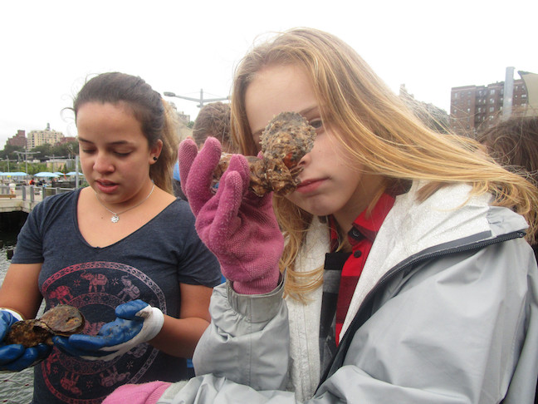 | 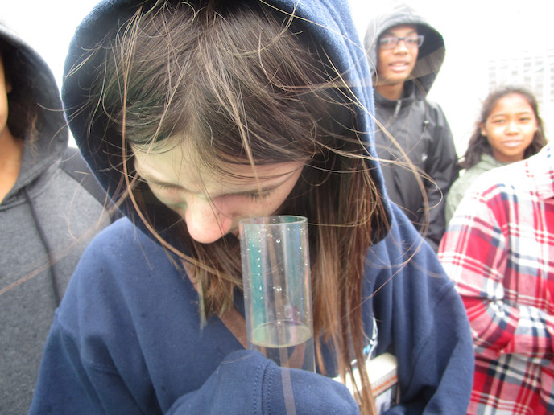 | 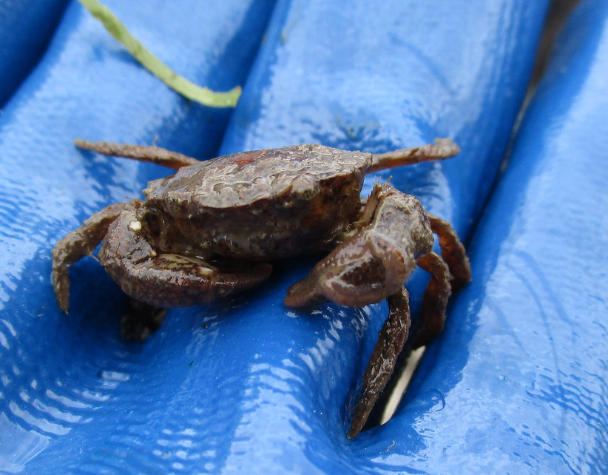
Location: East River, south of the Manhattan Bridge @ the new Brooklyn Bridge Park, Dumbo Section
Area: 100% Urban residential, Park
Surrounding Land Use: beach, pier, grassy, 90% Industrial/Commercial and 10% beach
Sampling Site: Sandy beach and riprap, rocky, bulkhead
Plants in area: no plants noted in water – maybe 10% had some type of marine plant
Water depth: 30 ft.
River Bottom: Sandy (a diver was present)
ITEM | TIME | 10/16/14 Data | TIME | 10/20/14 Data
Physical
Air Temperature | 9:58 AM | 16 °C | 55°F
Wind Speed | Beaufort 2 | Light Breeze | 0.5-1 wave height in ft. | South
Cloud Cover | Mostly Cloudy 51-75%
Weather today | A little precipitation
Weather last 3 days | Warm for October, some rain Monday
Water Surface | Calm
Water Temp. | 9:59 AM | 20 °C | 68°F
Turbidity – secchi long sight tube | 9:10 AM | >120 cm  >120 cm
Chemical
DO - | 10:06 AM | 13.7 ppm | 20°C | Very high DO – 130% saturated
pH - meter | AM | 6.92  6.93
Salinity – vernier meter | 10:01 AM | 21.67 ppt  21.67
Nitrates | 10:04 AM | 1.0 ppm
Fish | Grubby Sculpin  (Myoxocephalus aenaeus) | 1 | New Species for DITL | DIV 1  TOTAL 1
macroinvertebrates | Sea squirts  mud crabs (sm)  Ribbed mussels  Barnacles  Squid (tiny) | Many  1 |  | DIV 5
Tides | 10:00 AM | Changing tide
Currents | NR
Boats | Large Ships  Greenpeace Arctic Star  Staten Island Ferry
\

