A Day in the Life of the Hudson River 10/12/17 Data
(Salt Front ~HR RM 65)
RIVER MILE East River 2.3– Cut out at Pier 5, Brooklyn Bridge Park
Christina Tobitsch, Brooklyn Bridge Park Conservancy &
Kathleen Nolan & Noemi Rivera St. Frances Afterschool Program - 15 - 6th graders
& 4 adults
40°41’41.5” N – -74°.00’0.17” W
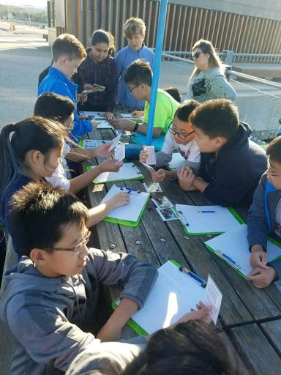

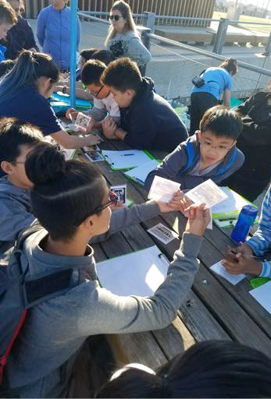

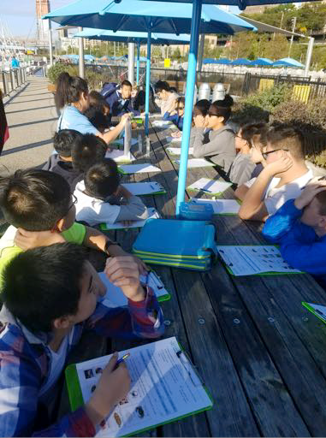

Location: Pier 5 of Brooklyn Bridge Park, south of the Manhattan Bridge and south of the boat marina and in front o the soccer field.
Area: Developed set of piers
Surrounding Land Use: Urban residential and park land
Sampling Site: Rocky shoreline, rip rap Plants in area: no plants noted in water Water depth:
River Bottom –unknown
Plants in area – Some algae collected in plankton tows and fish traps

ITEM | Time |  | Reading 1 | Reading 2 | Comments
Physical
Air Temperature | NR |  | °C  °F
Wind Speed | NR
Cloud Cover
Weather today | Wet earlier but clear now
Weather last 3 days | Warm and bit wet
Water Surface | NR
Water Temp. | NR | °C
Turbidity – site | NR
tube
Chemical
DO – | 5:38PM | 4.0 mg/L  5.0 mg/L | LaMotte* CHEMets | *2 others were zero but kit old
pH – LaMotte | 5:54 PM | 7  7  7 | pH Pen | 8.1
Salinity –  hydrometer | 5:00 PM | 25 ppt
MacroCatch –  oyster cages | Sand worms  Shore shrimp  Mud crab Slipper snail Sea squirts | 3  6  1  1  TMTC |  | DIV – 5  TOTALS – 11  plus sea squirt
Other Items

