Day in the Life of the Hudson River 10/12/17 Data
(Saltfront ~RM 65)
RIVER MILE 100.5
South Cove at Falling Waters, Glasco, Ulster County
Brian Robinson, Saugerties High School, 18 AP Env. Sci. 11th grade students and 1 adults
N 42. 046752, W-73.939081
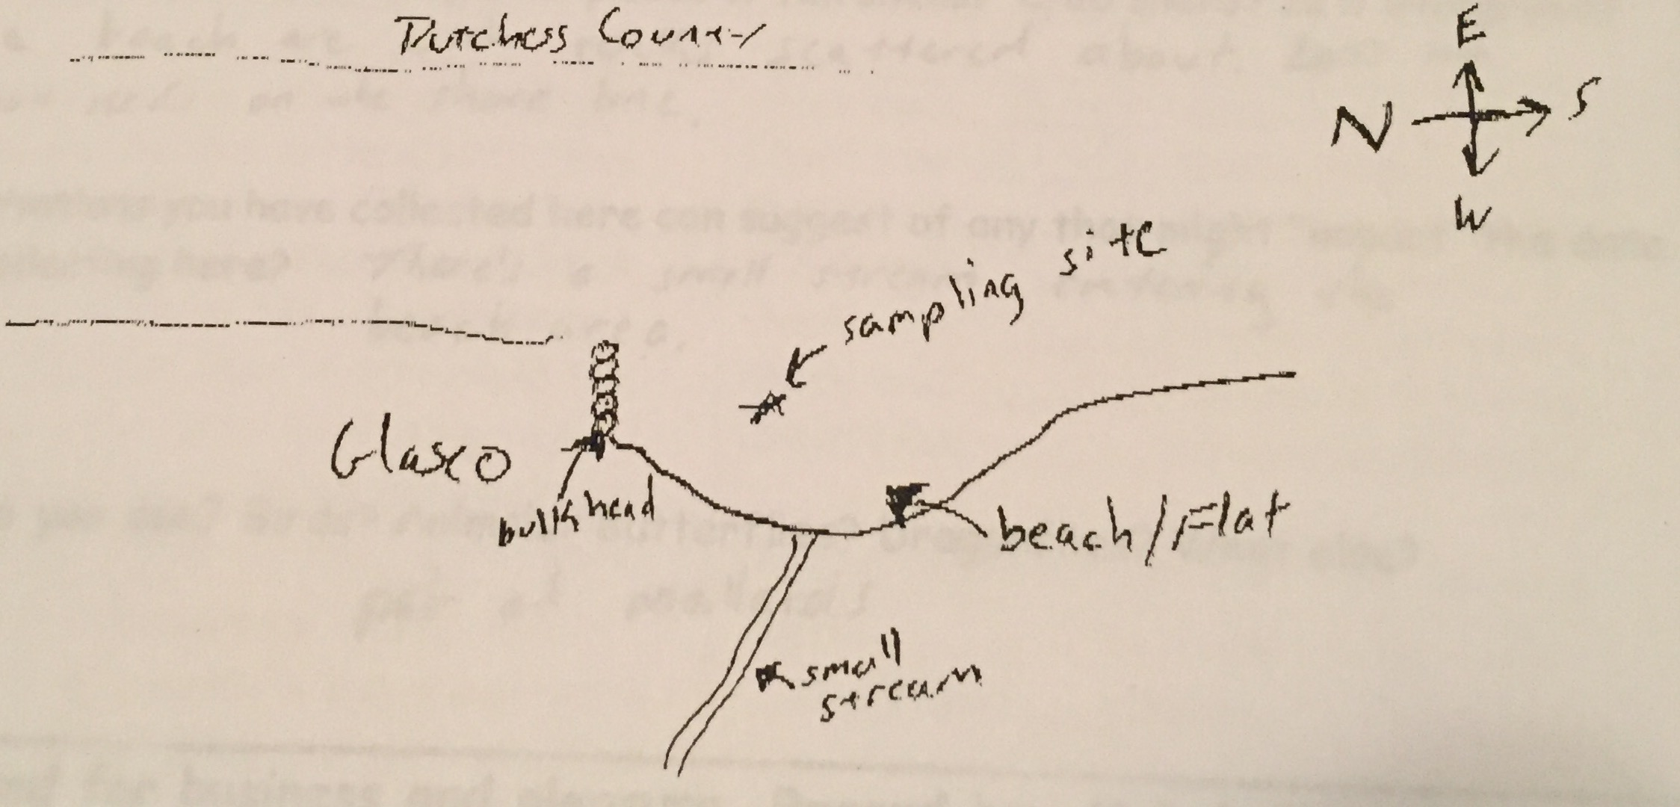

Location: Falling Waters protected area, South Cove, Glasco, Ulster County
Area: Forested, cove with a shallow beach
Surrounding Land Use: 50% forested, 50% beach – mostly forested with a viewing area overlooking the beach/cove area
Sampling Site: Parkland, beach covered in vegetation, concrete bulkhead
Shoreline: Sandy, muddy, rocky
Depth: could not see bottom
Plants in area: lots of water celery along the shoreline – 25% cover no other plants seen
Site Observations: Old brick pieces on the ground names on bricks are Wasburn, Lent, …Bury, lots of old washed up logs, water celery
Bottom: Sandy– 2 ft. deep H2O
Water: Choppy

ITEM | Time |  | Readings
Physical
Air Temperature | 8:25 AM |  | 11°C | °F
Wind Speed | 10:42 AM |  | Beaufort 3
Cloud Cover |  |  | Mostly
Weather today | No precipitation
Weather recently | Light rain last night
Water Temperature | 8:30 AM  8:40 AM | 19.9°C  19.3, 19.1 |  | °F | 19.2 average
Turbidity -secchi | 8:40 AM | 1 meter
Chemical | Time | ppm |  | Temp | % Sat
DO  Drop count kit | NR |  |  | °C
pH  color match test | 8:45 AM | 7.5
Salinity –titration strips | 8:30 AM |  |  | 38 ppm Chl | 68 ppm TS
Alkalinity | 8:30 AM | 40 ppm
Nitrates
Phosphates
Fish Catch – 30 ft. 8:30 AM | Species | # caught |  | Length of largest | TOTALS
11:00 AM – 4X30 ft. ½ mesh seine | Sunfish | 2 |  | 13 cm | DIV 4  TOTAL 20
6 seines – catch in seine # 3 | Herring | 15 |  | 6 cm
 | Golden shiner | 1 |  | 7 cm
 | Banded Killifish | 2 |  | 10 cm
Tides - water depth | Time | Distance to water |  | Rate of change | Flood or Ebb
 | 8:30 AM |  |  | 0.15 cm/min | Falling
Currents | Time | Cm/30 sec |  | Cm/sec | Knots &  Ebb/Flood
 | NR
Shipping | 9:06 AM | 2 mast sailboat |  |  | Northbound
 | 9:10 AM | Barge & Tug |  |  | Northbound

