Day in the Life of the Hudson River 10/12/17 Data
(Saltfront ~ RM 65)
RIVER MILE 117.5 (a)
Hudson River Waterfront Park, City of Hudson
Shelley Forester, Cary Institute of Ecosystem Studies
Sandra Fischer, Chatham High School, Catham, NY
60 students, Environmental Science, Ecology Club, 8 adults
Latitude – N 42°25’ Latitude – W -73°80’
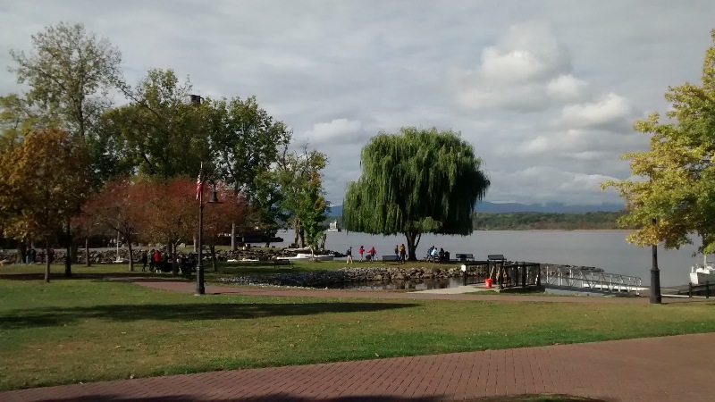 | 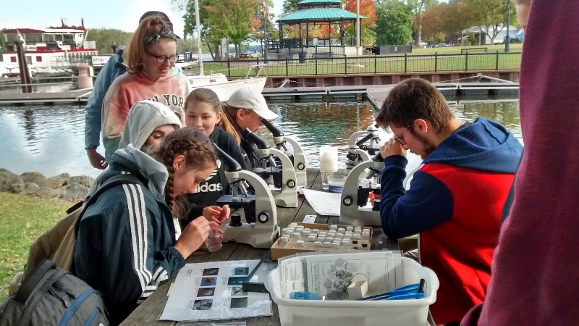

Location: Hudson River Waterfront Park, City of Hudson, Columbia County
Area: 1st dock in the waterfront property used for fishing, marina, picnics, large grassy area, just north of the old quarry site, has a parking lot –
Surrounding Land Use: 50% Industrial/Commercial, 50% Urban Industrial
Sampling Shoreline: waterfront with banks/shoreline is 70% is rocky and 30% muddy.
Sampling Site: 100% altered to include wooden & concrete bulkheads and large riprap on shoreline, pier, grassy, parking lot
Plants in area: 0.5% % water chestnut, 0.5% water celery, 1% milfoil
Water - Calm
River Bottom – bottom rocky, muddy

 | Time | Reading 1 | Reading 2 | Comments
Physical
Air Temperature | 9:10 AM  9:50 AM  12:00 PM | 12°C  13°C  15°C | °F
Cloud Cover | 8:51 AM | Mostly Cloudy 51-75%
Wind – | Time  AM | Beaufort  N/R | m/s - meter  1-4 | Direction  ENE
Weather today
Weather recently | Mild, no precipitation
Water | calm
Water Temperature – | 9:12 AM  12:07 PM  12:15 PM | Surface  Surface  2.9 meters depth | 19.8, 19.7°C  20.4, 20.4  21, 20.8 | 19.75 °C avg  20.4  21
Turbidity – 120 cm long site tube | 9:30 AM to 12:30 PM | 93 cm  97 cm  95 cm | < 10 NTU
We felt the water was not very turbid. You could see 1m down from the dock and kids were surprised by the results from the long tube.
Chemical | Time | Temp C | DO ppm | % sat.
DO - meter | 9:15 AM  10:20 AM  12:08 PM | 20  20  21 | 7.65  7.96  7.87 | 85%  89%  89%
pH – Aquacheck strips | 9:35 AM  10:16 AM  12:06 PM | 5, 5, 6  5, 6, 6  6, 5, 6 | averages | 5.3  5.6  5.6
Salinity Quantabs | Time  9:15 AM 10:19 AM  12:41 PM | Quantab #  1.4  1.4  1.4 | Chloride ppm  32 ppm  32 ppm  32 ppm | Total Salinity  58 ppm  58 ppm  58 ppm
Nitrates - Aquacheck strip | 9:48 AM | 2 ppm  2 ppm
Phosphates –
Fish Catch  Seine net 6 feet X 4 ft., 1.4 inch mesh | Time | Species | Total Catch for Day | Length
Fish |  | Banded Killifish | 38 | 7 cm
 |  | Bluegill Sunfish | 37 | 9 cm
 |  | White Perch | 2 | 4 cm
 |  | Bay Anchovy | 2 | 3 cm
 |  | Shiner | 2 | 7.5 cm
Fish Totals | DIV 5 | TOTAL | 81
Macros |  | Cladocera,  Waterfleas | 2
 |  | Volvox algae | 2
 |  | Ostracod - Crustacea | 1
 |  | Amphipod | 2
Macros Totals | DIV 4 | TOTALS | 7
Tides | 8:52 AM  9:23 AM  9:50 AM  11:55 AM  12:22 PM  12:37 PM | 185 cm  200 cm  180 cm  178 cm  160 cm  149 cm | Set point  Rising  Falling  Falling  Rising  Rising | On a dock measuring down to water
Currents | Time | Cm/30sec | Cm/sec | E/F/S
 | 8:55 AM. |  | 38.1 cm/sec | Ebb
 | 9:15 AM |  | 25.4 cm/sec | Flood
 | 9:26 AM |  | 224 cm/sec | Flood
 | 11:41 AM |  | 25 cm/sec | Ebb
Core Sample | Length/ | Rare | Common | Abundant
Collected in vegetated area | - 20.3 cm (8 inches)  - no smell | Leaves  Wood  Brick  Living Vegetation | Clay  Mud  Sand  Gravel  Pebbles
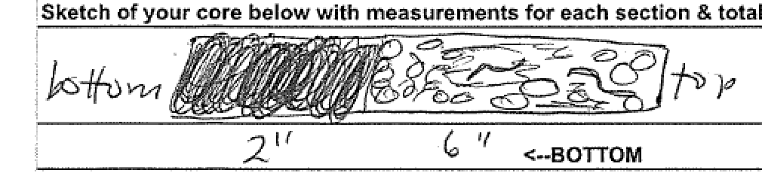
Traffic - commercial | Time | Name | Color | Direction/Loaded or Light
 | 10:45 AM | Coral Coast | Blue | Northbound, light
 | 10:59 AM | RTC107 | Black | Southbound, loaded
 | 11:04 AM | No Name | Black | Northbound, light
 | 11:45 AM | Coastguard | Orange | south
 | 12:15 PM | Doubleskin | Black/Yellow | Southbound, loaded
Recreational | 11:13 AM | Sailboat | Black | Northbound
 | 11:40 AM | Speed Boat | White | Southbound
 | 11:55 AM | Hudson Spirit | Red/White | Southbound, Loaded
Other Observations | Not overgrown, public park.  Grassy peninsula with rocky shore, 1 pear, boat launch  No bricks, coal, shells etc, manicured park  The area is inlets with docks so perhaps the water is not moving as freely which might affect sampling.  There is a creek from an industrial site flowing into the river  There is rock processing next door as well.  Lots of yellow jackets and a few seagulls in the area

