Day in the Life of the Hudson River 10/12/17
(Salt Front ~ RM 65)
RM 140 Papscanee Preserve
Staats Island Rd., Castleton-On-Hudson
Kate Perry, Parker School 2nd & 3rd and 6th & 7th, 36 students & 16 adults

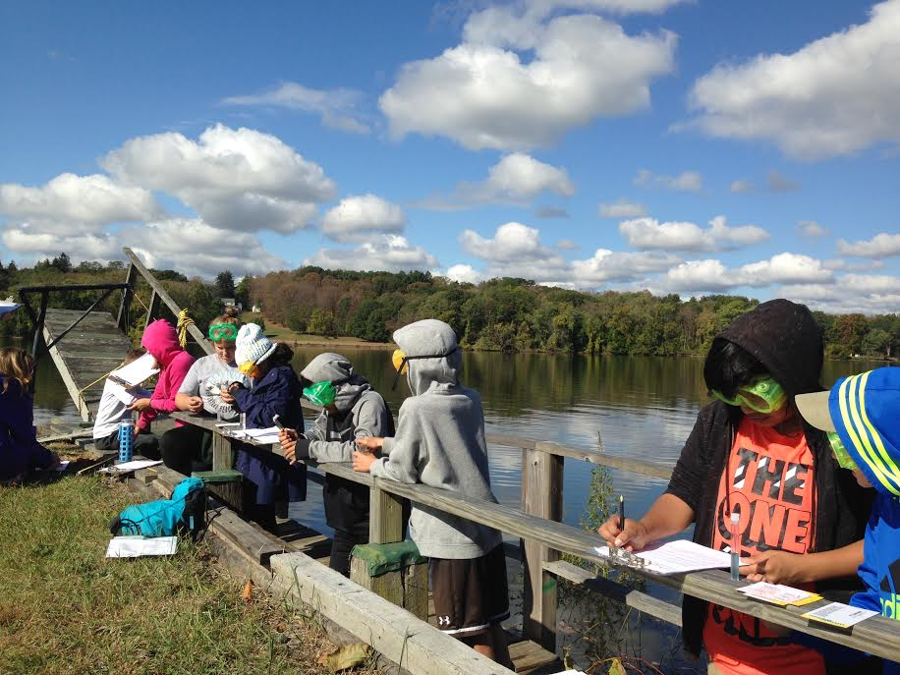 | 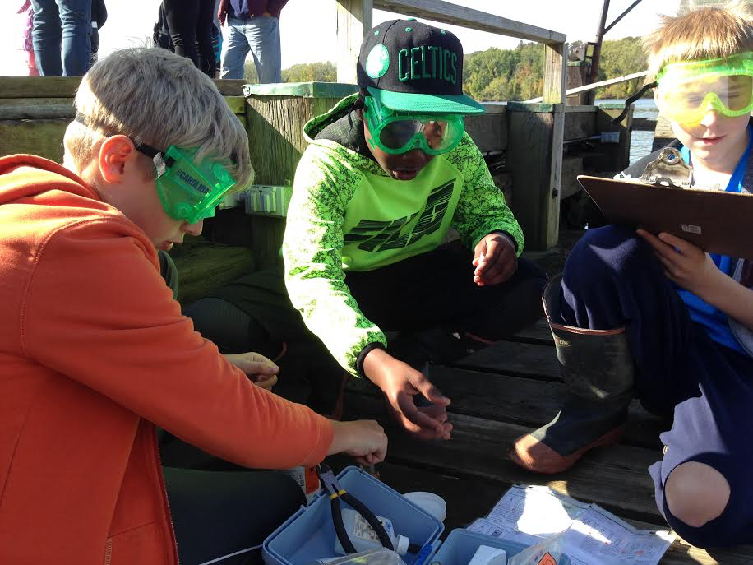 | 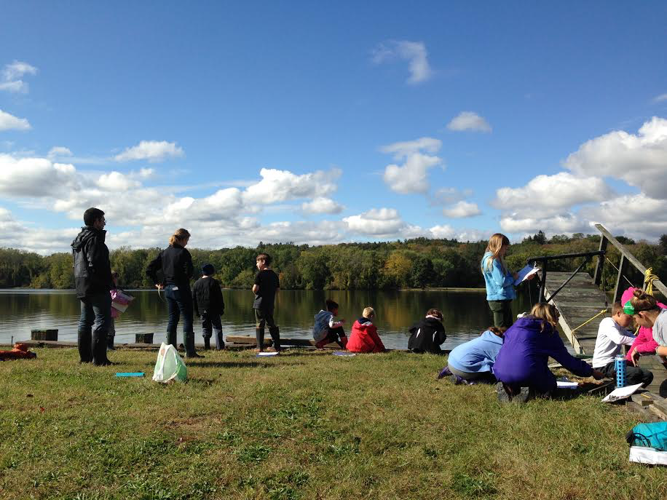

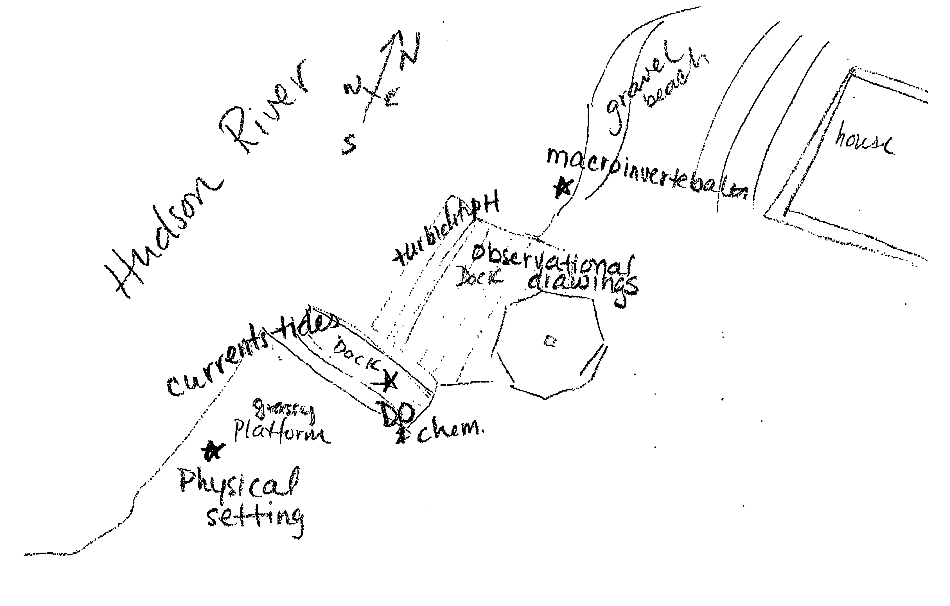
Sampling Site
Location: 150 Stats Island Rd, Staats Island Rd, Castleton-On-Hudson, Rensselaer County
Surrounding Land Use: 80% Urban/residential, 10% forested, 10% beach (gravel)
Sampling Site: Mostly vegetation covering larger rocks. One section of gravel beach.
Plants in area: plants covered by water at highest tide – otherwise along edge – 5%.
Water milfoil and water celery, and also found 3 devil head seed pods but no water chestnut plants seen. Grasses and reeds present.
Water depth: shore to 1.22m mostly
River Bottom: rocky, gravely with some mud
NOTE: Fish catch from students listed below. DEC also brought fish including:
1 Catfish (30.5 cm)
5 White Sucker (38 cm)
1 Freshwater Drumfish (45.7 cm)
1 Northern Hog Sucker (35.6 cm)

All sampling occurred between 9:30-11:00 & 11:30 and 1:00 PM
 | Time |  | Reading 1 | Reading 2 | Comments
Physical
Air Temperature | 10:50  11:33 |  | 19°C  20 | 66.2 °F  68
Wind Speed |  |  | Beaufort | S-SW
Cloud Cover | Partly cloudy, clearing as morning went on
Weather last 3 days | Unseasonably warm, rain evening of 10-11-17
Water Surface | Mostly calm
Water Temperature | 10:45  11:30  11:50 | 16°C  16  16 |  | 16ºC  16 | 16ºC  16  16
Turbidity  Long Sight Tube | 10:45 | 71.2 |  | 68 | 69
Chemical
DO - drop count | 10:50 AM | 5mg/l |  | 16°C | 50% saturation
pH (test strips) | 10:50 | 6, 6, 6 |  | Litmus paper | Average: 6
Salinity -  (Low-range Quantab) | 10:45 | 1.2 Quantab unit  (below detection)
Nitrates  (NO₃⁻) | 11:07 | 0ppm |  | 5ppm | Average: 2.5 ppm
Phosphate | 11:07 | 0.04ppm |  | 0.04ppm | Average: 0.04ppm
quantabs | 11:25 AM | 39 mg/l Cl- |  |  | 70 ppm
Tides | Time | Height |  | Rate | Rising/Falling
Measuring dock to water surface | 10:40  10:50  11:06  11:16  11:43  11:46 | 60cm  61  50  56  61  66 |  | 1.0cm/min  0.7  0.55  0.06  0.4  1.0 | Falling  Rising  Falling  Falling  falling
Currents | Cm/30 sec | Cm/sec |  | Knots | N/S – Ebb/Flood
10:40 | 353.9 | 11.8 |  |  | S/Ebb
11:00 | 178.3 | 5.9 |  |  | S/Ebb
11:30 | 240.4 | 8.01 |  |  | S/Ebb
Data was collected off of a dock with a platform alongside it. Boat traffic and student error may have created data discrepancy
Sediment Core  20 cm depth | Description | Rare |  | Common | Notes
 | Length of core: 90cm | Mud  Pebbles  Leaves  Shells Oysters  Freshwater Mussels  Zebra mussels  Macroinvertebrates  Brick  Coal  Slag |  | Sand  Gravel  Wood | Roots with diameter ranging from 2mm to 4mm
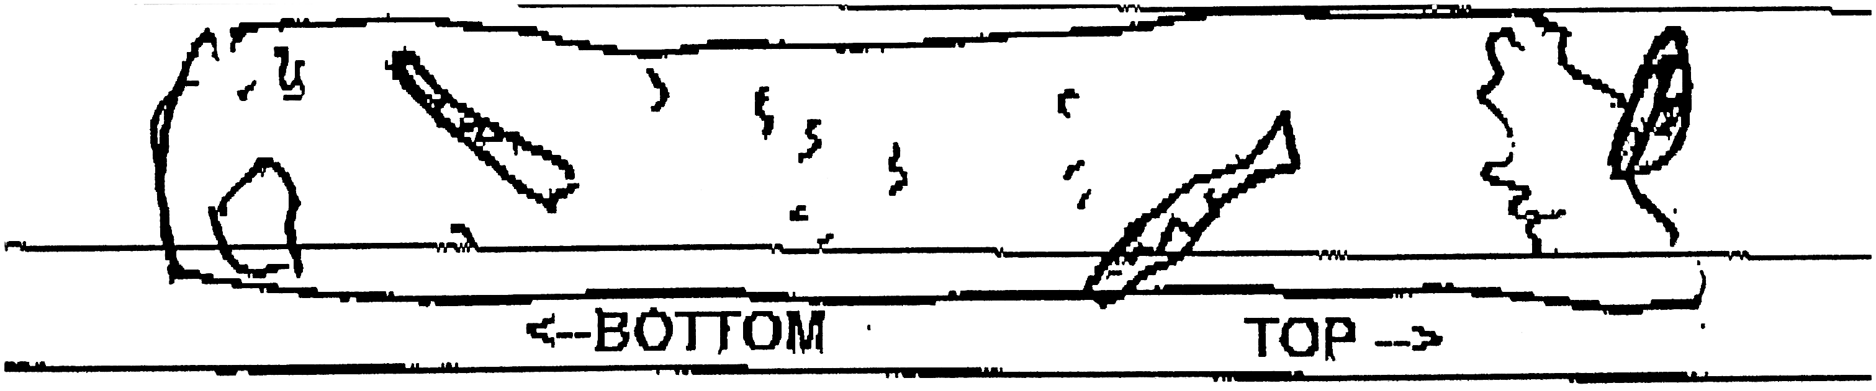
Fishing – seine 20 ft. net & a 40 ft. pull | Count | Species |  | Length largest | Seine #s
 | DIVERSITY 1 | CATCH 6
CPUE
Shipping | Time | Type (Recreational/ Commercial) |  | Type | Cargo
 | 9:50  10:30  10:55 | R  C  R |  | Yacht  Coastguard  Speedboat | People  People  People
Other items of interest | Historic Staat’s House, grasshopper missing a leg, baby mice in a nest along shore, gull
An amazing day at Stats Island. Three dozen young scientists marveled at the cool winds, gentle tides, blue sky and Hudson River fish. They mysterious devils pod chestnut seeds created rich inquiries. Avian life abounded in the nearby trees still holding fall leaves.

