Day in the Life of the Hudson River 10/12/17 Data
(Saltfront ~RM 65)
RIVER MILE 145.5
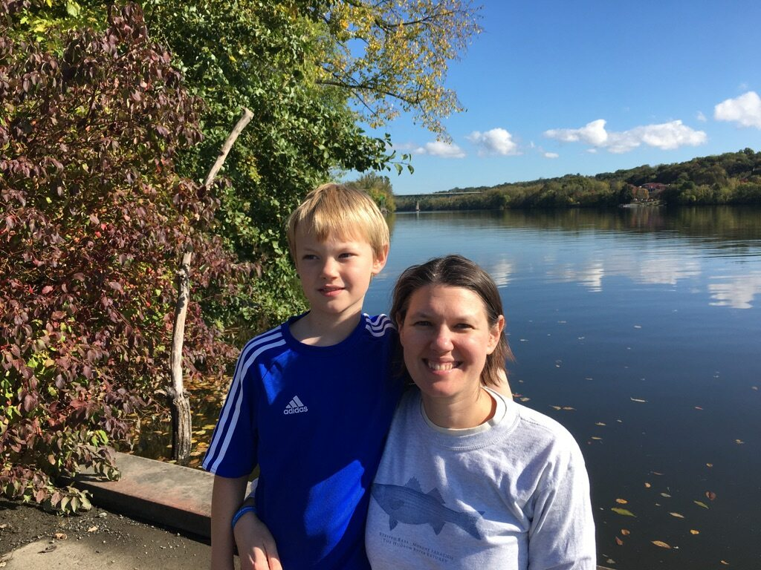
Karen Strong, Sean Madden NYDEC HREP, Corning Preserve, Albany Boat Basin, Albany (and DEC Commissioner Seggos)
Deanna Carras, Natalie Aiello, Montessori Magnet School, 4th grade, 45 students, 8 adults
Latitude 43 Longitude 74
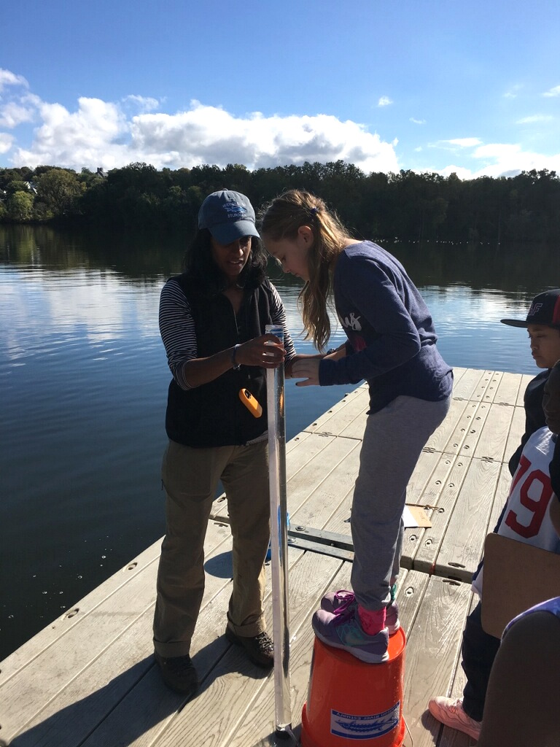 | 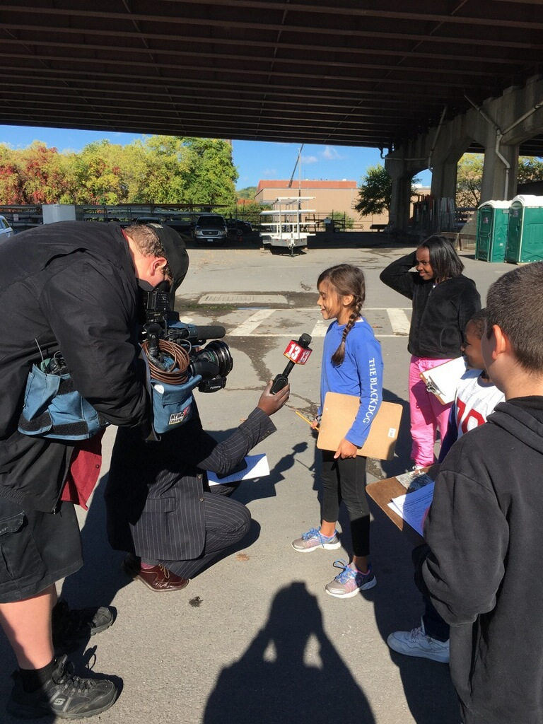
Location: Floating dock at riverfront park
Area: A path along the beach with rising forested hills, trees along both sides, plants along shore, bridges and boats. Dock on the shore, 2-3 pipes going into the water. Large bridge for trains over water. Highway elevated.
Surrounding Land Use: 70% Industrial/commercial; 25% Urban/Residential, 5% Park – used for fishing, jogging, boating
Sampling Site: vegetation, banks altered, shoreline with riprap – floating dock, concrete bulkhead,
Plants: no plants in water. Along shoreline cottonwood and maple trees.
River Bottom: muddy
ITEM | Time |  | Reading 1 | Reading 2 | Comments
Physical
Air Temperature | 10:00 AM |  | 19.7°C | 67°F
Wind Speed | 10:00 AM |  | 0 mph
 | 1:05 PM |  | 3.3 mph | N
Cloud Cover | Partly cloudy |  | 26-50%
Weather today | Clear with a few clouds - more sun later in the day
Weather recently | Warm and some wet
Water calm | NR
Water Temperature | 10:15 AM | 18°C |  | 64.4°F
Turbidity – long site tube | 10:20 AM | 120 cm |  | Water fairly clear | AVERAGE 122 cm
 | 11:04 AM | 126 cm
 | 1:20 PM | 120 cm |  | Water fairly clear
Chemical
DO | 9:50 AM | 10 mg/L |  | 18°C | 100%
 | 10:33 AM | 10 mg/L |  | 18°C | 105%
 | 12:00 PM | 10 mg/L |  | 20°C | 105%
pH – color match | 12:05PM | 7.7
Salinity - quantab | 12:17 PM | 2.2 quantab reading |  | 55 ppm Cl- | 99 ppm Total Salinity
 |  | 0.8
Fish Catch  Seine 19 ft. X 3 ft | Number Caught | Species |  | Length | Seine
11:00 AM | 3 | Spottail Shiner |  | 5 cm | Diversity 3
 | 8 | Banded Killifish |  | 9.5 cm | Total Catch 18
 | 1 | Brook Silverside |  | 8 cm
 | 6 | killifish |  | 9.5 cm
Tides | 9:37 AM | Low Tide
 | 12:47 PM | Extremely Low Tide
Currents – | Time | Secs. in 762 cms |  | cm/sec | Average
 | AM | Still |  | Orange did not move
 | 12:05 PM | 39.25 secs/762 cm |  | 19.41 | 0.38 kts
 | 12:05 PM | 38.85 secs/762 cm |  | 19.61 | 0.38 kts
 | 12:05 PM | 39.64 secs/762 cm |  | 19.22 | 0.37 kts
Commercial Traffic | 9:52 AM | DEC fishboat |  | Gray | Northbound
 | 10:08 AM | Coastguard boat |  | Gray | Southbound
Recreation traffic | 12:30 PM | Sailboat |  |  | Southbound
 | 1:45 PM | Cruise |  | Independence | Southbound
Other items | Grasshoppers, frogs, birds (seagulls), fish jumping in water, butterfly.

