Day in the Life of the Hudson River 10/12/17 Data
(Saltfront ~RM 65)
RIVER MILE 145
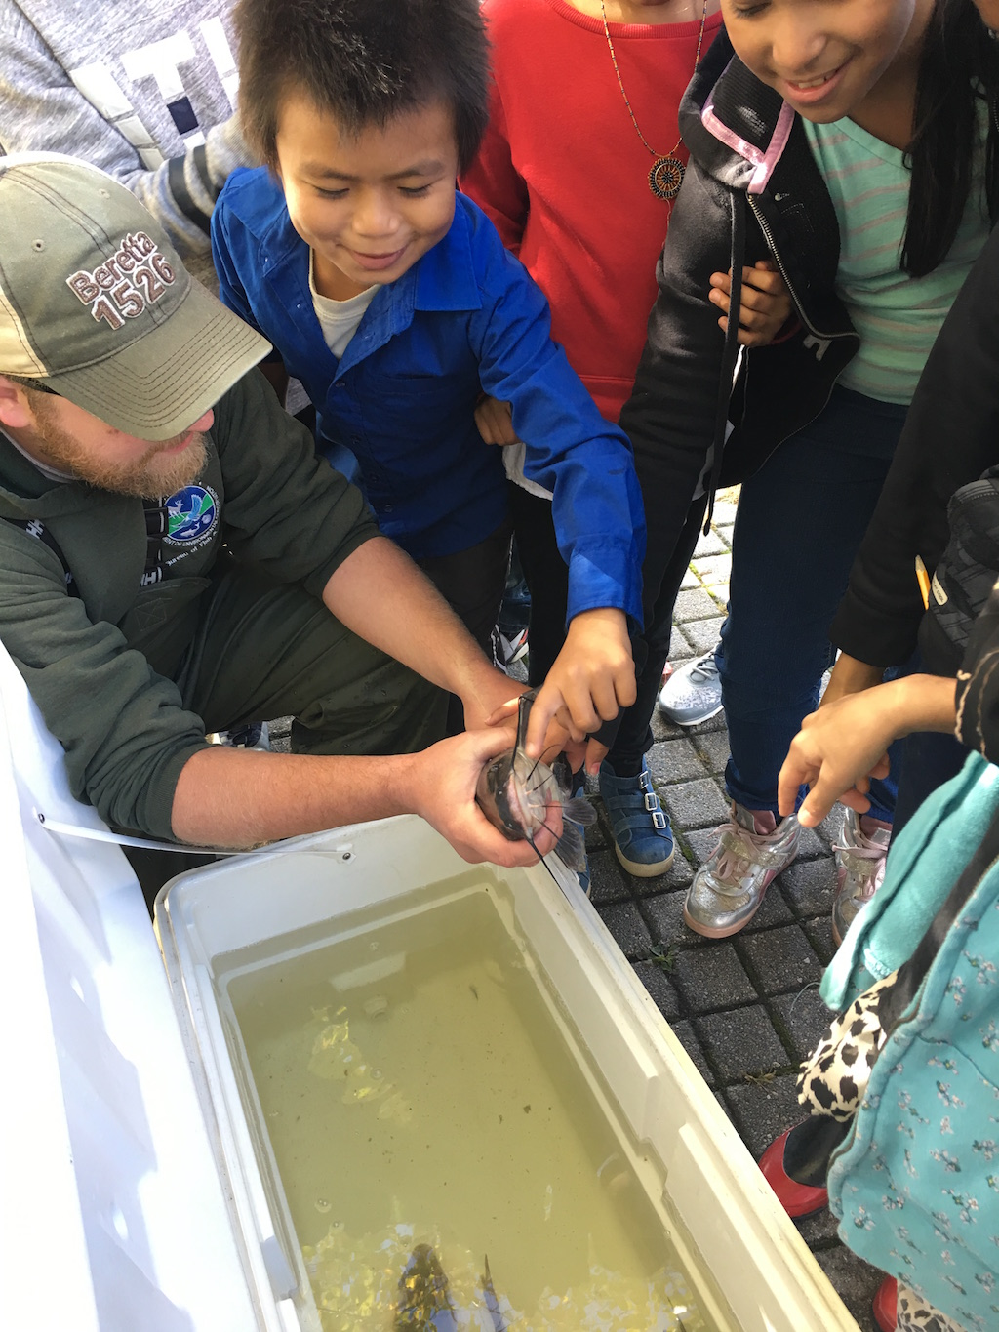
Jennings Landing, Albany
Betsey Domenico, Griffen Memorial Elementary School 4th grade,
80 students, 8 adults
Latitude 42.650810 Longitude -73.746875
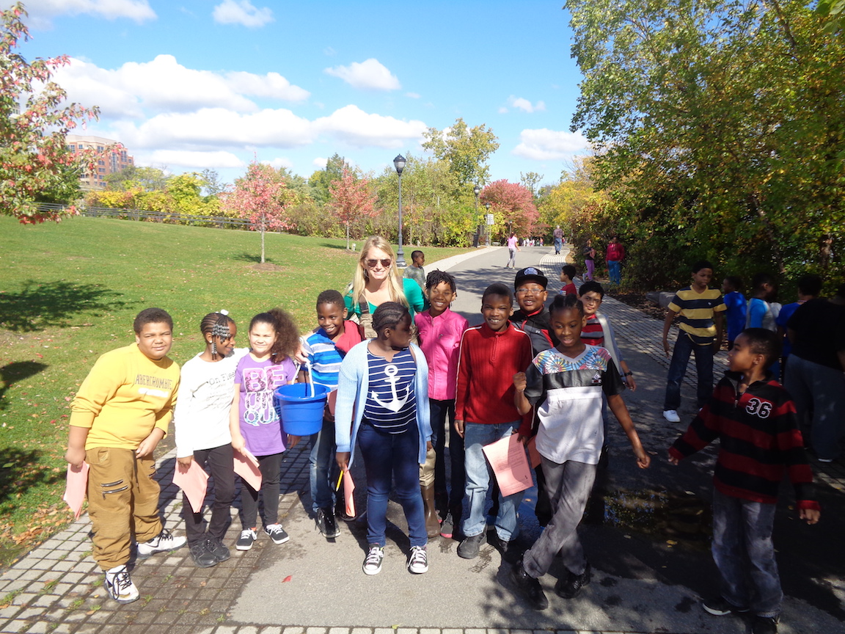 | 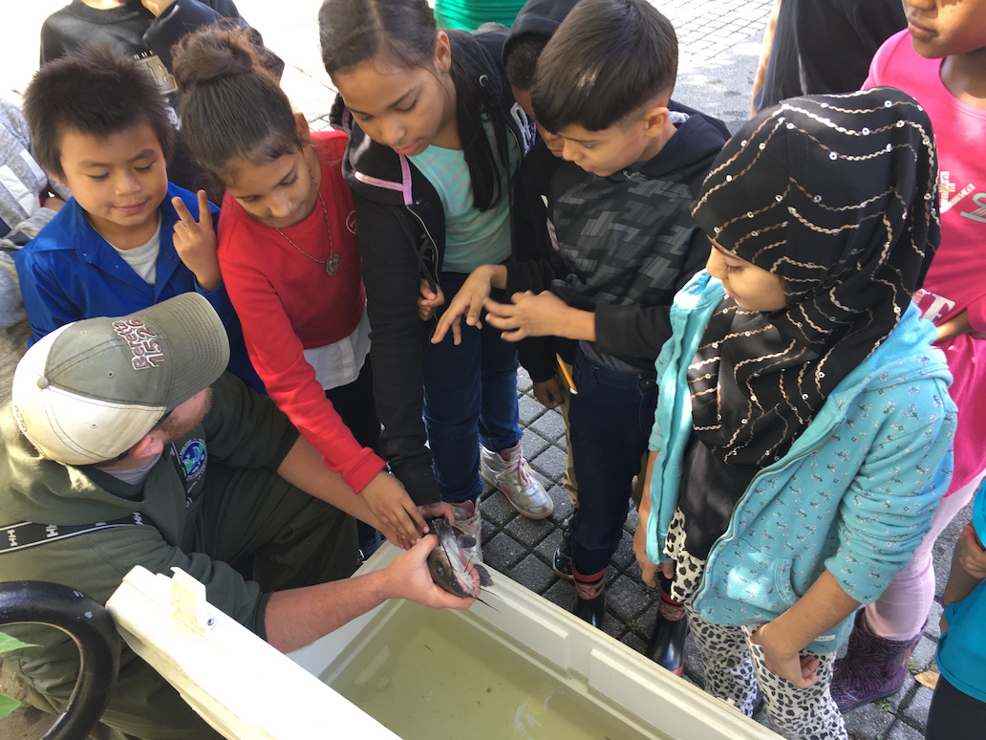
Location: Riverfront area at Jennings Landing, Albany
Area: Grassy riverfront park,
Surrounding Land Use: 100% Urban/commercial;
Sampling Site: rocky shoreline, riprap edges and pipe entering water
Plants: no plants in water.
River Bottom: muddy
ITEM | Time |  | Reading 1 | Reading 2 |  | Comments
Physical
Air Temperature | 10:00 AM  11:15 AM |  | 19.7°C  20 °C | 67°F  70°F
Wind Speed | 11:10 AM |  | Beaufort 2 | N |  | Light Breeze
Cloud Cover | 11:10 AM |  | Partly cloudy | 26-50%
Weather today | Clear with a few clouds - more sun later in the day
Weather recently | Warm and some wet
Water calm | NR
Water Temperature | 10:15 AM | 18°C |  |  | 64.4°F
Turbidity – long site tube | Reading 1 | Reading 2 |  |  | Reading 3 |  | Average
 | 39 | 57 |  |  | 64 |  | 53
 | 81 | 33 |  |  | 75 |  | 63
 | 29 | 33 |  |  | 53 |  | 38
 | 29 | 33 |  |  | 53 |  | 38
 | 28 | 33 |  |  | 53 |  | 38
 | 33 | 31 |  |  | 33 |  | 32
 | 28 | 33 |  |  | 45 |  | 35
 | 31 | 34 |  |  | 38 |  | 34
 | 48 | 38 |  |  | 53 |  | 46
 | 8 | 33 |  |  | 45 |  | 29
 | 8 | 33 |  |  | 45 |  | 29
 | 20 | 33 |  |  | 53 |  | 35
 | 8 | 33 |  |  | 45 |  | 29
 | 18 | 22 |  |  | 41 |  | 27
 | 33 | 45 |  |  | 45 |  | 41
 | 33 | 20 |  |  | 53 |  | 35
 | 23 | 58 |  |  | 18 |  | 33
 | 23 | 56 |  |  | 18 |  | 32
 | 23 | 58 |  |  | 54 |  | 45
 | 30 | 57 |  |  | 78 |  | 55
 | 37 | 33 |  |  | 41 |  | 37
 | 8 | 33 |  |  | 45 |  | 29
 | 8 | 33 |  |  | 45 |  | 29
 | 34 | 57 |  |  | 64 |  | 52
 | 8 | 33 |  |  | 45 |  | 29
 | 37 | 33 |  |  | 41 |  | 37
 | 37 | 32 |  |  | 41 |  | 37
 | 23 | 28 |  |  | 54 |  | 35
 | 23 | 58 |  |  | 81 |  | 54
 | 23 | 58 |  |  | 54 |  | 45
 | 34 | 63 |  |  | 85 |  | 61
 | 33 | 28 |  |  | 54 |  | 38
 | 34 | 54 |  |  | 55 |  | 48
 | 28 | 33 |  |  | 34 |  | 32
 | 33 | 35 |  |  | 62 |  | 43
 | 41 | 45 |  |  | 33 |  | 40
 | 32 | 33 |  |  | 55 |  | 40
 | 23 | 58 |  |  | 81 |  | 54
 | 51 | 58 |  |  | 81 |  | 63
 | 58 | 81 |  |  | 54 |  | 64
 | 23 | 58 |  |  | 54 |  | 45
 | 58 | 58 |  |  | 54 |  | 57
 | 37 | 33 |  |  | 41 |  | 37
 |  | GRAND |  |  | AVERAGE |  | 46 cm
Chemical
DO – drop count | 11:15 AM | 8 mg/L |  |  | 19°C |  | 85%
 | 11:43 AM | 10 mg/L |  |  | 23°C |  | 115%
 | 12:26 PM | 11 mg/L |  |  | 20°C |  | 120%
 | 12:35 PM | 2* mg/L |  |  | 20°C |  | 20% Problem expected
 | 12:48 PM | 8 mg/L |  |  | 22°C |  | 120%
 | 12:48 PM | 10 mg/L |  |  | 22°C |  | 115%
pH – color match | 11:40 AM  12:55 PM | 7.0  7.0
Salinity – quantab LR | 11:15 AM  1:05 PM | 1.2 quantab  1.2 quantab |  |  | Below detection |  | (1.4 started at 32 ppm)
Fish Catch | Number Caught | Species |  |  | Length |  | Seine
Tides | 11:10 AM | 20 inches
 | 11:50 AM | 17.5 inches |  |  | 2.5 inches |  | falling
Commercial Traffic | 10:15 AM | Fishing boat |  |  | White & Red |  | Northbound - loaded
Recreation traffic | 12:42 PM | Sailboat |  |  | White |  | Northbound – light
 | 1:44 PM | Mini Cruise ship |  |  | White |  | Northbound - Light
Other items | Man made - Boats, , part of a pipe, cans, trash, picnic table, minnow trap, wrappers in the water,  Natural - Driftwood, rocks, crab apples, sticks, pond, leaves, slime on the rocks, trees, grass, boulders in the water  Animal - Butterfly, geese,

