Day in the Life of the Hudson River 10/12/17 Data
RIVER MILE 153
(Salt Front ~ RM 65)
River Park, Green Island Park, Green Island NY
Dawn Baldwin, SUNY Poly CMOST
Dan Shepard & Susan O’Dell Taylor School
16 - 5th & 6th grade students, 4 adults
Latitude 42° 44”53.04” N – Longitude -73° 41’20.62” W
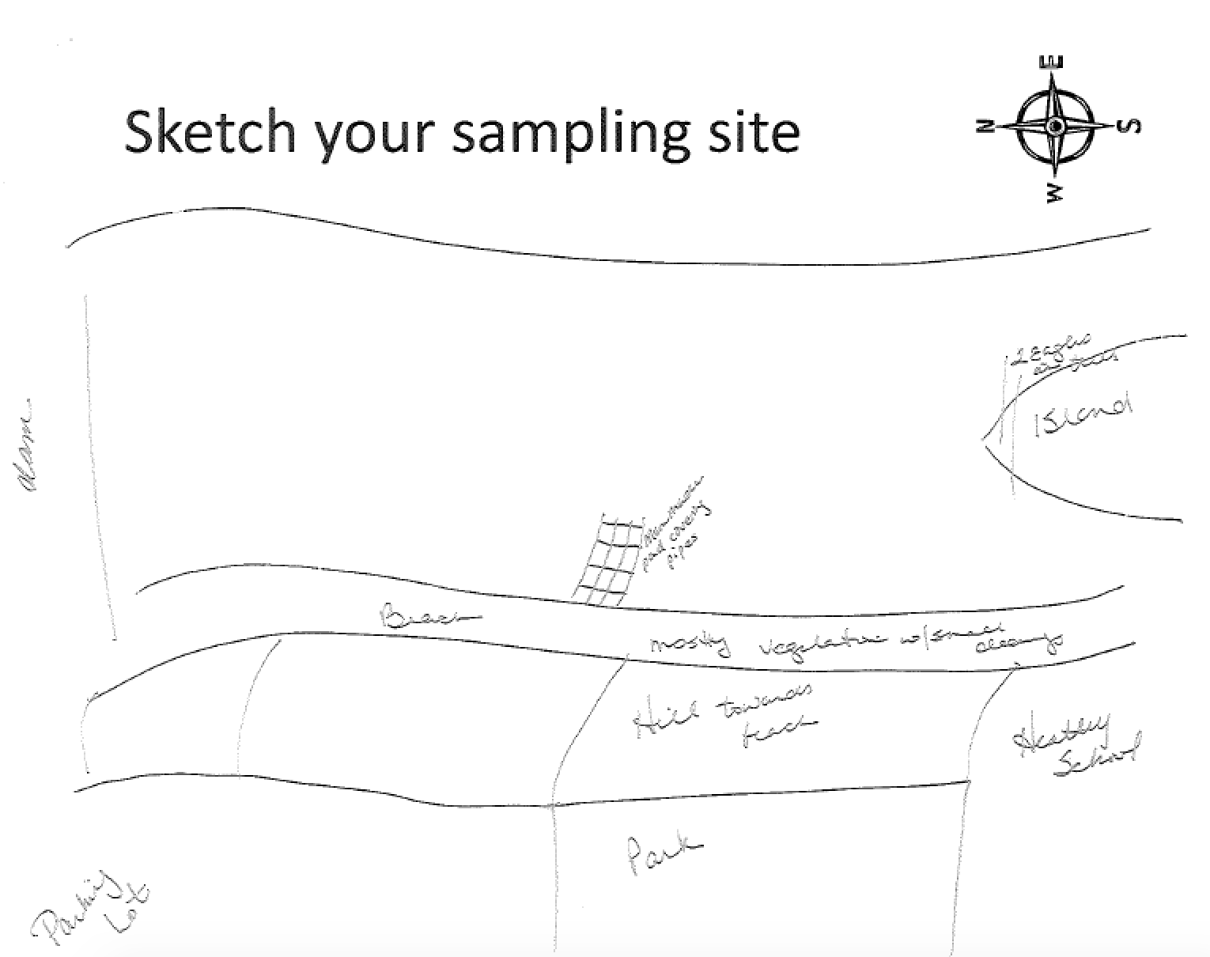

Location: Green Island Park boat ramp, below the Troy Dam, Albany County, NY
Area: Beach area with a lot of vegetation, very muddy and rocky. The Troy dam is directly to the north
Surrounding Land Use: Forested, Rocky, Fishing access, gravel, some vegetation
Sampling Site: 40% urban/residential, 30% beach, 20% industrial/commercial, 10% forested
Shoreline: Beach is rocky, broken concrete docking, very rocky shoreline, slag, concrete at the launch, brick pieces, 50 % vegetation, pipe directly across sampling site
Plants in water: less than 1%
Water depth; Sampling was done from approximately 2 feet of depth
River Bottom: mainly rocky
ITEM | Time |  |  | Reading 1 | Reading 2 | Comments
Physical
Air Temperature | 10:20AM |  |  | 55°F  12.78°C
 | 11:20 AM |  |  | 57°F  13.89°C
Wind Speed | #1 Beaufort
Cloud Cover | Clear
Weather today | none
Weather recently | Slightly warm fall days Mon & Tues and Wed. night rain – today is Thursday
Water surface | Calm with ripples
Water Temperature | 10:20 AM |  | 13.33°C |  | 56°F  55.5  56 | Average 55.75°F
 | 11:00 AM |  | 13.33°C |  | 56°F  56°F  56°F | 56 °F
Turbidity –short site tube | 10:25 AM |  | 0 JTU X 3 |  | 0 JTU
Chemical | 10:00 AM |  | 1.0
DO  Drop count kit | 11:00 AM |  | 13.33°C |  | 7 ppm | 68%
pH –indicator solution | 12:44 PM |  | 7.5  7.0  7.0 |  |  | Average 7.25
Salinity –hydrometer | 12:00 noon |  | Below Detection |  | Unable to read salinity in this area with hydrometer.
Nitrates | 12:30 PM |  | 0.5 ppm |  | 3 tests
Fish Catch – | Time |  | Number Caught |  | Species | Size Largest
Four tries to seine but no fish |  |  | ZERO
Tides | Time |  | Height in c |  | Rising/Falling | Rate of change
 | 9:00 AM |  | 5 cm |  | Rising
 | 9:20 AM |  | 20 cm |  | Rising | 0.75 cm/min
 | 9:50 AM |  | 27cm |  | Rising | 0.23 cm/min
 | 10:19 AM |  | 32.5 cm |  | Rising | 0.19 cm/min
 | 10:35 AM |  | 35 cm |  | Rising | 0.16 cm/min
 | 10:55 AM |  | 37.5 cm |  | Rising | 0.125 cm/min
 | 11:30 AM |  | 34 cm |  | Falling | 0.1 cm/min
 | 12:00 PM |  | 1 cm |  |  | 0.55 cm/min
 | 1:00 PM |  | Water receded beyond tide stick
Currents | Time | Cm/30 secs | Cm/sec |  | North South | Ebb/Fld/Still
 | 10:15AM | 228.6 | 7.62 cm/sec |  | South | Ebb
 | 11:15AM | 274.32 | 9.14 cm/sec |  | South | Ebb
Traffic Recreational | Not traffic other than a DEC boat first thing in the am
Other Observations | Two bald eagles nesting in a tree within sight of our location. They came out over the river twice – spectacular!  Students from Susan O’Dell Taylor Middle School gathered on the shore waiting to see what the DEC brought to show them. They and their partners from CMOST were thrilled to see an eagle swoop down to catch some breakfast.

