Day in the Life of the Hudson River 10/12/17
(Saltfront ~RM 65)
RIVER MILE 17
Mt. St. Vincent College Campus, NYC
Tara Anderson – Mt. St. Vincent College – 1 adults, 1 college
Latitude 40.91° N Longitude 73.91° W
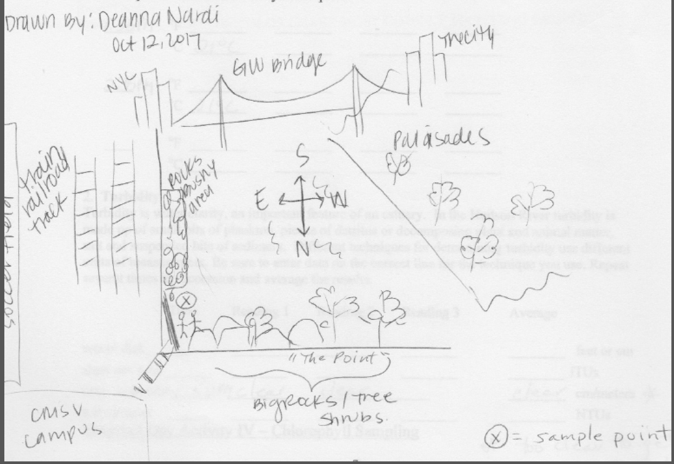
Location: Waterfront of Mt. St. Vincent’s College
Area: Forested, grassy
Surrounding Land Use: Urban/residential 65%, Forested 15%, Industrial Commercial 20%
Sampling Site: Shoreline is 100% rocky –bulkhead, drainage pipes in area, beach area, covered in vegetation, 50 cm storm pipe at the site, some slag
Plants in water of sampling area: no plants in the water
Plants in the area: No plants in water area
Water depth: 90 cm
River Bottom – rocky
Water: A little choppy @ 12:15 PM/Water calm at 2:00 PM
ITEM | Time |  | Reading 1 | Reading 2 |  | Comments
Physical
Air Temperature | 12:15 PM  1:55 PM |  | 21°C  16, 21 °C
Wind Speed | 12:15 PM  1: 59 PM |  | Beaufort #3  Beaufort #2 | NW  NW
Cloud Cover | 1:30 PM |  | Partly cloudy.
Weather today | At start was overcast  Later few clouds but mostly sunny - dramatic change in weather
Weather recently | Warm for last 3 days, this AM a few rain periods
Water Temperature – | 12:10 PM  1:55 PM  2:35 PM | 21°C  21  21
Turbidity  60 cm site tube | 1:50 PM | Exceeded tube >60 cm
Chemical
DO  LaMotte kit 7414 | 2:00 PM | 6.0mg/L |  | Temp 21° C |  | 65% saturated
pH – LaMotte kit 5858 | 2:05 PM | 9.5* solution old
Salinity -  refractometer | 12:00 PM  2:40 PM | 15 ppt  16
Nitrates | 2:25 PM | <1 ppm
Phosphates | 2:10 PM | <1 ppm
Fish Catch – 10 ft. net – 2 pulls | No fish caught | Species |  | Length
Tides | 12:15 PM  2:42 PM |  |  | Rising  Still rising
Currents | 2:20PM | 280 cm/60 secs  4.7 cm/sec |  | 0.09 kts |  | N Flood
Note | St. Vincent Point juts out into the river N of our sampling site
Traffic – commercial | 2:30PM | Double Barge |  | South |  | Loaded gravel
Recreational | 1:45 PM | Sightseeing |  | South
 | 1:42 PM | Speedboat |  | South
 | 2:35 PM | Rec sailboat |  | South
Other observations | Also incubated some micro samples for bacteria. Counts were very low.

