Day in the Life of the Hudson River 10/12/17 Data
(Salt Front ~RM 65)
RIVER MILE 18.3
Elisa Caref - Sarah Lawrence College Center for the Urban River @ Beczak
Penny Kelly, Lincoln High School (AP Bio, AP Chem, APES) 30 second graders, 4 adults total
Latitude – N 40.9379702 - Latitude – W -73.9029181

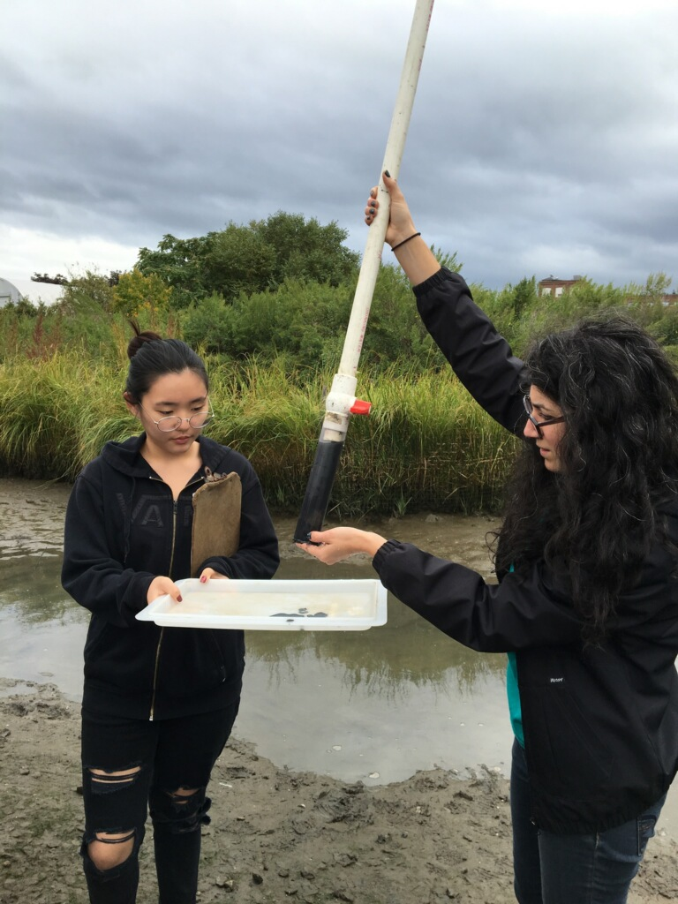
Location: Habirshaw County Park, Seining beach, SLCC@ Beczak, Yonkers, Westchester County
Area: 2 acre riverfront county park covered mostly by a grass lawn leading down to the river where it meets a tidal wetland and sandy beach. Property used for fishing, boats, seining, field trips and education programs – Park and some urban – 75% urban residential, 25% waterfront/beach,
Surrounding Land Use: Beach – 2 acre park
Sampling Site shoreline: sandy beach, tidal marsh area covered with vegetation, banks altered, large riprap on shoreline, collected wood/debris in area,
Plants in area: no plants in the shoreline waterfront however in the marsh area there is: mud wort, reed grass, saltwater cordgrass, big cordgrass
River Bottom – muddy
ITEM | Time |  | Reading 1 |  | Reading 2 | Comments
Physical
Air Temperature | 10:20 AM  11:04 AM  11:38 AM |  | 17°C  18  17 |  | 62.8°F  64.4  62.8 | Air cooler than water
Wind Speed | 10:25 AM  11:01 AM  11:37 AM |  | 1.5 Beaufort  1  1.5 |  | NE  NE  NE
Weather today | Mostly cloudy, no precipitation
Weather recently
Water calm | calm
Water Temperature – | TIME | Hand held |  | Hand held | Probe | Probe
 | 10:26 AM  10:54 AM  11:29 AM | 68°F |  | 20°C -  20  20 | 66.9 °F  67.1  66.38 | 19.4 °C  19.5  19.1
Turbidity – | Sight tube –  10:35 AM  11:11 AM  11:48 AM | 49 cm  54 cm  55.8 cm |  |  | DigitalProbe  10:38 AM  11:17 AM | 7.5 NTU  6.4 NTU  6.3 NTU
Chemical – | Time | Digital Probe |  |  | H2O Temp | % saturated
DO – probe | 11:38 AM  11:19 AM  11:48 AM | 7.9 ppm  6.79  6.94 |  |  | 20°C | 85% satur.  80%
pH – indicator solution | 11:30 AM | 7.8  7.79  7.83 |  |  | Avg – 7.8 | Digital Probe
Salinity – | 10:27 AM | 22 ppt  14 ppt  18 ppt |  |  | Avg – 18 ppt | Hydrometer
 | 10:36 AM | 15.6 ppt |  |  | 15.6 ppt | Probe
 | 11:02 AM | 18 ppt  14  16 |  |  | Avg. 16 ppt | Hydrometer
 | 11:15 AM | 14.73 ppt |  |  | 14.73 ppt | Probe
 | 11:25 AM | 16 ppt  14  18 |  |  | 16 ppt | Hydrometer
 | 11:35 AM | 14.69 ppt |  |  | 14.69 ppt | Probe
Fish Catch - Seine net 30 feet X 4 ft., 1.4 inch mesh- | Number Caught – | Species |  |  | Size of largest | Notes
FISH | 1 | Bay Anchovy
 | 1 | Atlantic Silverside
 | 4 | Striped Bass
 | 19 | mummichog
 | 3 | Naked goby
 | 1 | Northern pipefish
TOTAL CATCH | 29 | FISH DIVERSITY |  |  | 6
macroinvertebrates
 | 19 | Blue Crab
 | 33 | Ctenaphore
 | 123 | Shrimp
MACRO INV |  | Moon Jelly
 | 1 OTHER DIVERSITY | 5 TOTAL OTHER
Tides | 10:18 AM | 9cm
 | 10:47 AM | 20 cm |  |  | Rising
 | 10:53 AM | 24 cm |  |  | Rising
 | 11:21 AM | 37 cm |  |  | Rising
 | 11:27 AM | 39 cm |  |  | Rising
 | 11:50 AM | 54 cm |  |  | Rising
Currents | 10:45 AM | Orange didn’t move |  |  | Still current
 | 11:15 AM | 15cm/sec |  |  | flood
 | 11:30 AM | 0.83 cm/sec |  |  | flood
Sediment Core | GROUP | TOTAL LENGTH |  |  | TOP | BOTTOM
 | Group 1 | 14 cm length |  |  | 2 cm brown top (oxidized) | 12 cm black color
 | Group 2 | 9 cm length |  |  | 0.5 cm more clay | 8.5 cm very dark and worms
 | Group 3 | 11.5 cm length |  |  | 1.5 cm oxidized top | 5.5 cm rocky pebbles
Other

