Day in the Life of the Hudson River 10/12/17 Data
(Salt Front ~RM 65)
RIVER MILE 2.9
Nina Hitchings, Toland Kister - The River Project
Scott Wassmuth, The Musem School – 32 students and 7 adults
Latitude N 40.7282554N Longitude -74.014880 W
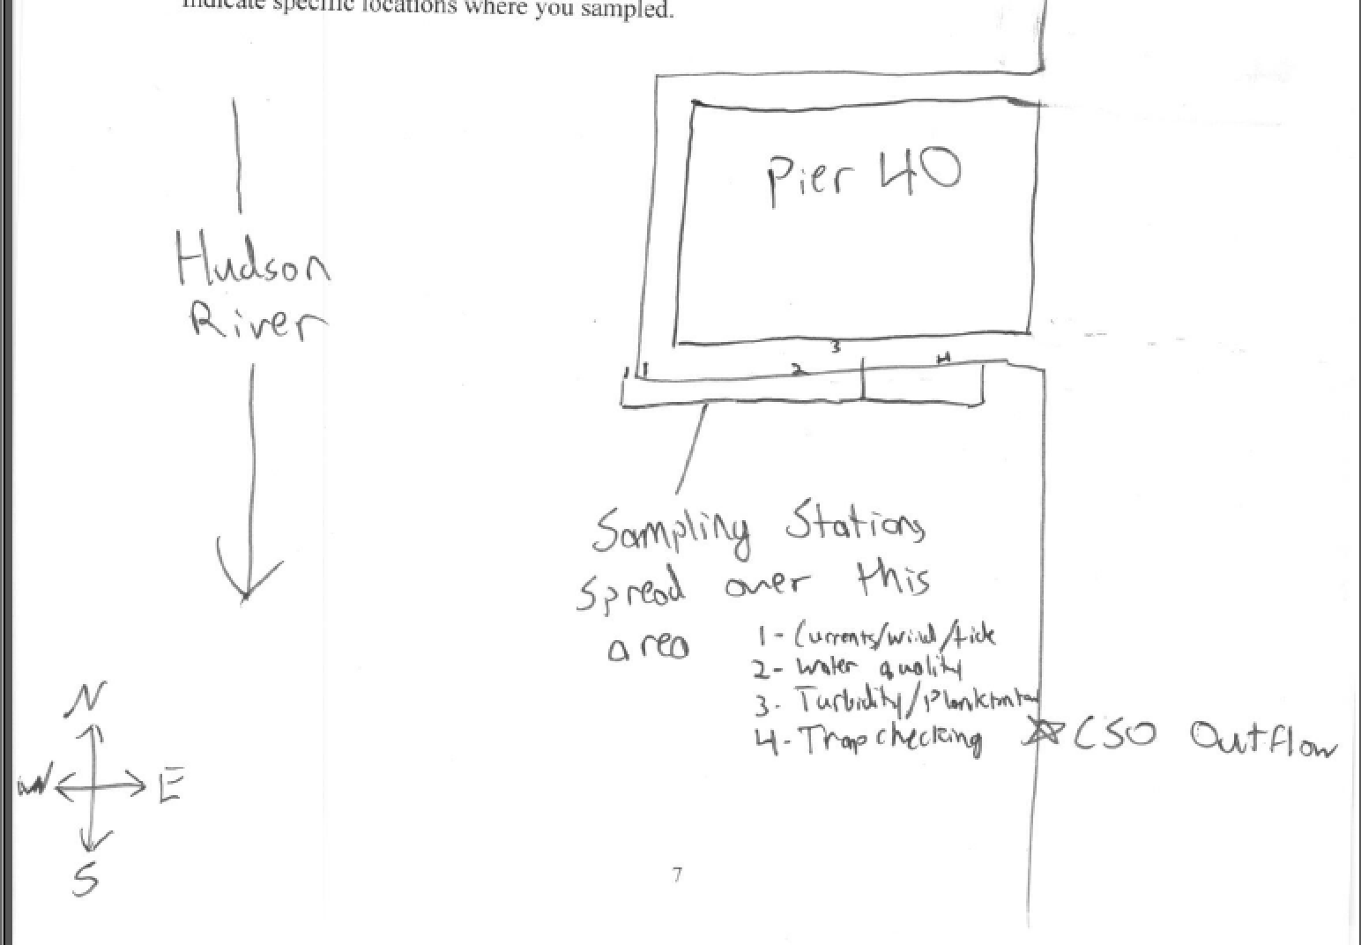

Location: Pier 40 Hudson River (also called North River)
Area: Off southern side of Pier 40 about 600-800 feet down the pier from shore. Large urban pier with many sports facilities: athletic fields, kayaking and boathouse, seasonal moorings available, parking, fishing on the pier, benches & picnic tables for the public
Surrounding Land Use: 100% Urban/residential;
Sampling Site: Bulkhead, Banks altered; concrete & wood pilings, large pier extends into river/cement bulkhead south ~ 100 m
Shoreline: Rocky
River Bottom: Soft sediment habitat, muddy
Plants: no
NOTE: This highly urban site is just west of the busy Westside Highway – it is the largest pier in Hudson River Park (with a 14 acre footprint); Pier 40 is used for recreation; school groups use the athletic fields; there are 3 public boathouses; there are many people by on the river’s edge: jogging, bike riding, walking.

ITEM | Time |  | Reading F | Reading C | Comments
Physical
Air Temperature | All Day |  | 62°F | 16.67°C
Wind Speed | Time |  | Beaufort Chart | Kestral – from spot somewhat protected by building
 |  |  | 2 | 4-7 mph 4-6 kts
Cloud Cover | Mostly cloudy (51-75% cover)
Weather today | Drizzling, became sunnier towards end of sampling
Weather recently | Fairly Warm for October, mostly sunny, rain on Monday
Water | choppy
Water Temperature -4 feet of water | 9:42 AM  10:05 AM  10:28 AM  10:46 AM | 66 °F  64 °F  66 °F  66 |  | 18°C  18°C  19°C  19 | Average  18.5 °C  65 °F
Turbidity (long site tube) | 9:42-10:46 AM | 87 cm  96.2  90  88.4 |  |  | Average 94cm
Chemical – each is an average of the 4 different rotation groups | TIME | TEMP. |  | PPM | % SAT.
DO – drop count kits | 9:42-10:46 AM | 18.75°C |  | 6 ppm | 64%
pH – Litmus paper | 9:42-10:46 AM | 7 X3 |  |  | Average 7
Salinity – hydrometer /Instant Ocean | 9:42-10:46 AM | 21  21.5  21  22 |  |  | Average 21.375 ppt
Nitrates | 9:42-10:46 AM | 0.5  0.75  0.6  0.75 |  |  | Average 0.65 ppm
Phosphates | 9:42-10:46 AM | 0.02 ppm  0.02  0.02  0.02 |  |  | Average 0.02 ppm
Fishing – Minnow Trap and Crab pots | 9:42-10:46 AM | Grass Shrimp  Sea Squirts  Comb Jellies  Isopods  Amphipods  Spider Crabs |  |  | Macro DIV 6
Tide - distance from pier to water | 9:39 AM  9:56 AM  10:00 AM  10:16 AM  10:35 AM  10:45 AM | 233 cm  221  200  210  190  185 |  | -  -0.71  -5.25  +0.625  -1.05  -0.5 | Set  Rising  Rising  Expect wave  Rising  Rising
Currents – averaged from student sheets | 9:42-10:46 | 11 cm/sec |  | 0.21 kts | South/Ebb
We sample from a pier and also located near the large air vents built to supply the Holland Tunnel which may impact out current readings.

