Day in the Life of the Hudson River 10/12/17 Data
Above the Troy Dam
RIVER MILE 200
Hudson Crossing Park, Lock 5, Schuylerville , Hudson River

Jessica Schwerd, Hudson Crossing Park
60 students 2nd and 4th and 14 adults
43°00.044’ N & 73°51.078’W
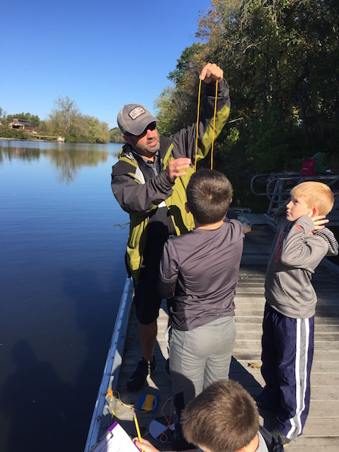 | 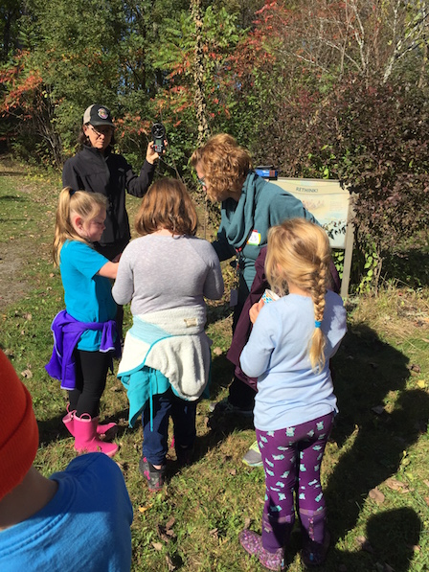 | 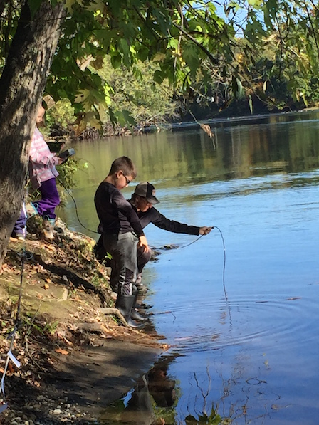

Location: Kayak launch, Hudson Crossing Park, Lock 5 in Schylerville, Saratoga Co.
Area: Old industrial site now used for recreation – waterfalls, boating, fishing
Surrounding Land Use: urban/residential several houses on the site; 85% forested; 1% beach, Industrial/Commercial dredging downriver, lots of barge activity
Sampling Site: Small beach area, pier and lock, construction gravel in the area and covered in vegetation
Plants in water: Rocky shoreline, yes - <5% has water celery
Plants in area: oak, sumac, honeysuckle
Water Bottom: sandy
Water depth: 3-5 ft.
ITEM | Time |  | Reading 1 | Reading 2 | Comments
Physical
Air Temperature | 10:00 AM |  | 17 °C  61 °F
Wind Speed |  |  | 2.0 mph
Cloud Cover | Partly cloudy to mostly cloudy
Weather today | No rain today
Weather past few days
Water Temperature | 11:00 AM | 19°C  60 °F
Water surface | Water calm
Turbidity - secchi | 10:00 AM | >2 meters |  | Secchi hit bottom
Chemical
pH – | 10:00 AM | 6.8
Salinity – quantabs | 10:00 AM | 32 mg/L Cl- |  | 58 mg/L TS
Dissolved Oxygen – digital titration | 10:00 AM | 9.83 ppm
Flow | 650 cm/30 secs | 21.7 Cm/sec
Shipping | 11:26 AM | Paddleboat |  | Docked

