Day in the Life of the Hudson River 10/12/17 Data
(Salt front ~ RM65)
RIVER MILE 28
Nyack Memorial Park
Kirsten Kleinman, Nyack High School – 3 APES Classes 80 students,
11-12th graders, 6 adults
Latitude 40°05.243’N, Longitude 73°54.988 ‘W
Location: Nyack Park where Nyack Brook feeds in
Area: Open and grassy, has a parking lot, used for picnics, fishing
Surrounding Land Use: 100% park
Sampling Site: beach, banks altered, riprap on shoreline, bulkhead
Plants in area: no water plants in area
Water depth: varied
River Bottom – sandy/muddy bottom , water calm

The students do their traditional sampling of a transect that runs from Nyack Brook (Station #1) out towards the Hudson River (Station #10)

ITEM | Time | Reading 1 | Time | Reading 2
Physical
Air Temperature | 9:15 AM | ºC | 12:30 PM | ºC
Cloud Cover | 9:15 AM | overcast
Water Temperature | 9:15 AM | 19.2 ºC | 12:30 PM | 20.2 ºC
Chemistry | * Complete set of DO, Salinity, Water Temp etc. in tables below for the comparative study.
Salinity | 9:15 AM Low Tide | 6.61 ppt | 12:30 PM High Tide | 5.44 ppt
QUANTAB reading 7.8 | 3416 ppm Cl- | 6171ppm TS | NOTE that students used Ohaus pen meter | recording 4.9 ppt or 4900 ppm
Nitrates – API test kit | Station 1 furthest inland | 8.8 ppm | Station 1 furthest inland | 0 ppm
 | Station 10 at the Hudson | 2.2 ppm | Station 10 at the Hudson | 2.2 ppm
Phosphates | Station 1 furthest inland | 0.5 | Station 1 furthest inland | 0.5 ppm
 | Station 10 at the Hudson | 0.7 | Station 10 at the Hudson | 0.8 ppm
Dissolved Oxygen | 9:15 AM | 7 ppm | 12:30 PM | 5.5 ppm
pH | 9:15 AM | 7.6 | 12:30 PM | 7.5 ppm
Turbidity – secchi | AM Sample | cm | PM Sample | cm
7 meters off new pier | 9:15 AM | 37 cm | 12:30 PM | 33 cm
Station 7 | 9:15 AM | 40 cm | 12:30 PM | 50 cm
End of Boat Launch | 9:15 AM | 20 cm | 12:30 PM | 30 cm
Fish Catch  Seine 12X4 | Number Caught | Species | Length of longest | TOTALS
20 hauls | 50 | Atlantic Silversides |  | FISH DIVERSITY 4
 | 4 | Striped Bass |  | FISH TOTALS 58
 | 2 | mummichog
 | 2 | White Perch
Macro-invertebrates | 20 | Comb Jellies |  | MACRO DIVERSITY 3
 | 5 | Blue Crab |  | MACRO TOTALS 30
 | 5 | Mud Crab
Tides | 9:40 AM  10:10 AM  10:40 AM  11:20 AM  11:40 AM  12:10 PM | 20 cm  36 cm  52 cm  60 cm  80 cm  93 cm
Currents | 11:17 AM | 181 cm/30 secs | 6.02 cm/sec | 0.12 kts FLOOD

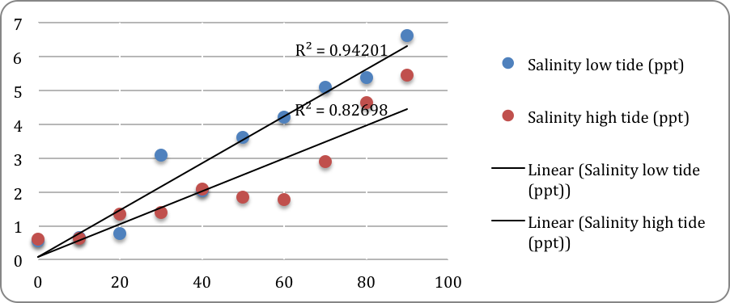
COMPARISON OF THE SALINITY IN THE AM (LOW TIDE) AND PM (HIGH TIDE) 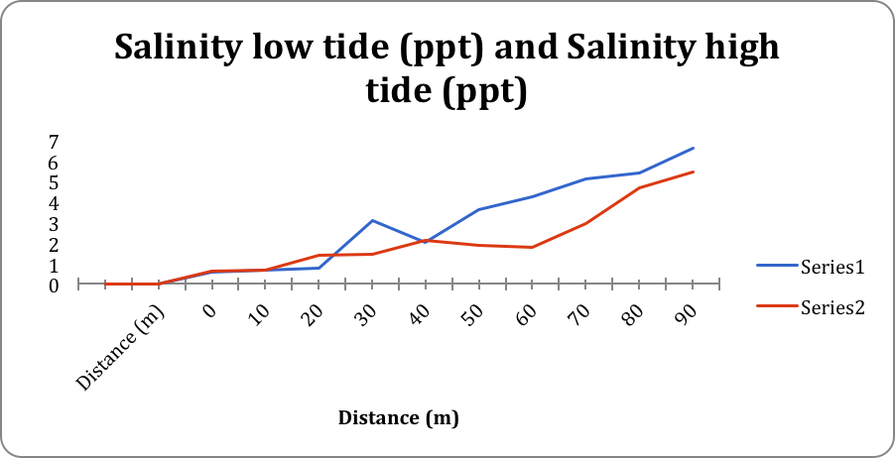
DIFFERENT WAY TO LOOK AT THE SAME DATA. SERIES 1 IS AM LOW TIDE SERIES 2 IS PM HIGH TIDE

Sketch Map of Sampling Site
1

2

3
4

Nyack Brook
5

6

7
8

9

10

Hudson River

Time: ___9:15 AM___ Tide: __Low_____ Depth: Surface Sample

Station # | Distance (m) | Depth cm | Salinity (ppt) | Temp (ºC) | DO mg/L | pH
1 | 0 | 8 | 0.55 | 17.1 | 7 | 8
2 | 10 | 10 | 0.66 | 16.7 | 6 | 7.6
3 | 20 | 37.5 | 0.77 | 16.9 | 6 | 7.5
4 | 30 | 60 | 3.09 | 17.9 | 5.5 | 7.3
5 | 40 | 55 | 2.03 | 17.5 | 5 | 7.6
6 | 50 | 35 | 3.61 | 18 | 6 | 7.3
7 | 60 | 48 | 4.21 | 19.6 | 4 | 7.4
8 | 70 | 45 | 5.1 | 19.2 | 4 | 7.5
9 | 80 | 42.5 | 5.39 | 19 | 6 | 7.4
10 | 90 | 35 | 6.61 | 19.2 | 7 | 7.6

Data Table 2: Time _12:30 PM Tide ___High Depth Surface Sample

Station # | Distance (m) | Depth cm | Salinity (ppt) | Temp (ºC) | DO mg/L | pH
1 | 0 | 9 | 0.61 | 16.7 | 5.5 | 7.8
2 | 10 | 30 | 0.63 | 16.8 | 7 | 7.7
3 | 20 | 46.5 | 1.36 | 17 | 5.5 | 7.6
4 | 30 | 97 | 1.4 | 17.4 | 8 | 7.3
5 | 40 | 84 | 2.1 | 17.3 | 4.5 | 7.5
6 | 50 | 52 | 1.85 | 17.9 | 5 | 7.5
7 | 60 | 64 | 1.78 | 17.7 | 7 | 7.5
8 | 70 | 72 | 2.91 | 18.1 | 6 | 7.4
9 | 80 | 56 | 4.65 | 19.4 | 5.5 | 7.4
10 | 90 | 57 | 5.44 | 20.2 | 5.5 | 7.5

