Day in the Life of the Hudson River 10/12/17 Data
RIVER MILE 3.2
(Salt Front ~ RM 65)
Pier 45
Tania Goicoechea & Eve Brown
Wallerstein Collaborative for Urban Environmental Education/NYU
Ellis Academy (20 High School, 7 adults) & Chelsea HS, (20 - 9th graders, 7 adults)
40.73ºN, 74.01ºW
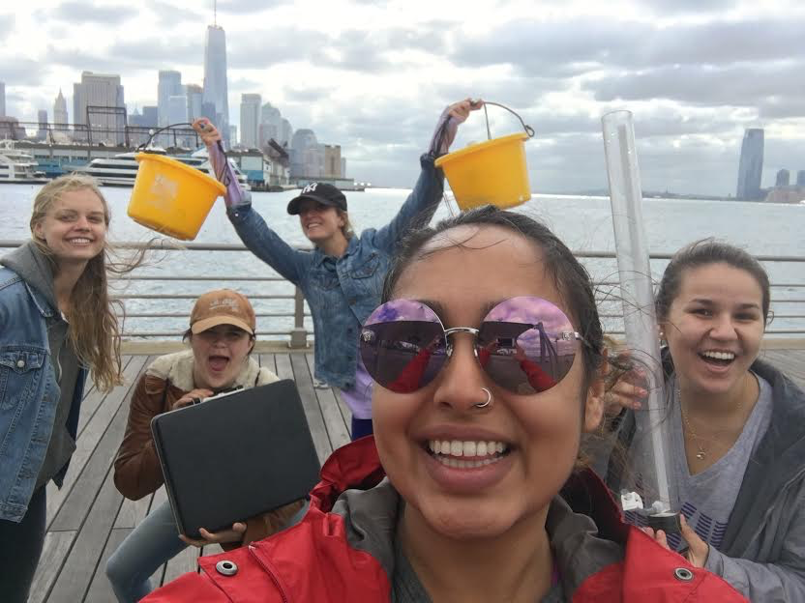
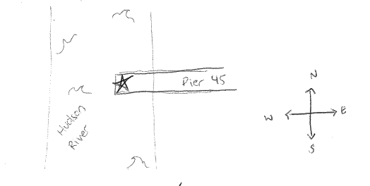

Location: Pier 45
Area: Pier, park
Surrounding Land Use: 60% urban/residential, 40% industrial/ commercial
Shoreline: park
Plants in area: None

ITEM | Time | Reading 1 | Reading 2 | Comments
Physical
Air Temperature | 11:00 AM | 57ºF | 14ºC
Wind Speed | NR
Cloud Cover | 11:00 AM | Partly cloudy
Weather today | Just sprinkling a little bit
Weather recently | Yesterday was warm, rainy, hot, & sunny
Water description | Calm
Water Temperature | 11:00 AM  12:00 PM | 63.75ºF  66.3 | 17.64ºC  19.01
Turbidity – Short Site Tube (60 cm) | 11:00 AM | 55.8cm | 52.6cm | Avg: 54.2cm
Chemical | Time | DO | Temp | % Sat
DO  Chemets Kit | 11:00 AM  12:00 PM | 5ppm  5.8 | 17.64ºC  19.01 | 50%  65
pH | Time | Litmus strips | Lamotte test kit | Average
 | 11:00 AM  12:00 PM | 6.75  6.62 | 7.45  7.125 | 7.1  6.87
Salinity | Time
Hydrometer | 11:00 AM  12:00 PM | 20 pm  20
Tides | NR

