Day in the Life of the Hudson River 10/12/17 Data
(Salt Front ~ RM 65)
RIVER MILE 30.5 – Nyack Beach Hook Mountain State Park, Steps
Nicole Laible, Brianna Rosamilia, Rockland County Division of Environmental Resources
Peter Park, Nyack College
Jessica Flanagan, Clarkstown North HS 14 students grades 11/12, 7 adults
41.12049N -73.911339W
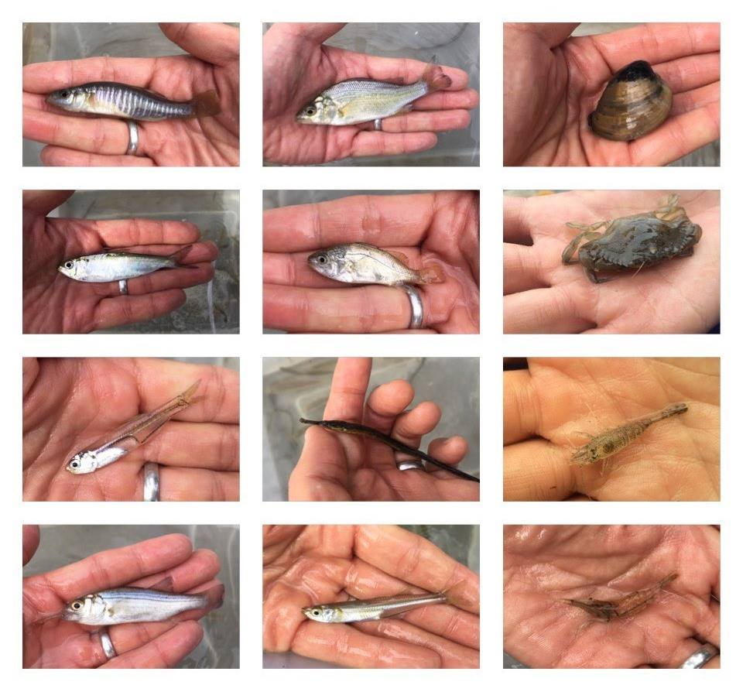
FISH SAMPLING FROM SITE

Location: Nyack South Beach, Upper Nyack, Rockland County NY
Area: Park/Boat launch, near Hook Mountain Sandy Beach by the large sitting stairs, Surrounding Land Use: 40% forested, 10% industrial/commercial, 40% beach – used for recreation & picnics
Sampling Site: Beach – sandy and rocky at edges, muddy offshore, covered with vegetation beyond the beach, stone wall, riprap shore, collected wood debris.
Piping coming into river south of sampling site
Water depth:
River Bottom –muddy, sandy, rocky
Plants: None growing in area

ITEM | Time | Reading 1 | Reading 2 | Comments
Physical
Air Temperature | 10:30 AM  11:55 AM  12:18 PM | 13°C  15.5°C  15°C | 56°F  60°F  59°F
Wind Speed | NR
Cloud Cover | Mostly overcast | 51-75%
Weather today | Light rain in AM
Weather last 3 days | Warm and rain yesterday
Water Temperature | 9:56 AM  10:32 AM  12:12 PM | 20.65 C  20.3 C  20.12 C
Turbidity –  Long site tube | 10:10 AM  10:40 AM  12:00 PM  12:24 PM | 42 cm  43 cm  30.4 cm  38 cm
Chemical
DO  Drop count | 9:56 AM  10:32 AM  11:44 AM  12:12 PM | 8.72 mg/L  8.33 mg/L  8.51 mg/L  9:08 mg/L | 20.65 C  20.3 C  NR  20.12 C | 102.5 %  97.9%  NR  105%
pH - YSI | 9:59 AM  10:39 AM  11:47 AM  12:15 PM | 7.8  7.87  7.91  7.91
Salinity – quantabs  8.4 quantab units High Range | 10:05 AM  10:30 AM | 4708 ppm  4708 ppm  Cl- | 8505 ppm TS  8505 ppm TS | TS = Total Salinity
Fish Catch  8:55 AM |  | Number Caught | Species | Latin Name
Seine 30 ft. |  | 19 | Atlantic Silverside | Menidia menidia
 |  | 5 | Striped Bass | Morone saxatilis
 |  | 5 | Northern Pipefish | Synanathus fuscus
 |  | 22 | White Perch | Morone americana
 |  | 6 | Bay Anchovy | Anchog mitchilli
 |  | 12 | Banded Killifish | Fundulus diaphanus
 |  | 3 | Bluefish
 |  | 1 | Herring
 |  | 2 | Silver Perch
 |  | 1 | Mummichog
FISH TOTAL DIV | 10 | TOTAL CATCH | 76
MACROINVERT |  | 1 | Moon Jelly
DIVERSITY |  | Too numerous to count but | Grass Shrimp | Palaemonetes spp.
TOTALS = Too numerous to count |  | 1 | Sand Shrimp | Crangon septemspinosa
 |  | 2 | Clam | Mercenaria mercenaria
MACRO DIVERSITY | 4 | TOTAL COUNT | 4 plus many Grass Shrimp
Tides | Time | Change in Time | Change in Height | Rate of change Flood/Ebb
 | 9:58 AM |  | 20 cm
 | 10:24 AM | 26 mins | 17 cm | 3cm/26 mins Ebb
RESET STICK | 11:48 AM |  | 25 cm
 | 12:10 PM | 22 mins | 32 cm | 7 cm/22 mins Flood
Currents
Distance Travelled | Time | Distance from Shore | Current Speed (cm/s) | Flood/Ebb
 | 9:58 AM |  |  | Ebb
 | 10:24 AM |  |  | Ebb
 | 11:48 AM |  |  | Flood
 | 12:10 PM |  |  | Flood
Sediment Core | Time | Description | Rare | Abundant
3 feet water depth | 10:45 AM | 10 cm length | Clay  Mud  Brick  Coal  Slag | Sand  Gravel  Pebbles
Commercial Boat | 12:08 PM | Red Barge | Southbound | Loaded
 | 12:29 PM | Tugboat | Northbound | Loaded
Recreational Boat | 11:40 AM | White Sailboat | NR
 | 12:08 PM | White Sailboat | Southbound
 | 12:38 PM | Fishing boat | Northbound
 | 12:48 PM | White Sailboat | Southbound
Observations | Bricks, lumps of coal, slag, devil’s heads | Building a new bridge which could impact our sampling | Ducks and crane (sandhill?)

