Day in the Life of the Hudson River 10/11/17 Data
Freshwater Section of the Hudson River
RIVER MILE 300
A Series of Adirondack spots around Newcomb NY
Doug Reed, Hudson Basin River Watch at Henderson Outlet
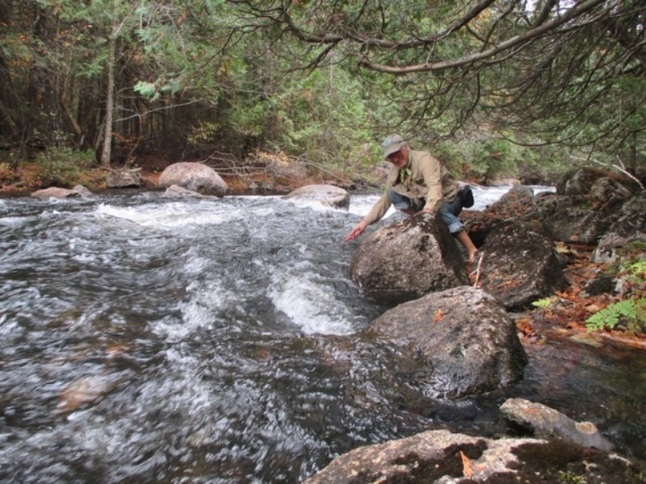
Twas the Night Before Day in the Life and…
Ice Meadows
Warrensburgh NY
Air Temperature | 9:15 AM | 58°F  14.4°C | Cloudy | Light Wind - North
Water Temperature | 9:15 AM | 60°F  15.5°C
Henderson Lake Outlet, Tahawus NY elevation 580 m | UTM  0575529 E  4882537 N
Air Temperature | 11:17 AM | 52°F  11°C | Medium to low flow
Water Temperature |  | 60 °F  15.5°C | 1 lone common merganser | flying low upstream
Cheney Pond
Newcomb NY
Air Temperature | 4:00 PM | 55°F  13°C | Cloudy
Water Temperature |  | 60 °F  15.5°C | Light Rain
Lock 5 Schuylerville
Air Temperature | 5:45 PM | 53°F  11.5°C | Cloudy | Light Wind - North
Water Temperature |  | 66 °F  19°C

