Day in the Life of the Hudson River 10/12/17 Data
(Salt Front Estimated ~ RM 65)
RIVER MILE 38
Haverstraw Bay County Park, Haverstraw Waterfront
Beth Michaluk –21 students, 11th & 12th graders in RCC course on Environmental Pollution, 3 adults
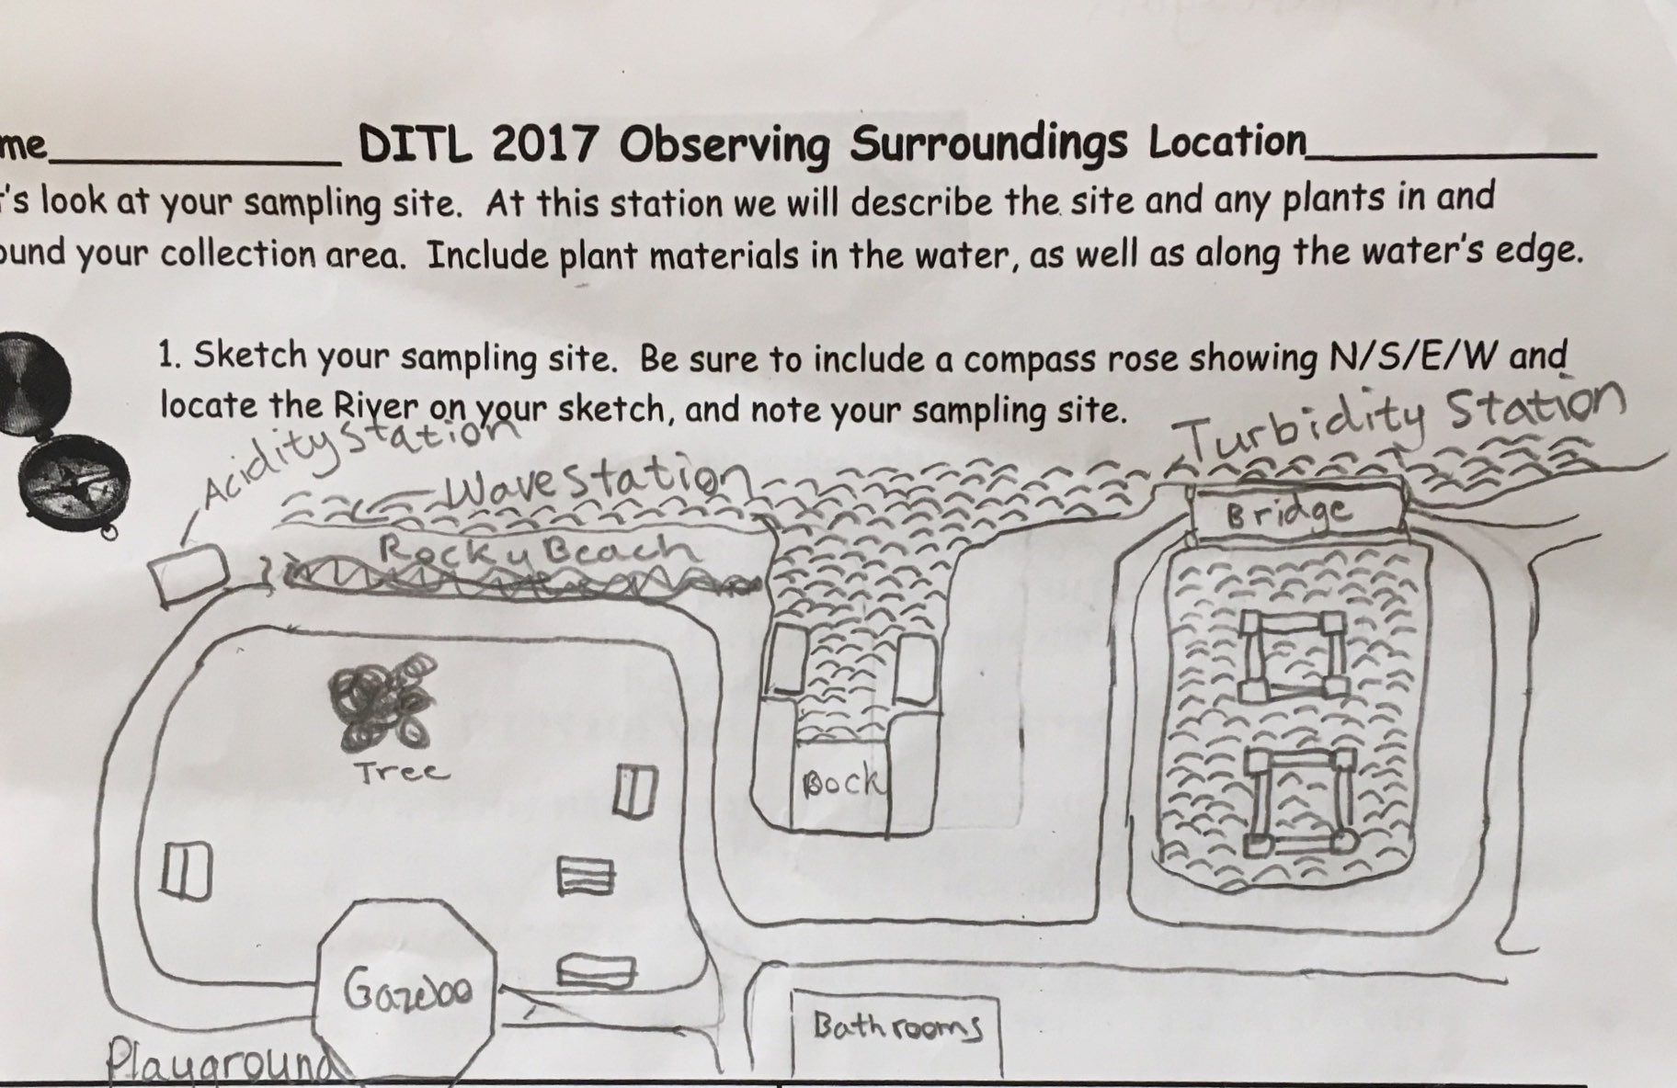
Location: North beach, dock and walking pier, Haverstraw Bay Park, Haverstraw waterfront, Rockland County NY
Area: Parking lot, recreation, fishing
Surrounding Land Use: 20% parkland, 40% Industrial/commercial, 30% urban/residential
Sampling Site: small beach, bank altered, large rip rap, bulkhead, concrete bulkhead, covered in vegetation
Water depth: 5 to 18 inches
Shoreline & River Bottom – 20% muddy, 40% sandy, 40% rocky
ITEM | Time | Reading 1 |  | Reading 2 |  | Comments
Physical
Air Temperature | 9:40 AM  10:30 AM  11:15 AM | 15.7°C  17  17.2 |  | 59.7°F  62.6  63
Wind Speed - Anemometer | 9:42 AM  10:36 AM  11:15 AM | 4.4 mps  2.8 mps  4.5 mps |  | 9.8 mph  6.3 mph  10:00 mph |  | Avg 3.9 mps /8.7 mph  North  Beaufort 1-2
Cloud Cover | Mostly cloudy | 51-75%
Weather today | Overcast | No rain
Weather last 3 days | Rain
Water | calm
Water Temp. avg. depth 2.5 ft | 9:59 AM  10:50 AM  11:24 AM | 20°C  18  18 |  |  | 68°F  64  64
Turbidity – Long site tube | 9:30 AM  10:30 AM  11:30 AM | 27cm  35 cm  43 cm
Chemical
DO  Drop count | 10:24 AM  11:12 AM  11:40 AM | 20°C  18  18 |  |  | 10 ppm  12 ppm  13 ppm | 110 % sat.  125 % sat.  125 % sat.
pH - color match test kit | 9:45 AM  10:57 AM  11:28 AM | 7.6  7.4  7.5
Salinity:  Quantabs HR | 9:57 AM  10:50 AM  11:22 AM |  |  |  | 3782 ppm Cl-3782 ppm Cl-  3782 ppm Cl- | 6832 ppm TS  6832 ppm TS  6832 ppm TS
Hydrometer | 9:57 AM  10:50 AM  11:22 AM | 8 ppt  6 ppt  6 ppt |  |  |  | Average 6.7 ppt
Turbidity - secchi | 9:45 AM  10:40 AM  11:25 AM | 60, 60, 60, 70, 40, 70 cm  50, 50, 50, 60, 50, 50 cm  50, 50, 50, 50, 50, 50 cm |  |  |  | Avg. 60 cm  Avg. 52 cm  Avg. 50 cm
Turbidity – long sight tube | 9:55 AM  10:50 AM  11:30 AM | 30, 28, 38, 35, 34 cm  35, 32, 24, 22, 22, 22, 24 cm  32, 26, 25, 46, 23 cm |  |  |  | Avg. 33 cm  Avg. 26.5 cm  Avg. 30.4 cm
Water very turbid, dark, cloudy, wavy, murky
Fish | Count | Species |  |  | Length largest
Net 20 feet | 11 | Atlantic Silversides |  |  | 6 cm | DIV - 1
 | 5 | Atlantic Silversides |  |  | 5 cm | TOTAL 16
Tides | 9:40 AM  10:00 AM  10:20 AM  10:40 AM  11:00 AM  11:26 AM  12:52 AM | 50 cm  40 cm  36 cm  35 cm  35 cm  37cm  55 cm |  |  |  | Set  Falling  Falling  Falling  Still  Flooding  Flooding
Currents | CM/30 secs | Cm/Sec |  |  | North/South Ebb/Flood/ | Knots
9:50 AM  11:00 AM  12:45 PM | 32.15 cm/30s  21 cm/30s  56 cm/30s | 1.1 cm/sec  0.7 cm/sec  1.9 cm/sec |  |  | Ebb  Ebb  Ebb | .02 kts  .01 kts  .04 kts
Core – | Properties | Rare |  |  | Common | Abundant
16 cm long | No smell, oil or oxidation | Clay  Pebbles  Wood |  |  |  | Sand
Shipping – Commercial
12:02 PM | Barge | Brown/Red |  |  | Southbound | Loaded
12:57 PM | Tug/Fish boat | White |  |  | Northbound | Loaded
Shipping Recreational
10:12 AM  11:40 AM  12:00 PM | Sailboat  Sailboat  Sailboat | White  White  White |  |  | Southbound  Southbound  Northbound | Light  Light  Light
Observations | Many bricks, coal, crab shells, rocks, sand and devil’s heads in the area. Remnants of past brickyard industry, coal transport and use, local industrial pollution. Many birds, chipmunks, bees, butterflies and flies, deer, dead turtle, seagulls

