Day in the Life of the Hudson River 10/12/17 Data
(Salt front ~ RM 65)
RIVER MILE 39
Riverfront Park, Stony Point Marina, Stony Point, Rockland
Jeanne Maguire, RCC Environmental Science Students through North Rockland HS – 49 12th grade students, 6 adults
Latitude N 41.2245828 - Longitude W 73.9639967
North Rockland High School
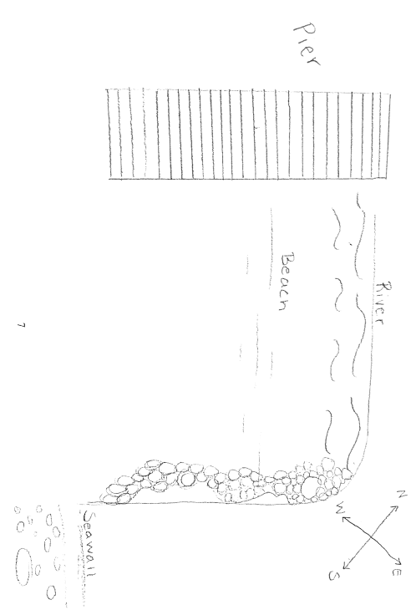
Location: Stony Point Marina Riverfront Park, City of Stony Point in Rockland County
Area: Located along the side of the road at the south end of the marina – Forested in the wider area, Pier, Grassy, Parking Lot
Surrounding Land Use: 40% urban/residential, 40% beach, 40% picnic and park
Sampling Site: Beach sandy and rocky near shore with rip rap edges.
Shoreline: Sandy beach, pier, shoreline RipRap.
Plants in area: No plants in the water, on the shore line: Water celery 50%, water chestnuts 20%, purple loosestrife 5%, Bur-reed 5%, jewelweed 5%, 15% other
Water Depth: 3 ft.
River Bottom –sandy and muddy

ITEM | Time |  | Reading 1 | Reading 2 |  |  | Comments
Physical
Air Temperature | 9:37  10:50 |  | 55ºF  59 | 12.7ºC  15.01
Wind Speed |  |  | 8.2mph | NE
Cloud Cover |  |  | Mostly Cloudy |  |  |  | Brief periods of sunshine
Weather today | No rain, mostly cloudy
Weather recently | It has rained the evening before and this morning
Water Surface | Choppy
Water  Temperature | 9:34  10:02  10:22  11:11 | 23ºC  23  19  20 |  | 73.4ºF  73.4  66.2  68
Turbidity –  Long sight tube | 10:00-11:25 | 23cm  24.6  19.2 |  | Average: 22.3
Chemical
DO | 10:02 | 23ºC |  | 9 ppm |  | 85% saturation
pH  LaMotte kit | 10:00-11:00 | 8.0  8.0  8.0 |  | Average: 8.0 |  | Average 7.6
Salinity –  High Range  quantabs | 9:18 AM-7.6 units  10:01 AM-8.8 units | .511%NaCl⁻  .995 |  | 3099 ppm Cl-  6035 ppm Cl⁻ |  | 5598 ppm TS  10903 ppm TS
Fish Catch- 9:05-11:30 AM | Number Caught | Species Fish |  | Size of largest |  | Seine
25ft seine net | 23 | Silversides |  | 2.0in | 5.1cm | DIV 3
3 fish per pull on average | 4 | White Perch |  | 5 | 12.7 | TOTAL: 35
14 seines total | 8 | Striped Bass |  | 5.5 | 14.0
 |  | Invert
 | 1 | Blue Crab |  | M 1.5cm
 | DIV 1 | Total Inverts 1
Tides | Time | Height in cm |  | Rate of Tidal Change (cm/min) |  | Rising, Falling, unchanged
 | 9:08  9:20  10:00  10:11  10:25  10:34  10:44  11:32  11:47 | 60  58  50  48  50  50  50  50  55 |  | -0.17  -0.2  -0.18  0.14  0  0  0  0.33 |  | Falling  Falling  Falling  Rising  Unchanged  Unchanged  Unchanged  Rising
Current | Time | Cm/sec |  | Kts |  | Ebb/Flood N/S
 | 9:14  9:35  10:07  10:30  10:50 | 2.6  24.8  7.5  10.5  6.3 |  | 0.05  0.42  0.15  0.20  0.12 |  | Ebb-South  Ebb-South  Ebb-South  Ebb-South  Ebb-South
Notes: We had wind pushing the water to the shoreline which was east of the river channel. Also there is a pier at our site.
Boating and Shipping | Type of Ship (Commercial/ Recreational) | Name |  | Northbound/ Southbound |  | Light/loaded
10:10  10:23  10:56  11:04  11:30  11:54  11:55 | R  R  C  R  R  C  R | Sailboat  Speedboat  Barge  Yacht  Sailboat  Barge  Speedboat |  | South  South  South  North  South  South  South |  | Light  Light  Loaded  Light  Light  Loaded (gravel)  Light
Other Items of Interest | 23 Red Billed Gulls  9 Mallards  2 Canadian Geese  America Crow  10 European Starlings  1 Peregrine Falcon |  |  | 1 Yellow Rumped Warbler  20 Housesparrows  1 Juvenile Bald Eagle  1 Lesser blackbilled gull  8 Turkey Vultures  1 Northern Mockingbird

