Day in the Life of the Hudson River 10/12/17 Data
RIVER MILE 4.1
(Salt Front ~ RM 65)
Buono Beach, Staten Island, NY

Mary Leou, Tania Goicoechea &
Wallerstein Collaborative for Urban Environmental Education/NYU (6 Adults)
David Scheffler, Curtis High School, 14 Marine Science Students
40°36’56.5”N and 74°03’46.4”W
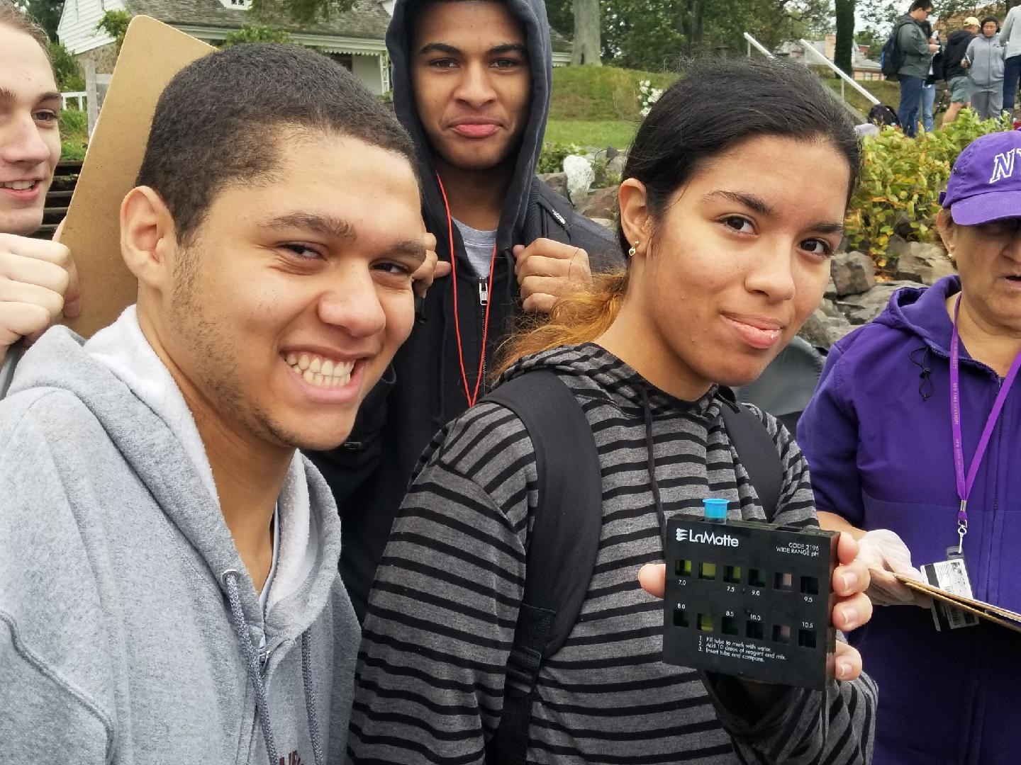 | 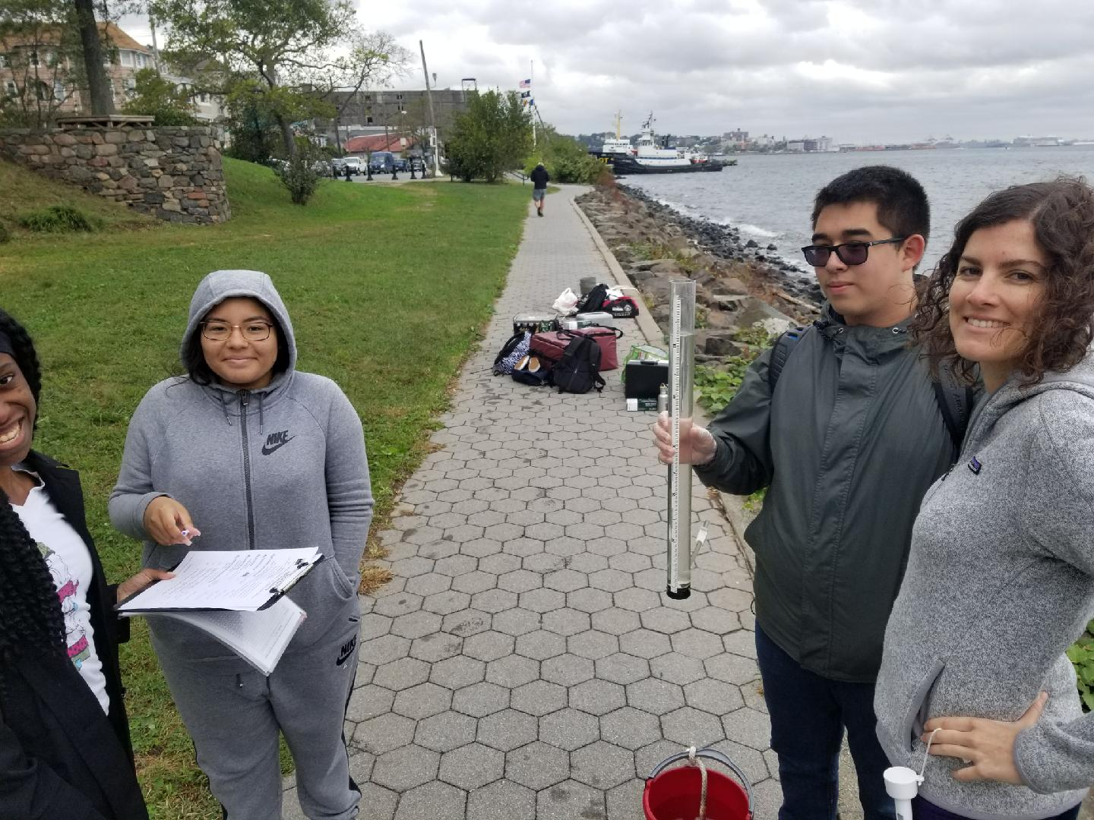
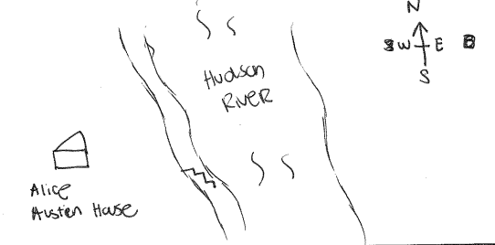
Location: Buono Beach at Alice Austen House, Staten Island
Area: Waterfront walkway and beach area. Mainly sand.
Surrounding Land Use: 60% urban/residential, 40% beach
Shoreline: beach with RipRap
Sampling Site: sandy, rocky bottom
Plants in area: None

ITEM | Time | Reading 1 | Reading 2 | Comments
Physical
Air Temperature | 10:30 AM  10:35 AM | 60.8ºF  64.4 | 16ºC  18
Wind Speed | NR
Cloud Cover | 10:35 AM | Mostly cloudy
Weather today | Cloudy
Weather recently | Windy
Water description | Choppy
Water Temperature | 10:22 AM  10:31AM | 68 ºF  62.6, 62.6ºF | 20ºC  17, 17ºC | Avg: 20ºC  Avg: 17ºC
Turbidity – 60cm site tube | 10:31 AM | 51.8cm | 52.4cm | Avg: 52.1cm
Chemical | Time | DO | Temp | % Sat
DO  Chemets Kit | 10:22 AM  10:31 AM | 5ppm  7, 7 | 18ºC  17, 17 | 55%  70, 70
pH – meter | 10:22 AM  10:31 AM | 7.5  7, 7
Salinity | Time
hydrometer | 10:31 AM | 27.7 ppt
Tides | Tides were very strong and may have impacted the water speed.
Other Observations | Rocks along the shoreline. Few bits of shell pieces and crab molts too. Mostly sandy area.  Also saw rats, pigeons, Canadian geese, double-crested cormorant,

