Day in the Life of the Hudson River 10/12/17 Data
(Salt Front ~ RM 65)
RIVER MILE 41
Steamboat Dock Park, Verplanck, Westchester
Bob Connick, Scott Rizzo, Trisha Johnson - Mahopac High School;
Environmental Research and Field Biology - Genesis Group 9th - 12th graders –
30 students, 4 teachers
Latitude N 41°14958 - Longitude W 73°936474
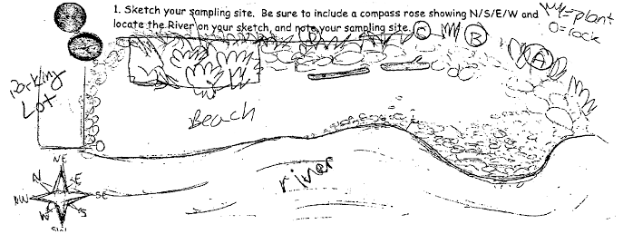
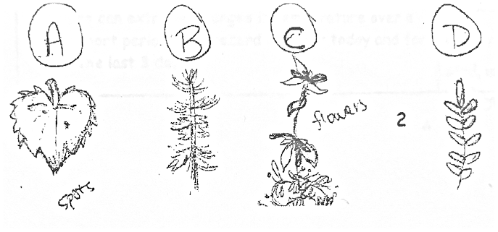
Location: Steamboat Dock Park beach, City of Verplanck in Westchester County
Area: located in a small cove between a point and a bulkhead – Pier, Grassy, Parking Lot
Surrounding Land Use: 30% urban/residential, 35% beach, 35% parking lot
Sampling Site: beach and parking lot
Shoreline: Sandy, rocky
Plants in area: no plants in water
Other: No plants in water but plants in the area around
Water Depth: 2ft
River Bottom – muddy, sandy, rocky

ITEM | Time |  | Readings |  | Comments
Physical
Air Temperature | 9:50  10:34  11:02 |  | 55ºF  58  59 | 13ºC  14  15
Wind Speed | 9:56 |  | Beaufort 4 | From North | 6 mph
Cloud Cover | 9:58 |  | Partly cloudy (26-50%)
Weather today | Rained this morning
Weather recently | Clear past 2 days, rain today
Water Surface | Calm
Water  Temperature  (2ft) | 10:29 | 73.8ºF, 73.8, 73.8 |  | 23.2ºC, 23.2, 23.2
Turbidity –  Long sight tube (cm) | 9:42  10:21  10:55 | 31.2, 30.2, 23.0  31.8  35, 33.1, 20.9 |  | Average 28.1  31.8  29.7
Observations: The water when first placed in the tube was very cloudy. You could not see the block that was on the bottom of the tub unless you released the water. It’s rusty.
Chemical
DO  (drop kits) | 10:30  10:40  10:45 | 23.3ºC  23.3  23.3 |  | 8ppm  8ppm  8ppm |  | 100% sat  100% sat  100% sat
pH  (color match test kit) | 10:30  10:55 | 7.5, 7.5, 7.5  8, 8, 8
Salinity  YSI SCT meter | 10:29 | 7.3 ppt
Alkalinity  (color match test kit) | 10:30 | 80, 100, 80mg/L |  | Average: 86.7mg/L
Nitrates  (color match test kit) | 10:36 | 0.02, 0.02, 0.02mg/L |  | Average: 0.02mg/L
Phosphates  (color match test kit) | 10:38 | 0.82, 0.82, 0.82mg/L |  | Average: 0.82mg/L
Fish Catch- 9:45 AM | Number Caught | Species |  | Size of largest
1 seine | 3 | Striped Bass |  | 10.2cm |  | DIV 4
 | 20 | Silversides |  | 15.2cm |  | TOTAL CATCH 31
 | 1 | Bluefish |  | 15.2cm
 | 7 | White Perch |  | 12.7cm
10:30
2 seines | 5 | Striped Bass |  | 10.2cm |  | DIV 3
 | 5 | Silversides |  | 10.2cm |  | TOTAL CATCH 17
 | 7 | White Perch |  | 10.2cm
11:30
1 seine | 6 | Striped Bass |  | 10.2cm |  | DIV 2  CATCH 13
 | 7 | Silversides |  | 10.2cm
Total Fish Catch | 61 | TOTAL DIV |  | 4
Macro catch | Number caught | Species
 | 25 | Green Crabs
 | 20 | Moon Jelly
Coring | Condition | Rare |  | Common |  | Abundant
Length: 10.2cm |  | Mud  Wood  Freshwater Mussels |  | Brick |  | Sand  Gravel  Pebbles
Tides | 8:32  8:54  10:15  10:30  10:45  10:50  11:13 | 71cm  68  64  67  26  67.5  27 |  | Boat wake  Boat wake
Current *  Full sampling time | Time | Cm/30sec |  | Cm/sec |  | Knots
Current *  Full sampling time | 9:00  9:51  10:18  10:28 | 40  43  21.8  30.8 |  | 1.3  1.4  0.73  1 |  | 0.03  0.03  0.01  0.02
Traffic Commercial | Name | Type |  | North/South |  | Loaded/Light
10:45  11:00  12:00 | Red  White/red | Gravel Barge  Tugboat |  | South  South  South |  | Loaded  Loaded  Light
Traffic Recreational | Type | Name/color |  | North/South |  | Loaded/Light
10:22 | Speed boat | Red/white |  | South |  | Light
Animals | Bald Eagles (2), Canadian Geese (16), herring gulls (20), Cormorant (1), Monarch butterflies (2), Mallards (6), Turkey vultures (4)
Other Observations | Rocks around beach. Rocks, Brick, logs on beach, plants around perimeter of sample area.

