Day in the Life of the Hudson River 10/12/17 Data
RIVER MILE 43.5
(Salt Front ~ RM 65)
Riverfront Green, Peekskill, Westchester
Michael Billy, Walter Panas High School - 29 students, 11-12th grade APES, 1 adult
Latitude N 41°17’13” Longitude W 73°55’53.53"
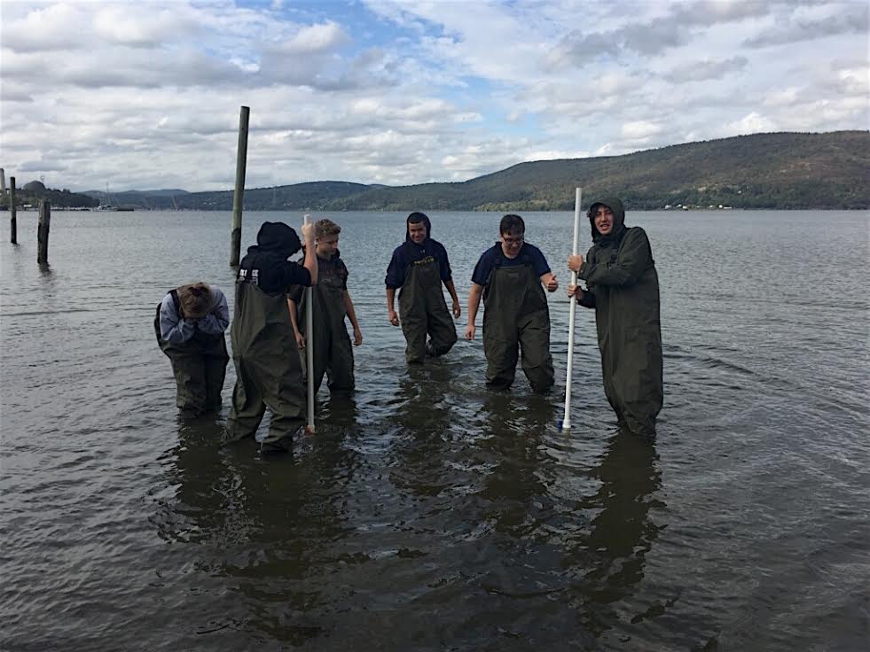
Location: Riverfront Green, Peekskill, Westchester County
Area: Grassy, park area with beachfront, pier, sandy beachfront, used for picnics, boating and fishing
Surrounding Land Use: 50 % grassy park; 40% industrial/commercial; 10% beach
Sampling Site: beach with brick, charcoal, slag and concrete bulkhead. Shoreline rocky, sandy, and muddy with pebbles
Water depth: 2 ft.
River Bottom – rocky
ITEM | Time | Reading 1 |  | Reading 2 | Comments
Physical
Air Temperature |  | 13ºC
Wind Speed |  | 9mph
Cloud Cover |  | 30%
Weather today | Cloudy, light rain
Weather recently | Rained within past 24 hours
Tide | Ebb | 4in/hr or 10.16 cm/hr | 0.169cm/sec
Water Temperature – | 10:50  11:01 | 15ºC  19ºC
Turbidity – | Secchi Disk  Long Sight Tube | 20cm  18cm
Chemical
DO | 11:34 | 19ºC | 8ppm |  | 86% saturation
pH | 10:50  10:53  10:57 | 6  7  7 | Average: 6.7
Salinity  Quantabs HR | 7.6% NaCl | 511 mg/L Cl⁻ | 923.1ppm TS
Fish Catch | Number Caught | Species | Length |  | Diversity/ Totals
Fish  Length of net: 20ft  13 pulls | 14  1  3  2  2  2 | Striped bass  Red breast sunfish  Spottail shiners  White perch  Anchovy  Shad herring |  |  | DIV: 6  TOTAL: 24
Macros | 1 (dead) | Crab
Sediment Core | Description | Rare | Common |  | Abundant
 | long |  |  |  | Clay  Mud  Sand  Gravel  Pebbles  Leaves  Brick

