Day in the Life of the Hudson River 10/12/17 Data
(Salt Front ~ RM 65)
RIVER MILE 5.6
Pier 84

N 40.764316 W-74.002065
Tina Walsh and staff from the Hudson River Park
AM CASA School and Lavonne Hunter – 40 sixth graders and 5 adults
PM Gateway School, Vicky Karkazis - 21 total 6th graders and 5 adult
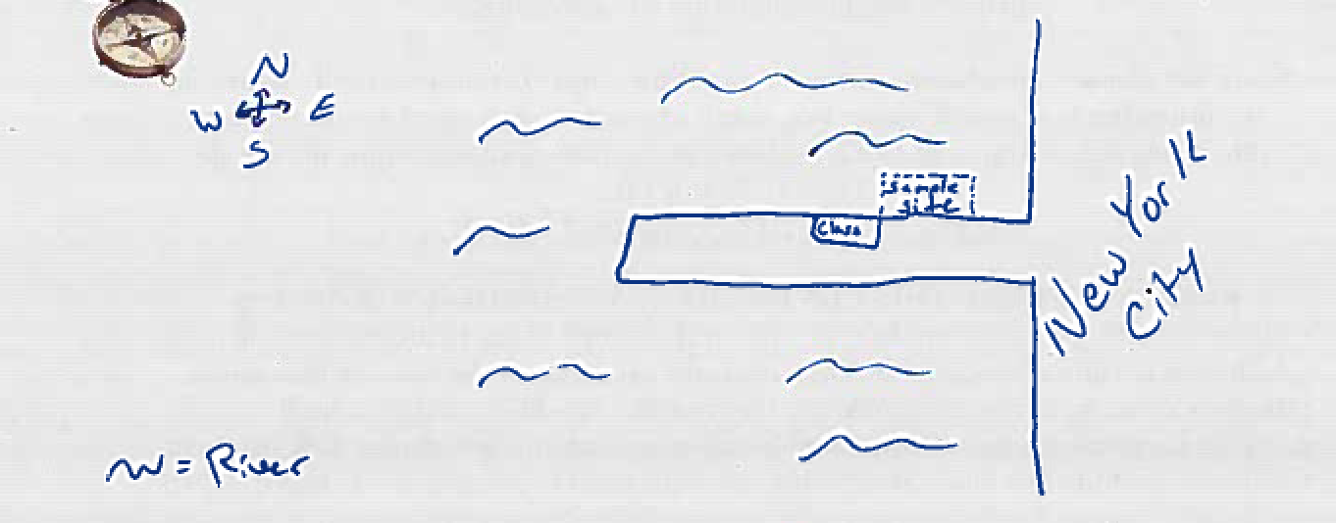
Location: Pier 84, is an educational pier used for picnics, boating, jogging, fishing
Area: Pier – bulkhead – mainly concrete & wood
Surrounding Land Use: 60% urban/residential, 40% Industrial Commercial
Sampling Site: Recreational pier – concrete bulkhead, rocks near the edge, banks altered – all hard edged, pipe entering water
Bottom: muddy
Depth: ~12 feet off pier
Plants in area: No plants
Water:
ITEM | Time |  | Readings
Physical
Air Temperature | 10:30 AM  11:30 AM  12:30 PM |  | 23.3°C  23.3°C  23.3°C | 74°F  74°F  74°F
Wind Speed | 10:30 AM |  |  | 5.2 kts | N
Cloud Cover | 11:30 AM |  | Partly Cloudy | 51-75% cloud cover
Weather today | 10:30 AM |  | Small bouts of rain | Water surface
Weather recently | Muggy, some rain, windy
Water Temperature | 10:45 AM  1:00 PM  1:15 PM  1:30 PM | 17.3°C  16 °C  16  16.7 |  | 63.2 °F  60.8 °F  60.8  62.2
Turbidity  Turbidity tube – cm | 1:00 PM | 47 cm  36 cm  57 cm |  | Avg. 46.67cm | Water pretty turbid, oil slick on surface, brownish green color
Chemical | Time | ppm |  | Temp | % Sat
DO  Estuary wide monitoring Kit – | 10:45 AM  11:15 AM  1:00 PM  1:15 PM  1:30 PM | 5,5,6  6,6,6  6  6  6 |  | 17.3  16  16°C  16°C  16.7°C | 62%  60%  60%  60%  60%
pH  kit as above | 10:45 AM  11:15 AM  1:00 PM  1:15 PM  1:30 PM | 7.4, 7.4, 7.4  7.8, 7.4, 7.8  7.4, 7,4, 7.8  7.8, 7.8, 7.8  7.4, 7.4, 7.4 |  | Average | 7.4  7.63  7.53  7.8  7.4
Salinity –hydrometer | 10:45 AM  11:15 AM  1:00 PM  1:15 PM  1:30 PM | 21,22,22  21,21,21  20, 20, 20 ppt  21, 21, 21 ppt  20, 24 |  | Average | 21.6 ppt  21 ppt  20 ppt  21 ppt  22 ppt
Fish Catch | Time | Species |  | # caught | Size
Macroinverts. – from oyster cage | 1 | Mud Crab
 | 24 | Grass Shrimp
 | 6 | Isopods
 | 4 | Amphipods
DIV | 4 | TOTAL 35
Tides - water depth | Time | Distance to water |  | Rate of change | Flood or Ebb
 | 10:15 AM  11:15 AM  1:00 PM | 183 cm  213 cm  244 cm |  | Falling  Falling | Ebbing  Ebbing
Currents | Time  NR | Ebb/Flood |  | Kts | Notes
Shipping | None recorded
Observations | Fallen leaves in the water and floating marine debris. Recent rain may have made the water more turbid.  Butterflies – monarch and painted ladies  Birds – Passenger pigeons, European starlings and house sparrows

