Snapshot Day 10/12/17 Data
(Salt Front ~RM 65)
RIVER MILE 51.5
Garrison Landing Park
Lisa Mechaley, Hudson Highlands Land Trust
Kevin Keegan, Garrison Union Free School
7th & 8th graders 20 students, 6 adults
41 22 57 N – 73 36 93 W
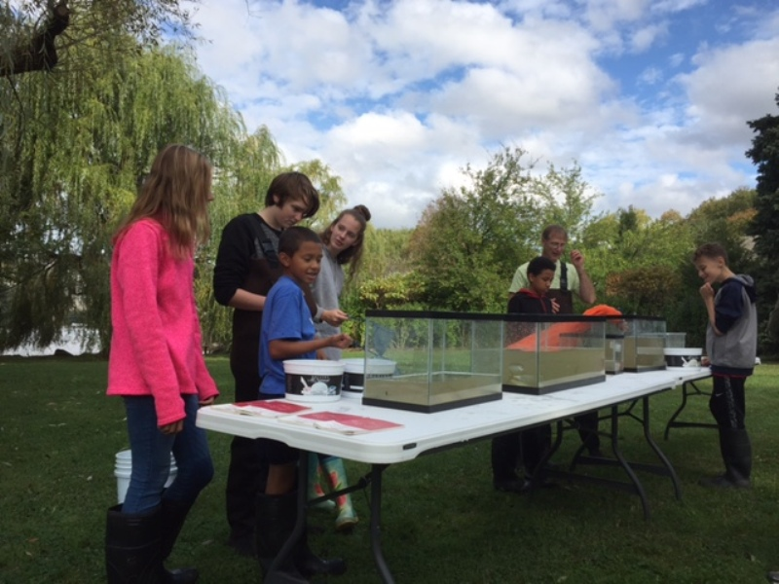 | 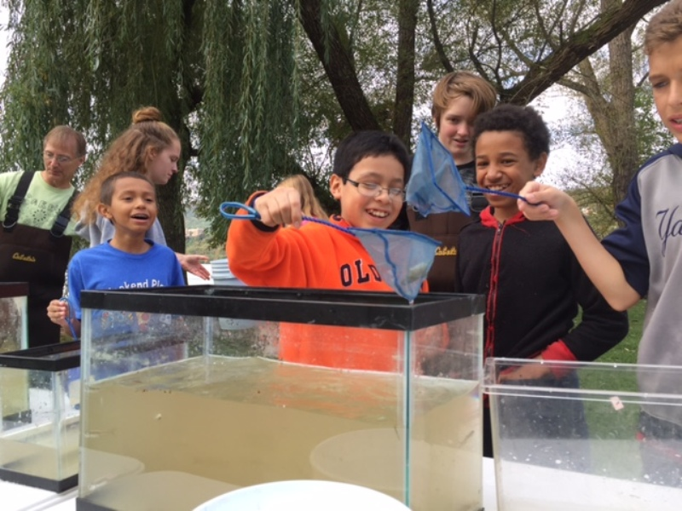 | 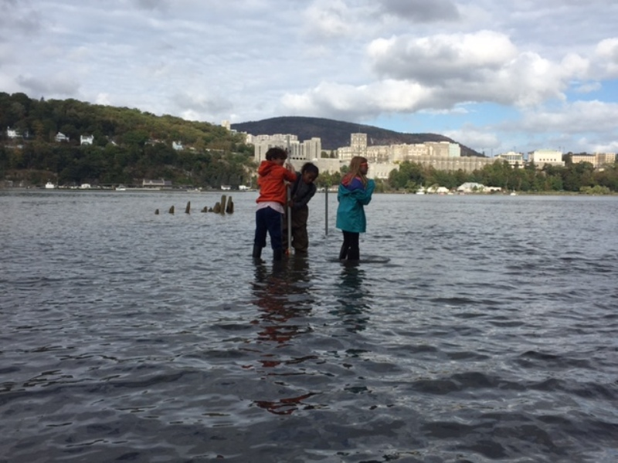

Location: Garrison Landing Park, Garrison, Putnam County, NY
Area: Waterfront beach area on front of grassy park primarily used for boating & picnics
Surrounding Land Use: Forested 60%, Urban/residential 20%, Industrial/commercial 10%, Forested 5%, Other 10%,
Sampling Site: Rocky shoreline, Pier, shore with bulkhead, riprap, grassy, parking lot
Shoreline: Sandy, muddy, rocky
Plants in area: 50% trees, 10% bushes, 30% grasses and 10% other plants
Water depth: 3 – 30 cms
River Bottom – muddy/rocky bottom
Plants in the water – none in water,
Water – Calm no waves

ITEM | Time | Reading 1 |  | Comments
Physical
Air Temperature | 10:15 AM  11:24AM  12:34 PM | °F | 16 °C  18°C  22°C
Wind Speed | Beaufort # | Knots | Mph | Direction
10:19 AM  11:25 AM  12:35 PM | #1  #1  #1 |  |  | North-North/West
Cloud Cover | 10:12 AM  11:26 AM  12:39 PM | Mostly cloudy  Partly Cloudy  Clear | 51-75%  26-50%  <25%
Weather today | No rain except this AM at 6:00-6:45 AM
Weather recently | No Unusually temperatures/weather
Water Surface | Calm, small waves – early in day brownish water
Water Temperature | 9:53 AM  11:14 AM  12:52 PM | 21°C  21°C  21°C | ° F | 0.5 ft.
Turbidity – secchi disk | 10:43 AM | 51 cm
Chemical
DO -titrator strips color match | 11:14 AM  12:52 PM | 3 mg/L  2 mg/L | 21°C  21°C | 21 %  15 %
pH – color match test | Time | Reading |  | Averages
 | 12:24 PM | 6  7.5 |  | 6.75
Salinity – quantabs HR | 9:36 AM  11:04 AM | 1830 ppm Cl-  1989 ppm Cl- | 6.4 units  6.6 units | 3306 ppm TS  3592 ppm TS
Tides - Time | Cm start ht | Stop Time | Cm end | Tide
Currents/Time | Cm/30 secs | Cm/Sec | Knots | Ebb/Flood/ Still
Seine – 60 ft. X 94.2 ft. pull – ¼ inch mesh | TIME | SPECIES | CATCH | SIZE/CM
Fish Group #1 | 10:05 AM | Bay Anchovy | 34 | 6.5 cm
 |  | White Perch | 3 | 15 cm
 |  | Alewife Herring | 4 | 13 cm
 |  | Striped Bass | 2 | 8 cm
 |  | Blueback Herring | 6 | 7.5 cm
Fish |  | Diversity 5 | Totals 49
Macroinvertebrates |  | Blue Crab | 1
 |  | Diversity 1 | Totals 1
Fish Group #2 | 11:00 AM | Blueback Herring | 3 | 6.7 cm
 |  | Alewife | 2 | 14 cm
 |  | Bay Anchovy | 51 | 7 cm
 |  | Striped Bass | 2 | 8 cm
Fish |  | Diversity 4 | Totals 58
Macroinvertebrates |  | Blue Crab | 1 | Male
 |  | Diversity 1 | Totals 1
Fish Group #3 | 12:15 PM | Blueback Herring | 21 | 6.5 cm
 |  | Banded Killifish | 3 | 6.5
 |  | Hogchokers | 2 | 10
 |  | Bay Anchovy | 9 | 6.5
 |  | White Catfish | 1 | 8
 |  | White Perch | 1 | 6
 |  | Shiner | 1 | 17
 |  | Smallmouth Bass | 1 | 9.5
 |  | Striped Bass | 3 | 6.5
Fish |  | Diversity 9 | Totals 42
Macroinvertebrates |  | Blue Crab | 3 | Male
 |  | Diversity 1 | Totals 3
GRAND TOTAL | DIV | 10 | COUNT | 149
MACRO TOTAL | DIV | 1 | COUNT | 5

