Snapshot Day 10/12/17Data
(Salt Front RM 65)
RIVER MILE 52
West Point South Side of Gee’s Point, Orange County
Patrick Bakerm United States Military Academy – Dept. of Geography & Environmental Engineering
Dana Onellette, Homeschool and Daisy Troop 192,
29 various ages ad 10 adults
41° 23’36. 46”N & 73°57’5.83 W
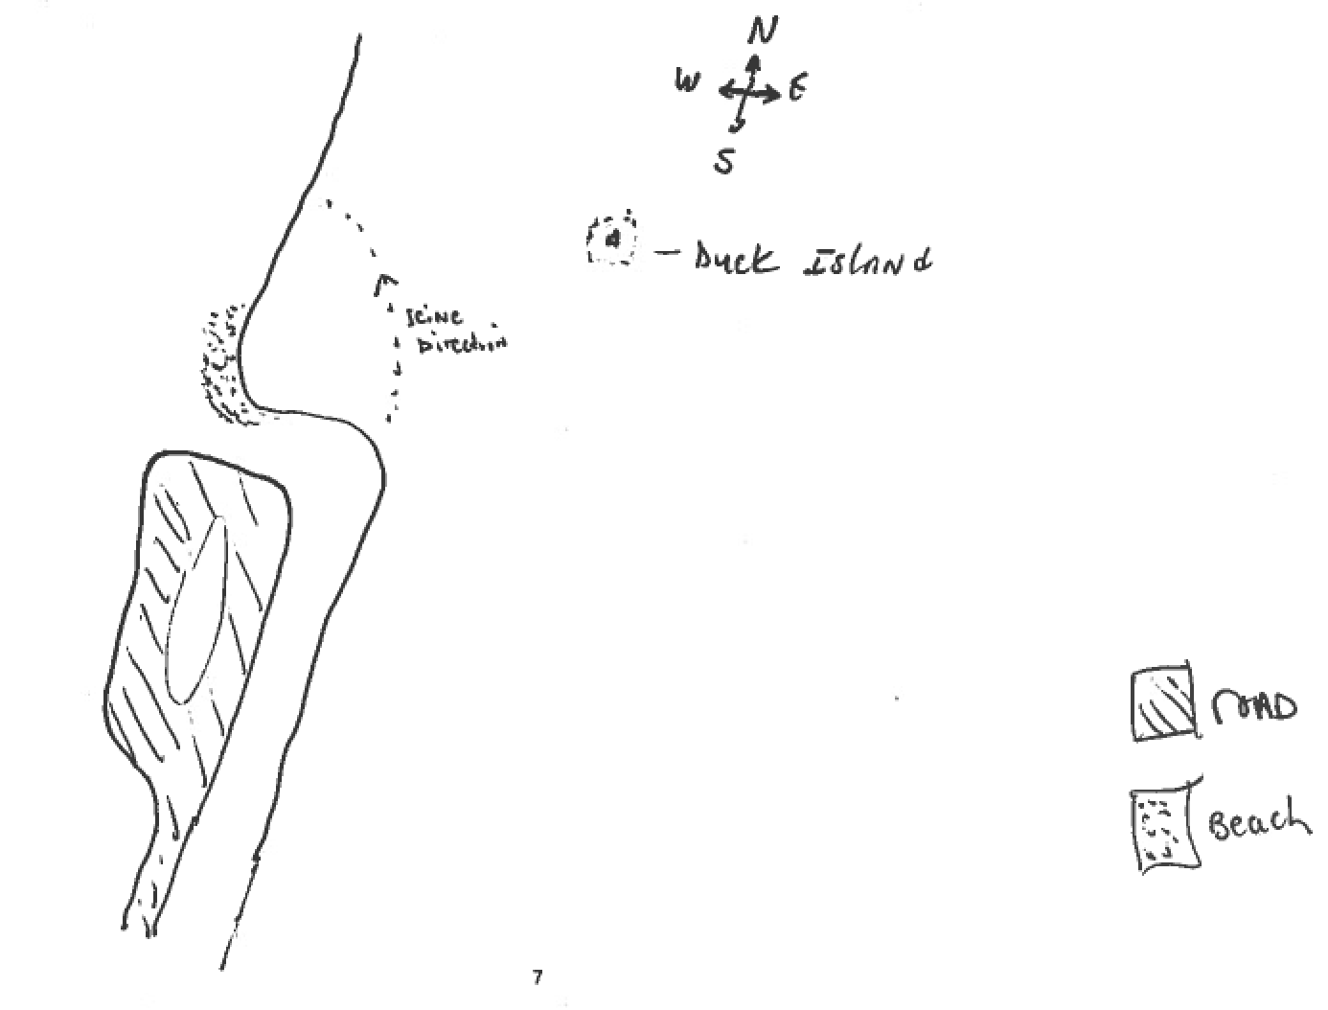
Location: Shallow Cover at South Side of Gee’s Point, West Point in the vicinity of Duck Island
Area: beach area on the waterfront along the West Point property
Surrounding Land Use: 50% forested and 50% beach
Sampling Site: shoreline is riprap,
Plants in area: 1% has plants in the water not identified
Tidal Shallows:
Water depth: 42 inches
River Bottom –sandy with large rocks

ITEM | Time |  | Reading 1 | Reading 2 | Comments
Physical |  |  | Celsius | Farenheit
Air Temperature | 2:15 PM  3:15 PM |  | 16°C  16°C | 61 °F  61 °F
Wind Speed | From N |  |  | Beaufort force #2
Cloud Cover | Clear |  | No rain
Water | Choppy
Weather recently | Rain last night
Water Temperature | 2:15 PM | 21.1°C  21.5  22.0 |  |  | 21.5°C average
 | 3:15 PM | 22.1°C  21.8  23.0 |  |  | 22.3°C average
Turbidity – secchi | 2:15 PM | 60 cm |  |  | 60 cm
HRECOS | 2:15 PM | 34.3 NTUs |  |  | 34.3 NTUs
Chemical
DO  (meter) | 2:23 PM | 7.54 mg/L |  | 22.7°C | 86.4%
pH – HRECOES |  | 7.7
Salinity - meter | 2:20 PM | 3.5 psu |  | In the Hudson psu ~= ppt
Fish Catch  Seine 30 ft. net with bag | Rank of total catch | Species |  | ~Number Caught
2 seines | 1 | Spottail Shiner |  | >100 | DIV 4
 | 2 | White Perch |  | >100 | TOTALS >225
 | 3 | Striped bass |  | >20
 | 4 | Bluefish |  | ~5
TOTAL SEINE | 105 |  |  | 81 | 186
Tides | 2:00 PM | Rising
Currents | NR
Observations | Also found blue crab molt

