Day in the Life of the Hudson River 10/12/17 Data
RIVER MILE 55
(Salt Front ~RM 65)
Little Stony Point
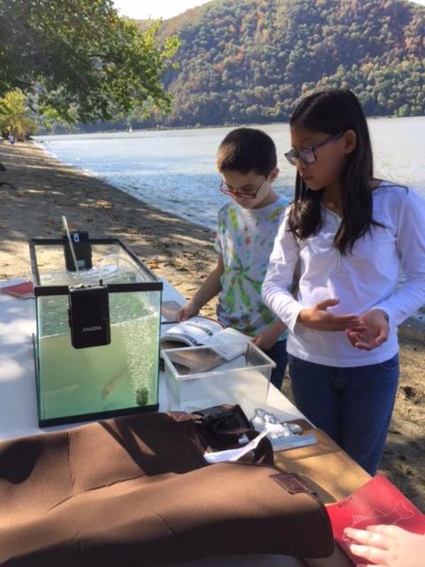
Pete Salmansohn, of the Hudson Highlands Land Trust
Mark Wick additional teachers/chaperones,
40 Haldane Middle (7th & 8th) and 5 chaperones
41°25’N - 73°58’W
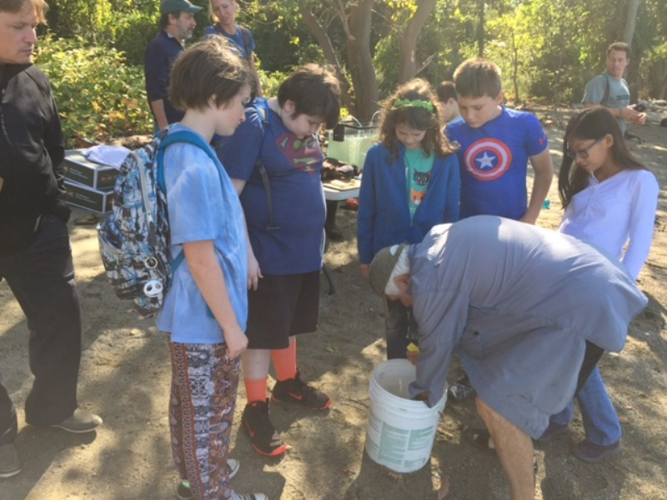 | 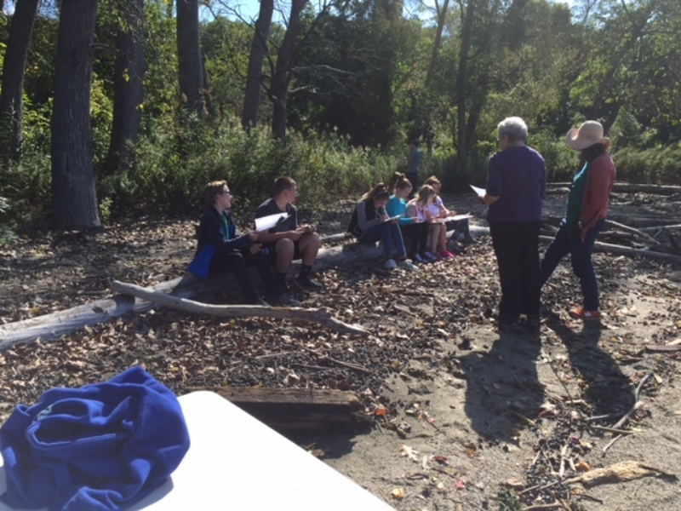

Location: Little Stony Point beach, Cold Spring, Putnam County
Area: On the beach at Little Stony Point, facing Beacon across from Storm King, swimming, picnics, boating, jogging and fishing are main uses
Surrounding Land Use: 80% forested & 20% beach
Sampling Site: beach area, concrete, docking with pier
River Bottom –sandy
SAMPLING TIMES 9AM to 1PM
ITEM | Time |  | Reading 1 |  |  | Reading 2 | Comments
Physical
Air Temperature | 12:42 PM |  | 21°C  29°C |  |  | 70 °F  79 °F | Shade  Sun
Wind Speed | 12:42 PM |  | Beaufort NR |  |  | 4-7 mph
Cloud Cover | NR
Weather today | NR
Weather recently | Warm but early fall
Water | NR
Water Temperature | 9:50 AM | 21.67°C |  |  | 71 °F
Turbidity – | NR
Chemical
DO  (ampules) | 12:42 PM | 6 ppm |  |  | 21.7°C |  | 68% saturated
pH – wide range pH strips | 12:42 PM | 7.8
Salinity – quantabs -LR | 12:42 PM | 4.0 ppt
Fish & Crab Catch | Time | Species |  |  | Number |  | Size of Largest
Diversity-5 |  | White Perch |  |  | 10 |  | NR
Totals - 48 |  | Bluefish |  |  | 1 |  | NR
 |  | Striped Bass |  |  | 15 |  | 6-7.5 cm
 |  | Striped Bass (yearling) |  |  | 2 |  | 15 cm
 |  | Atlantic Silverside |  |  | 8-10 |  | 8 cm
 |  | Spottail Shiner |  |  | 10 |  | NR
Macroinvert |  | Bluecrabs (Female) |  |  | 1
Div = 1
Totals 1
Tides – tide stick | NR
Currents | Time | Cm/sec |  |  | Cm/Sec
 | 12:42 PM | 945 cm/30 sec |  |  | 31.5 cm/sec
Core Description | Length | Rare |  | Common | Abundant |  | Notes
Traffic | 12:42 PM | kayak |  | Sailboat | Seaplane |  | North
Other Observations | Monarch butterfly, seagull, bald eagle!

