Day in the Life of the Hudson River 10/12/17 Data
(Saltfront ~RM 65)
RIVER MILE 57
Donahue Memorial Park, Cornwall Landing, Village of Cornwall-On-Hudson, Town of Cornwall, Orange County, NY
Christopher O’Sullivan, NYSOPRHP Trailside Museums & Zoo
Deborah Gilson and teacher team @ Willow Ave. Elementary -
Tom Lake, DEC HREP
5th grade – 51 students, 10 adults
GPS Latitude 41°26’36”N Longitude 74°0’1”W
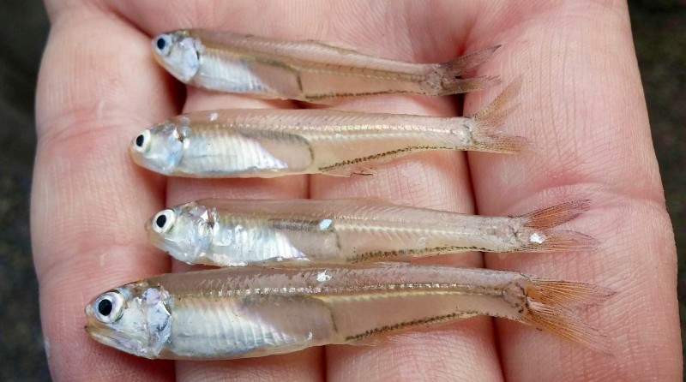
BAY ANCHOVIES AS FAR NORTH AS CORNWALL
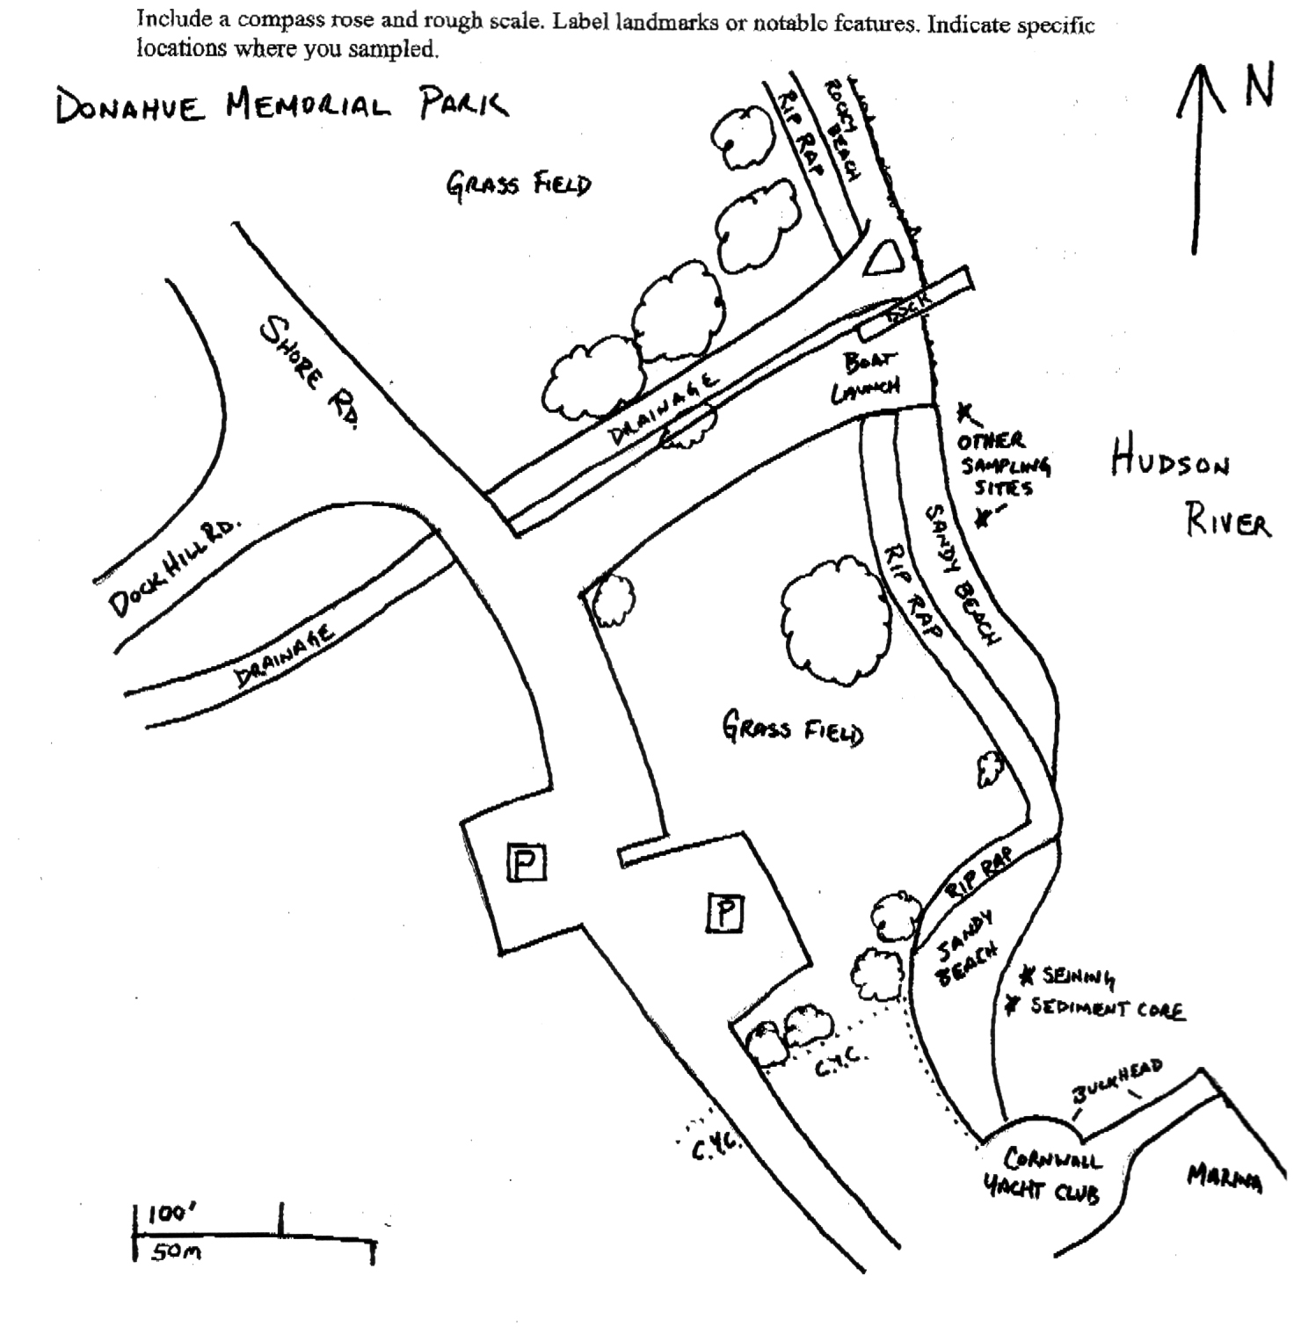
Location: Donahue Memorial Park
Area: Sandy beach used for seining & sediment core, 2nd beach are for other sampling.
Surrounding Land Use: 100% open and grassy park
Sampling Site: pier, sandy beach, altered banks, shoreline riprap, bulkhead, collected wood & debris in area,
Plants in area: NR
Water depth: NR
River Bottom – muddy, rocky
Observations – Rocky, algae in sampling area and sampled in sunlight

ITEM | Time |  | Reading 1 | Reading 2 | Comments
Physical
Air Temperature |  |  | °C
Wind Speed
Cloud Cover
Weather today
Weather recently
Water Temperature | Tom | 20.6°C  °C |  | 69°F
Water Surface | NR
Turbidity
Long sight tube
Chemical
DO  Drop count kit | NR
pH (indicator sol.)
Salinity - | Tom | 4.0 ppt
Fish Catch | Number Caught | Species |  | Size |  | Comment
 | 79 | Blueback Herring |  | 57-75 mm |  | yoy
 | 78 | Spottail shiner
(Yoy) = young of yer | 57 | Striped Bass |  | 70-110 mm |  | yoy
 | 27 | White perch
 | 10 | Tessellated Darter
 | 8 | Bay Anchovy |  | 54-62mm |  | yoy
 | 5 | Atlantic Menhaden |  | 75-80 mm |  | yoy
 | 5 | Alewife |  | 80-85 mm |  | yearling
 | 3 | Atlantic Silverside
 | 1 | Golden Shiner
 | 1 | White Sucker
 | 1 | Pumpkinseed
Total Catch | 275 | Diversity 12
Tides | TIME | RISING/  FALLING |  | HEIGHT IN CM |  | RATE OF CHANGE
Currents
Boat
Other Observations

